**PROGRAMMER ANALYST**

* **CAPGEMINI [ 2020 – PRESENT ]**
* **COGNIZANT TECHNOLOGY SOLUTIONS [2016-2020]**

**EDUCATION**

Bachelor of Technology, Computer Science and Engineering,

SRM University [2012-2016]

|  |
| --- |
| **Work Experience** |
| **As a Security Engineer-**   * Currently, Working as a Forgerock Developer/Support Analyst in IAM Engagement with an AGILE practice. * Working in a Banking Solutions Project as Security Engineer with Extensive implementation of OpenIDM(v**6.5**) with integration on LDAP & Microsoft Active Directory Services for Authentication and Authorization. * Good understanding of REST & Soap APIs with complete implementation in the IAM solution and endpoint interactions. * Worked extensively for Access Management with understanding of OAuth, Security and Authorization through Tokens and also Multi-level authentication using Password Vault Technique. * Understanding of Active Directory, OpenAM(6.5), OpenDJ (6.5), Linux RH7.8, Windows Server 2008, 2016. * Worked on enabling SSO using SAML and also using WebAgents. * Implementations: * Provisioning through external Rest API on OpenIDM with use of both external rest connector and Sample endpoint via scripting. * Implement 2nd level authentication through Vault-feature on Authorization Server. * Implement Authentication feature via LDAP through SOAP web service running on a cluster of servers.   **Other Projects –**   1. Also worked as Java Developer with Core Java & J2EE for implementing Multi-factor Authentication through RSA.  * Hands on experience on process automation and performance management using technologies – TMON with Elastic search(v6.8) & Kibana 5.4.  1. Also, Worked also as Dev Support for Applications on Access Management involving Authentication/authorization and Governance.  * User Access certification with Sailpoint IIQ ( v7.0e2). * Roles involvement Application + Infrastructural Support with process deployment, development on Resilience. * Testing Web services and operations using multiple Clients (Java, C#, C++) |
| **Key Skills** |
| * OpenIDM, Soap API. * Access Management, Authentication and Authorization via token * Password Vault and Multilevel authentication. * Use of Custom Connectors – LDAP, Oracle DB, Rest API. * Development for Process Automation, TMON |
| **Other known Skills** |
| * Sailpoint IIQ (v7.0) * Javascript, SAML, OAuth 2.0, OpenDJ * C++, .Net 2.0 & .Net 4.5, 4.7.1 (with Hands-on Experience) * REST API * SQL, PL/SQL, Oracle 11g, 12C, MySQL 5.7. |

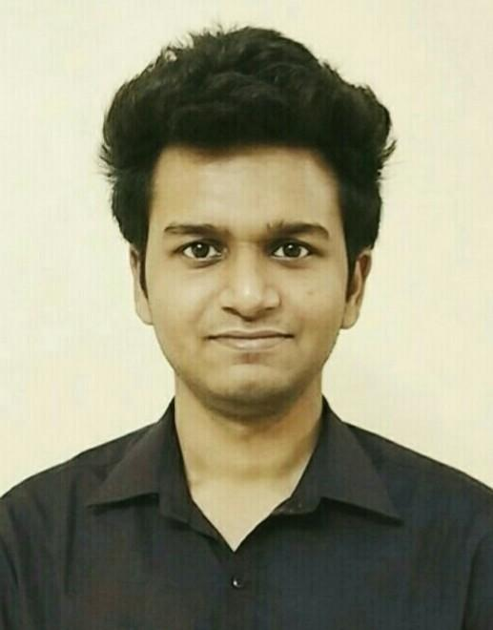

|  |
| --- |
| **ABOUT ME**  Ambitious professional with 4+ yrs. of proven expertise in IT-Security (Cyber Security and Development) along with Consulting with Banking and Support Engagement Projects. Comprehensive mastery of Software Development, Problem & change Management, Quality Improvement, Operational and Process Excellence. Expert at both local and global vendor networks. Able to work independently with little to no supervision. |
| **CONTACT**  **EMAIL**  shashwatgaur72@gmail.com  **Phone**  +91-7800339020  **LinkedIn**  <https://www.linkedin.com/in/shashwat-gaur-79894a147> |
| **PERSONAL**  **Languages known**  Hindi  English  German  **Date of Birth**  04-MARCH-1993  **Birthplace**  Lucknow, Uttar Pradesh  **Interests**  Movies, Travel, Cars, Basketball, Cricket |