
JITHENDER SIMHADRI
Senior Management Professional
jithin00@yahoo.co.in
+91-9848086745

Key Skills | Taxation (Direct & In-Direct) | Strategic Finance & Accounts | Financial Planning & Analysis |  Strategist, visionary, leader & achiever with championing organization values & vision with consistent record of delivering results in compliance
  Financial Analysis & Reporting
  Taxation (Direct & In-Direct)
  Accounts Payable/ receivable
  GST Audits and Assessments
  E-invoice implementation
  Annual Operating Budgets & Variance Analysis
  Budgeting & Forecasting
  Audits, Internal Control & Compliances
  SAP, Tally and MS Office
 | Profile Summary
- Diverse experience in managing end-to-end finance and accounts activities such as financial accounting & reporting, finalization of accounts, indirect & direct taxation, AR & AP management, compliance and audit activities
- Expertise in ensuring accurate reporting on tax returns by identifying, researching and evaluating alternative tax positions in order to determine a cost-effective filing position
- Hands-on experience in formulating business strategies, leading financial, cost accounting, treasury, budgeting, analytical forecasting
- Exhibited excellence in ensuring successful transition of processes like General Accounting, Taxation, Closing & Reporting, Statutory & Regulatory Reporting and Controls
- Excellence in initiating and integrating tax planning opportunities, monitoring industry issues and analyzing legislative proposals to maximize tax savings opportunities
- Ensured seamless execution GST implementation
- Impressive success in managing the structuring, consolidation, and analysis of financial data; developed budgets, forecasts and other financial reports for specific organizational sub-divisions, i.e., departments, regions and units

Career Timeline
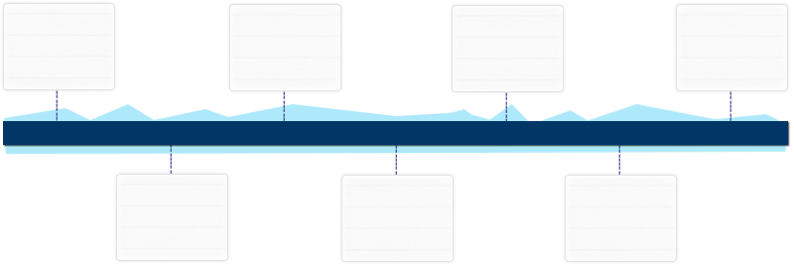
Sampath & Ramesh Chartered Accountants as Sr. Audit Executive

Bank of America [BACS], Hyderabad as Financial Analyst
Sampath & Ramesh CA as Sr. Audit Executive
Mar’03-Mar’07
Jan’08-Jul’09
Jul’09-Nov’10
Janapriya Engineers Syndicate Limited as AM – F&A
Nov’10-Jul’14
Jasper Industries Private Limited, as Asst. General Manager

Since Feb’19

GVPR Engineers Limited
as Assistant Manager- F&A

StatCom CFO Services Private Limited, as Sr. Manager – F&A
Aug’14 -Sep’15
Sep’15 - Feb’19

Work Experience | Since Feb’19  Jasper Industries Private Limited, Hyderabad as Asst. General Manager  Sep’15 – Feb’19: StatCom CFO Services Private Limited, Hyderabad as Sr. Manager – F&A  Role:  - Heading finance functions involving determining financial objectives, designing & implementing systems, policies & procedures to facilitate internal financial and process controls  - Extending support in imparting training to F&A professionals, conducting performance review of the team and recommending appropriate roadmaps  - Worked as a SPOC for recruitment of F&A resources, product development & presentations while managing a team of approximately 4 members; facilitating appraisals, mentoring & identifying various skills enhancement  - Designing business plans / strategies for maximizing the profitability & revenue generation and realizing corporate goals  - Implementing  - systems, procedures & manuals for preparation & maintenance of statutory books of accounts & financial statements, ensuring compliance with statutory requirements  - Managing the complete planning and management activities for ensuring completion of various types of audits within the time and cost parameters  - Formulating annual budgets and conducting variance analysis to determine difference between projected & actual results and implementing corrective actions
Saved cash outflow in form of tax by efficiently planning net ST payable on certain contracts. (Regular & RCM cases)

Reduced income tax demand by researching & submitting proof of no tax based on court judgments on cases which demand raised

Automated finalization process by implementing Vlookup within financials (TB to Financials; provisional entries; audit entries)

Improved monthly closing time from 5 working days to 2
Implemented simplified Tax SOP for accountants to follow uniform policy, which reduced time spent on rectifications and interest payable

Previous Experience
Preparation of Tax Audit Annexure and enclosures  Engagement includes ensuring compliance with Accounting Standards, Schedule VI, CARO, TDS, Service Tax, Sales Tax and applicable statutes  Preparation of material for submissions to Income Tax Department | Aug’14-Sep’15 with GVPR Engineers Limited, Hyderabad as Assistant Manager- F&A  Nov’10-Jul’14 with Janapriya Engineers Syndicate Limited, Hyderabad as AM – F&A  Jul’09-Nov’10 with Sampath & Ramesh Chartered Accountants, Hyderabad as Sr. Audit Executive  Jan’08-Jul’09 with Bank of America [BACS], Hyderabad as Financial Analyst
Articleship | Mar’03-Mar’07 with Sampath & Ramesh Chartered Accountants, Hyderabad as Sr. Audit Executive
Education | - CA Inter from ICAI in 2006  - B.Com (O.U.) from Badruka College of Commerce in 2004  IT Skills  - MS Office & Tally, SAP FICO  - Good Exposure to IOT
Personal Details | Date of Birth: 8th June 1982  Languages Known: English, Hindi & Telugu  Address: Flat # 1A, Mohan’s Vinodam, Ashoknagar, Hyderabad – 500020

