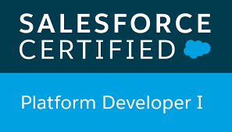 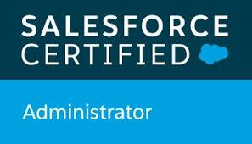

**Charishma Chowdhary (B. Tech, M. Tech, M.S.E)**

**+91 8328012109**

# SUMMARY

*I am a 2017 Graduate with a dual Master Degree in Engineering from Asian Institute of Technology, Thailand and Masters in Technology from JNTU Hyderabad. I was also selected for the AP Civil Services, but was offered a role that did not match my interest.*

*I have developed a strong understanding of the Salesforce platform as a Salesforce Analyst at BSquare Solutions. I am primarily responsible for working on an in-house banking project while mentoring other new hires on projects. I am also a Salesforce Certified Administrator with a strong understanding of APEX, Triggers, and Lightning.*

# EXPERIENCE

***BSquare Solutions & Services Jan 2020 - Current***

*Salesforce Analyst*

**Technical Environment:** Salesforce Admin/Developer, MS Office, SQL

**Key Responsibilities**

* As a Salesforce Analyst, my initial 2 months were spent on training for Salesforce Administrator and Developer
* I am currently working on an in-house retail banking project in Salesforce
* Created the necessary custom objects and fields for Customers, Accounts, and Transactions for the app
* Created workflow rules that allow users to receive an alert if their account has been debited or credited
* Created necessary profiles and roles for data entry and supervisor that would enhance data security
* Created deposit options for the customer for Cash/Cheque/Demand Draft with printing to PDF option
* Created functionality to create multiple account types for a single customer while displaying roll ups and summaries
* Created Account statements for customers and also created reports and MIS that would report customer transactions
* Developed VisualForce pages, buttons, and formulae fields as necessary for the application
* Well versed with Page Layouts, Apex Scripts, Triggers, Controllers, and Lightning concepts
* I also worked on a sample e-commerce application in Lightning that would allow users to buy required products from the website and check out products or services.

***Andhra Pradesh Civil Services Preparation Jan 2018 - Oct 2019***

* Prepared for the AP Civil Services exam and successfully achieved a position with Mahila Sisuankshema Sakha as Assistant. Declined the offer as it did not align with my interests

# EDUCATION

**ASIAN INSTITUTE OF TECHNOLOGY Bangkok, Thailand**

*Master of Engineering* ***2017***

**JAWAHARLAL NEHRU TECHNOLOGICAL UNIVERSITY Hyderabad, India**

*Master of Technology* ***2017***

**JAWAHARLAL NEHRU TECHNOLOGICAL UNIVERSITY Hyderabad, India**

*Integrated Course, Bachelor of Engineering* ***2012 – 2016***

# Certifications

# 

**Salesforce Certified Administrator October 2020**

**Salesforce Platform Developer 1 January 2021**

# Technical Skills / Languages

SAP Business Objects Data Services (Trained), SQL, Salesforce Admin/Developer */ English, German Level 1, 2, 3*