LUMAN KUMAR KANITHI  Lead Software Engineer |  |  | E-MAILluman.pgi@gmail.com  MOBILE+91-9866221946/+91-9347866914  LOCATION  Hyderabad / Bangalore / Vishakhapatnam
Achievement-driven professional targeting challenging assignments in Software Development & Design / Project Management preferably in IT industrywith an organization of high repute
PROFILE SUMMARY
- Offering chronicled success of10+ years in Project Management,Web Development & Maintenance,reviewing test cases and codes for conducting Unit & System Integration Testing.
- Gained exposure in working as an Administration and Developer in Salesforce.com; comprehensive knowledge of Technical and Functional aspects of Salesforce.com, on demand CRM package.
- Strong experience in Salesforce Development and Design.
- Exceptional proficiency in Apex Classes Visualforce Migration Tool and other programs in Salesforce developer toolkit.
- Excellent understanding of Eclipse and other Integrated Development Environments.
- Sound ability to integrate various business processes across different systems.
- Work directly with Business POC's and independently perform development, testing, implementation and documentation relates to the SalesForce.com development.
- Work with business leaders and the current development team to document and develop enhancements to our current Salesforce.com org.
- Proficient in providing technical design and architectural leadership to multiple teams & projects to help ensure applications are integrated and adhered to stated architectural and design principles & standards.
- Expert in implementing Project Methodologies like Agile / Scrum Methodology; Possess broad technical knowledge of application design, architecture and application integrations.
- Skills in coordinating with stakeholders during the course of problem diagnoses, requirements gathering, detailed level design, development, system test and production implementation to ensure that optimal resolutions were achieved.
- Capabilities in managing overall software development life-cycle involving requirement analysis, system study, designing, architecture, testing, programming, coding, de-bugging, documentation, implementation and maintenance.
- Exhibited excellence in mapping client / business requirements, application design & development, integration, testing and deployment of complex information systems.
- Proficiency in developing three-tier and two-tier Client-Server Applications in an Intranet /Internet Environment; technical expertise in Web APIs, C#.NET, ASP.NET and SQL Server.
- High integrity & energetic leader, capable of leading & motivating individuals to maximise levels of productivity; a customer-centric professional and knack for motivating large work-force for exceeding customer expectations in delivery of committed services.

CORE COMPETENCIES
Project Management  Debugging / Defect Management  Client Relationship Management | Requirement Gathering  Software Development & Designing  Coding & Testing | Database Administration  Team Building & Leadership  Software Architecture

SOFT SKILLS  Change Agent  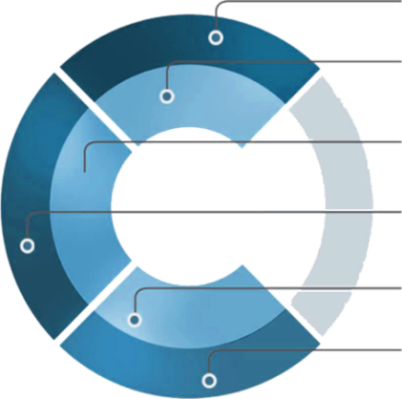  Thinker  Planner  Innovator  Communicator  Collaborator |  | EDUCATION  B.Tech. from Vardhaman Engineering College, Hyderabadin 2004  
CAREER TIMELINE

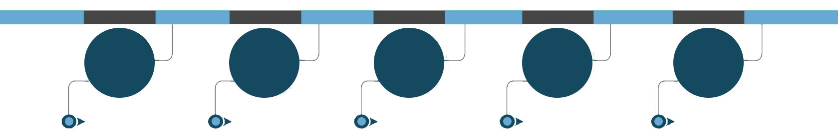
Since Jun’17





Mar’08 - Mar’09
Jul’09 - May’10
Jun’10 - Jul’16
Aug’16 - Dec’16

WORK EXPERIENCE

Since Jun’17 with ISSquared India Pvt. Ltd., Hyderabad as Team Lead

Key Result Areas:
- Designing the pages using HTML5, CSSand jQuery; leading the designing of custom objects, fields, role based page layouts, tabs, reports, report folders, report extractions to various formats, visual force pages, dashboards and other components as per the client and application requirements.
- Customizing the applications on Sales force platform & Force.com; steering deployment using force.com IDE & change sets
- Develop, maintain, create, and improve validation rules, custom workflows, Visualforce pages, Apex customizations, custom objects, fields.
- Seek out ways to utilize SFDC to improve processes and productivity, and make recommendations to support an organization scaling at a rapid pace.
- Coding APEX and custom applications for Salesforce instances.
- Design, code, and support solutions to meet business needs in Salesforce, including configurations, customizations and integrations.
- Participate in software development on the Salesforce.com platform using Agile/Scrum methodologies.
- Experience with use of the Salesforce.com APIs (via .Net, or through web services) to integrate.
- Provide recommendations on how to improve our Salesforce operational platform.
- Interfacing with clients for gathering business needs, conducting system analysis and finalizing technical / functional specifications and high level design documents; contributing to the development of physical & logical architecture diagrams including testing, troubleshooting & debugging of the database.
- Defining the coding standards; developing process of sending approach, sizing (estimation document) and test cases with test results for effectively closing on the trackers or change request.
- Creating database tables, writing store procedure and triggers for audit tables; writing and preparing repos using data members, class & interface along with dB Context.
- Analyzing the user's’ needs and business requirements for determining feasibility of design within time and cost constraints; consulting with customers/clients about software system design and maintenance.
- Conducting system study and coordinating with team members for product documentation, system design & integration, coding and application maintenance.
- Recognizing documents related to components and maintaining detailed study of the same as per the product changes, by getting in touch with the product developers.
- Providing post-implementation, maintenance and enhancement support to the client with regards to the product / software application.
- Undertaking development & testing, defect & issue management for software applications; conducting reviews of codes & test cases and analyzing change requests / enhancements.
- Implementing projects from the stage of initiation till monitoring & control and closure including planning, estimation & scheduling, cost estimation & budgeting; updating information to stakeholders, integrating change control, controlling base lines, planning risk responses and contingency planning.

PREVIOUS EXPERIENCE

Aug’16 - Dec’16 with Avenir IT Pvt. Ltd., Hyderabad as Team Lead

Jun’10 - Jul’16 with Ramboll India Pvt. Ltd., Hyderabad as Senior Software Engineer Lead

Jul’09 - May’10 with Sirgrace Technologies Pvt. Ltd., Hyderabad as Senior Software Engineer

Mar’08 - Mar’09 with Tanla Solutions Ltd., Hyderabad as Software Engineer

Sep’04 - Dec’07 with Purna Global Infotech Ltd., Hyderabad as Software Engineer

IT SKILLS

Force.com Technologies | Apex, VisualForce, SOQL, Apex Triggers, Apex Dataloader
Microsoft Technologies | C#.NET, ASP.Net, VB.NET (3.0/3.5), Web Services, Web API, AJAX, SSIS, SSRS, MVC 6.0
RDBMS | SQL SERVER 2000/2005/2008
Distributed Technologies | IIS
Web Technologies | HTML, Java script, jQuery, CSS
Operating Systems | Windows XP/2k/Vista
Others | Microsoft Visual Source Safe, TFS
IDE | Force.com IDE

PERSONAL DETAILS

Date of Birth: 05thJuly 1982
Languages Known: English and Hindi
Address: Erragada, Hyderabad

For Project Details, please refer the Annexure:
ANNEXURE
At ISSquared India Pvt. Ltd.,
Project: EIS (Enterprise Information System)
Form / Domain: Development and Maintenance / Pharmaceutical
Platform used: C#, VS2013, ASP.NET MVC, Web API, SQL Server 2012
Duration: 3 Years
Client: AMGEN

Project: MyAccess Portal
Form / Domain: Development and Maintenance / Pharmaceutical
Technology: Salesforce.com
Duration: 3+ years
Client: AMGEN

At Avenir IT Pvt. Ltd.,
Project: ISM
Form/ Domain: Development and Maintenance / Marketing
Platform used: ASP.Net MVC, C#, SQL, Windows 2010
Duration: 6 Months
Client: ISM

At Ramboll India Pvt. Ltd.,
Project: TELENOR (Telecom Operator)
Form / Domain: Development and Maintenance / Telecom
Platform used: ASP.Net, C#, SQL, Windows XP
Duration: 6 years
Client: Telenor
Third Party Controls: Dundas, Google Earth

Project: RAMBASE (Ramboll India Pvt. Ltd.)
Form / Domain: Development and Maintenance / Telecom
Platform used: ASP.Net, C#, SQL, Windows XP
Duration: 6 years
Client: RAMBOLL

Project: ESSP (Employee Self Service Portal) (Ramboll India Pvt. Ltd.)
Form / Domain: Development and Maintenance / Telecom
Platform used: ASP.Net, C#, SQL, Windows XP
Duration: 6 years
Client: RAMBOLL

Project: Executive Portal (ExPo) (Ramboll India Pvt. Ltd.)
Form / Domain: Development and Maintenance / Telecom
Platform used: ASP.Net, C#, SQL SSRS, Windows XP
Duration: 6 years
Client: RAMBOLL

At Sirgrace Technologies Pvt. Ltd.,
Project: PRISMS6.1
Form / Domain: Development and Maintenance / Pharmaceutical
Platform used: ASP.Net, C#, SQL, Windows XP
Duration: 1 year
Client: Abbott

At Tanla Solutions Ltd.,
Project: Outcast BMG
Form / Domain: Development and Maintenance / Telecom
Platform used: ASP.Net, C#, SQL, Windows XP
Duration: 1 year
Client: Outcast.TV, UK

At Purna Global Infotech Ltd.,
Project: CookieMan
Form / Domain: Development and Maintenance / Financial
Platform used: ASP.Net, C#, SQL, Windows 2000
Duration: 1 year
Client: CookieMan (Australia)
Project: OASIS
Form: Development and Maintenance
Platform used: ASP.Net, C#, SQL, Windows 2000
Duration: 1 year
Client: Oasislegal, USA

Project: PhillipsDirect
Form: Development and Maintenance
Platform used: ASP.Net, C#, SQL, Windows 2000
Duration: 1 year
Client: Phillips Plastics, UK

Project: DR.CAR ERP
Form / Domain: Development and Maintenance / Automobile
Platform used: ASP.Net, C#, SQL, Windows 2000
Duration: 1 year
Client: ACER MOTORS, Hyderabad

