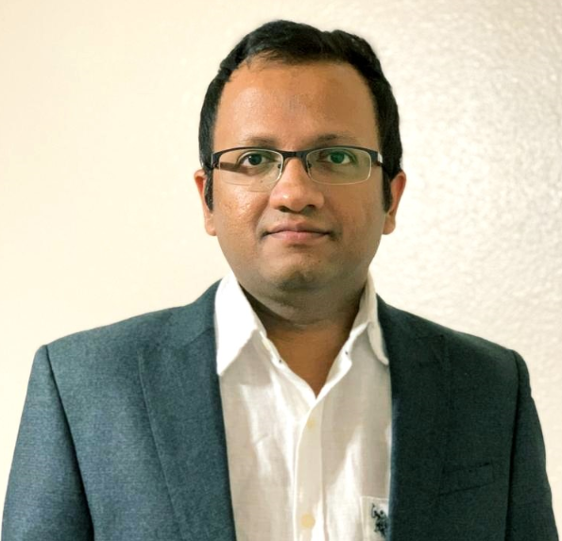
VIKRANT SACHAN

An enthusiastic & high energy driven professional targeting senior level assignments as ETL & DW Architect / Technical Architect / Senior Data Warehouse Developer / Data Engineer with an organization of high repute across IT industry preferably in Delhi-NCR/Pune/Bengaluru/Hyderabad

sachan.vikrant@gmail.com +91 7233802174

CORE COMPETENCIES    Data Architecture & Warehousing  Project Management  Technological Roadmap & Consulting  Strategy Planning & Execution  Extract, Transform and Load (ETL) Solution Architecture  Requirement Gathering & Analysis  Process Improvement & RCA  Data Modelling & Profiling  Stakeholder Management  Unit Testing & Test Case Management  Migration & Integration  SOFT SKILLS  Collaborator    Organized  Pro-active  Communicator  TECHNICAL SKILLS  - ETL Tools: Informatica 10.x/9.x, Talend 7.1.1  - Risk & Regulatory Reporting Tools: AxiomSL Controller View  - Data Virtualization Tools: Denodo  - Database: Oracle 18c/12c/11g/10g, SQL server, Netezza, IBM-DB2  - Languages: SQL, PL/SQL, Unix/Linux Shell Script  - Other Tools: TOAD, Git, Putty, Microsoft Office - Word, Excel, Visio, PowerPoint, SQL Developer  - Scheduling Tools: Autosys, Automic, Control M  - Operating Systems: Windows 7/8/10, Unix and Linux, Mac OS X  - Cloud Platform: Amazon Web Services (AWS) | PROFILE SUMMARY  - Seasoned IT Professional with over 11 years of experience including 4 years of onsite experience to United States and expertise in ETL & DW Architecture and techno-functional experience in leading & delivering large scale and very complex ETL integrations & migrations with high quality  - Technocrat holding valid H1B visa and domain expertise in Banking- Finance, Cards & Payment verticals; a keen planner, strategist with expertise in managing global delivery frameworks and new technology implementation for streamlining related activities within time & cost parameters  - Expertise in all the phases of Software Development Life Cycle (SDLC) entailing requirement analysis, design, development, testing, implementation, delivery and troubleshooting with comprehensive experience in technical solution architecture (using Agile models)  - Extensive experience in working with large scale Data Warehouse implementations using Informatica PowerCenter, Talend, Oracle, Netezza, IBM-DB2, SQL Server, Shell Scripting and expertise in Performance Tuning  - Leveraged working skills on developing PL/SQL Stored Procedures, Functions, Packages, Views, Triggers, Complex SQL Queries, FTP, SFTP and CI/CD DevOps Model (Jenkins, Git)  - Administered entire gamut of business analysis by gathering requirement, interacting with business managers/ vendors/ multinational clients/ consultants & other stakeholders, writing business and functional specifications, educating the team, bridging the gap and maintaining & monitoring requirements traceability throughout implementation, user acceptance and roll-out  - Insightful knowledge of:  - Regulatory Reports (Basel, FR2052A, ODS, OFSAA, RWA, FR Y-9C, FR Y-15, FFIEC 031) in Axiom Technology Platform using AxiomSL Controller View  - Amazon Web Service S3, EC2, Route 53, ELB, Redshift, Kinesis, Lambda, Databases in RDS, VPC and Application Services in Cloud  EDUCATION  B.Tech. in Computer Science & Engineering from Uttar Pradesh Technical University, Lucknow  2009  CAREER TIMELINE      Aug’20-till date        Feb’10-Nov’11  Nov’11-Oct’14  Nov’14-Aug’20
WORK EXPERIENCE

Aug’20-till date: MUFG Union Bank, Tempe, Arizona, United States of America as Technical Lead/Senior Software Engineer
Technologies Used: Informatica, AxiomSL Controller View, Oracle, SQL Server, SQL, PL/SQL, Shell Scripting, Toad, Autosys, AWS Cloud Platform

Nov’14-Aug’20: Infosys Limited, Richardson, Texas, United States of America as Technology Lead
Major Client managed: American Express, Phoenix, Arizona, United States of America
Technologies Used: Informatica, Talend, Oracle, SQL server, SQL, PL/SQL, Netezza, Denodo, Python, AWS Cloud Platform, UNIX Shell Scripting, CI/CD DevOps (Jenkins, Git), Toad, Automic

Growth Path: Joined Infosys as Technology Analyst and rose to the position of Technology Lead

Key Result Areas:
- Simulating, designing, developing & deploying computationally complex and practical data; building and delivering comprehensive data strategy roadmaps; ensuring final deliverables are of the highest quality
- Updating information to stakeholders, integrating change control, controlling baselines, planning risk responses and leading contingency planning; gathering data warehouse requirements in close coordination with cross-functional teams
- Evaluating all business & functional requirements; mapping documents & troubleshooting development processes
- Analyzing and defining client’s business strategy and determining system architecture requirements to achieve business goals; formulating strategic plans for component development to sustain future project objectives
- Guiding teams for delivery of full lifecycle development, architecture, systems, production operations/support, data analysis and ad-hoc reporting
- Creating the ETL architecture and providing strategy related to data cleansing, data quality and data consolidation; developing ETL Mappings, Mapplets, Workflows, Worklets using Informatica PowerCenter 10.x; preparing corresponding documentation
- Conducting defect analysis, patch testing, requirements analysis, implementing configurations and developing reports on Axiom Technology Platform; supporting to define the coding standards for the entire application
- Monitoring the development of integrations supporting standard data warehousing objects while working on multi-dimensional modeling and creating Star Schema, Snowflake Schema, Data Marts, slowly changing dimensions implementations (types I, II, III), dimensional surrogate key handling and incremental loading implementations
- Implementing best practices and tuning SQL code for optimization
- Participating in the roll-out of any changes to the production environment and setting new standards using change control, documentation, and communication with the operations and support
- Performing code reviews, deployment activities and unit test plan reviews in order to build the application conforming to project standard and requirements
- Working within a disciplined change-and-configuration management environment to maintain control over the development and introducing new functions to the operations
- Heading the design of all program specifications and performing required tests, as required
- Identifying bottlenecks, tuning the DW environment, SQL query tuning (collecting statistics, analyzing explains & determining which tables needed statistics), Database tuning and Informatica mappings tuning, Workflow tuning (targets, sources, mappings, and Sessions)
- Delivering excellence in identifying areas of improvement by analyzing vast amount of data, interpreting problems and providing solutions using data analysis & data warehousing techniques

PREVIOUS EXPERIENCE

Nov’11-Oct’14: HCL Technologies Ltd., Noida as Lead Engineer
Technologies Used: Informatica, Oracle Utilities Customer Care and Billing, Conversion Central, Oracle, Putty, UNIX Shell Scripting, SQL Developer, SQL, PL/SQL, Control M

Feb’10-Nov’11: ArohaTech IT Services Ltd., Noida as Software Engineer
Technologies Used: Oracle, SQL * Loader, SQL, PL/SQL, Toad, UNIX shell scripting, Putty, SQL Developer

PERSONAL DETAILS

Date of Birth: 27th February 1985 || Languages Known: English and Hindi || Address: MIG 55, BARRA 5, Kanpur – 208027, Uttar Pradesh

