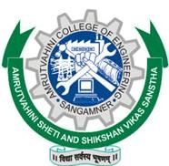 | MR. SOMESH SHIVAJI NAVALE |  |  |  | 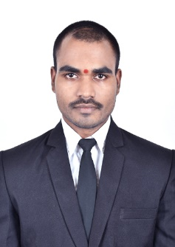
 |  | Devgaon Road, near Siddhkala Aurvedic College ,Sangamner Kd,Sangamner-422605
 |  | 20/10/1997 |  | Someshnavale123@gmail.com
 |  | 9146639224 |  | linkedin.com/in/someshs-navale-3054bb138
 | Career Objective:
 | To work in a firm with a professional work driven environment where I can utilize and apply my knowledge skills which would enable me a fresh graduate to grow while fulfilling organizational goals.
 | Educational Qualification: (BE- INFORMATION TECHNOLOGY Aggregate : 7.48)
Qualification | Year | College | University | % / CGPA | Class
BE | 2018-19 | Amrutvahini College of Engineering, Sangamner,  Dist.: Ahmednagar | SPPU, PUNE | 8.80 | Distinction
TE | 2017-18 |  | SPPU, PUNE | 8.78 | Distinction
SE | 2016-17 |  | SPPU, PUNE | 6.66 | First Class
FE | 2015-16 | AVCOE, Sangamner | SPPU, PUNE | 7.04 | First Class
HSC | 2014-15 | Dr.D.A O'Hara College, Sangamner | PUNE Board | 69.52 | Distinction
SSC | 2012-13 | Amruteshwar Vidyalaya, Sangamner kd. | PUNE Board | 79.82 | Distinction

 | Achievements:
              - Topper of department.
              - Leader of final year project.
- Communication Skills
- Presentation Skills
- Soft Skills
- Career Guidance Framework Resume Writing Group Discussion Skills
- Interview Skills Business Etiquette
- Effective Email Writing
- Telephone Etiquette
- Accounting Fundamentals IT Foundational Skills
- Overview of Artificial Intelligence* (Source: NPTEL)I was selected in Indian Navy.
 | Certification Courses:
- Computer Network CCNA Infinity IT certified
- Career Edge - Knockdown the Lockdown online course offered by TCS-iON
- An Entire MBA in 1 Course: Award Winning Business School.
- The Complete Presentation and Public Speaking/Speech course
➢ Activities:
• Wheebox Employability skill test
 | Languages: English, Hindi, Marathi, Sanskrit
 | Extra-Curricular activities:
- Workshop Attended:
              - Presentation and Public Speaking/Speech course
- MBA in 1 course: Award Winning Business School.
- Software-Skills:
              - Programming Language : C, C++, Core Java, Android
              - Database : MySQL, Mongodb
              - Networking : Routing and switching
              - Operating System : A user of Ubuntu, Windows 7 & 10
 | Experience:
1. | NCSI Technology Pune 14th June To 10th June 2020(1Year Experience)
Trainee-Engineer
-Works in Java Software Development various running projects like:
1.i-Exam(Examination System Development)
2.HR Management Projects
3.Assignment Projects
4.Healthcare Projects
2. | Smart Parking System (Tourism) Selected at AICTE New Delhi.
 | Objective: Today’s need of each and every person is vehicle so accident rate is goes on increasing till they are not worried about that how they are behaving. So to handle such situation the Smart Parking are comes in existing to reduce pollution.
3. | IOT and Big data for Smart home energy management system.
 | Objective: To design and develop energy control & management system in which automatically manage, control, monitor the energy.
 | Strength: My greatest strength is Learn from Anything & NEVER GIVE UP.
 | Hobbies: Reading the Book, Marketing, Meeting New People, Public Speaking.
Date:
Place: Sangamner (Mr. Somesh Shivaji Navale)

