Manohar k y 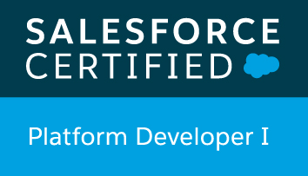 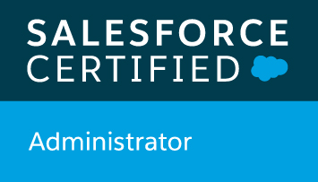 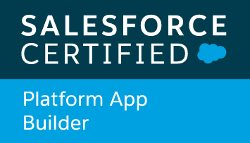 
Email : kymanohar@gmail.com
Mobile : +91 9652080579/9182709123

Work Experience:

- An experienced and passionate Salesforce Developer with expertise in developing, supporting projects, been working for 2.5+ years on Force.com platform.
- Experience in handling multiple projects and responsible for quality deliver of the projects.
- Well versed in development areas (like Apex Classes, Email Services, Triggers, Batch Apex, Schedule Apex and Visualforce pages) as well as Lightning Apps, Lightning design System.
- Around 1+ year of professional experience in Lightning App & Lightning component development.
- Expertise in administrative tasks like creating Objects, Custom Apps, Layouts, Validation Rules, Workflows, Communities and Approval Process.
- Experience in implementing Object-level and Record-level security using Profiles, Permission Set, OWD, Roles and Sharing Rules.
- Hands on experience in building Lightning Components.
- Developed Apex Controllers and visual force pages where multiple groups of people having different pages to perform their actions on their respective jobs
- Deployment of components using Change Sets and ANT migration tool.

Technical Skills:

- Programming Languages: Apex, Visualforce, C, Java
- Scripting Languages: Java Script
- Web Development languages: HTML
- Lightning Experience Development: Salesforce Lightning Design System and Lightning Components, Aura Framework, JavaScript Controllers, Server-side Controllers, Basic Lightning Web Components
- Tools: Salesforce Offline Connect, Data Loader, VS Code, JIRA, GIT, Ant
- CRM Product: Salesforce.com

Certifications

- Salesforce Certified Platform App Builder
- Salesforce Certified Platform Developer I
- Salesforce Certified Administration
- Einstein Analytics Consultant

Work Experience
- Working for Solunus, as a Salesforce Developer from August 2018 to Till Now.

Project Experience:

Project : Sales & Service Cloud
Role : Salesforce Developer
Description: The Scope is based on Client’s maintenance and support Needs. The approach will be leveraged to manage, capture, prioritize and ultimately deliver Client objectives over the course of the engagement. Client agrees to contract for capacity and access to the Solunus Managed Services Resources, scope is not fixed to any one initiative, but work related to the Salesforce Backlogs items.

Responsibilities:
- Worked on client assigned backlog items.
- Developed Visualforce pages for custom search functionalities and Apex Classes to handle various functionalities.
- Developed custom Approval Process and Email Services to overcome certain limitations
- Worked on PDF generations using Visualforce Pages
- Created validation Rules and Formula fields based on their business criteria.
- Designed and configured various Reports as per the client requirements
- Developed apex classes as per the requirement.
- Written Test Classes for code coverage
- Developed the Custom objects, Custom fields, Record Types, Custom tabs, Field Dependencies and Validation rules.
- Developed automations using Configurations like workflow, Process builder etc.
- Developed the email templates with connection to visual force components

Project : Project Management Tool
Role : Salesforce Developer
Description: To develop custom application in Salesforce to handle Project Management activities in Lightning Experience.

Responsibilities:
- Developed Apex Classes, Visualforce Pages and Triggers for functional needs in the application.
- Created page layouts and Assigned to the users based on their business criteria.
- Involved in Deployment Activities using change sets and ANT Migration Tool.
- Involved in migration of business data to Salesforce using the Apex data loader.
- Configuring Permission Sets and worked on User records
- Written Test Classes for code coverage
- Developed various Visual force email templates for Management activities

Project : Employee Performance Review AppExchange Product
Role : Salesforce Developer
Description: To develop custom application in Salesforce to handle: Employee Performance Management activities in Lightning Experience. The tickets are assigned by the client depending on the story acceptance criteria we need to implement the task.

Responsibilities:

- Developed Apex Classes, Lightning Components and Triggers for functional needs in the application.
- Created page layouts and Assigned to the users based on their business criteria.
- Lightning tasks which are groomed by client.
- Custom email functionality from lightning
- Involved in implementation of lightning custom components
- Configuring all admin related functionalities in lightning.
- Involved in migration of business data to Salesforce using the Apex data loader.
- Configuring Permission Sets and worked on User records
- Written Test Classes for code coverage

Project : Buyer’s Consortium (App Exchange Product)
Role : Salesforce Developer
Description: To develop a Tender Management app for Lightning Bolt Solution.

Responsibilities:
- Involved in Salesforce.com Application Setup activities and customized the apps to match the functional needs of the Bolt Solution.
- Created Lightning Components, lightning apps combining Lightning Design System, events and server-side controllers to meet the business requirements, added CSS and Design Parameters that makes the Lightning component look and feel better.
- Enabled Aura Framework, by adding Aura Attributes and Aura Handlers for Events to focus on Logic and Interactions in Lightning Applications.
- Minimized code in JavaScript Controllers by adding reusable functions in Helper Component. Updated the APEX Controller and Helper functions regularly making the Component Context Aware as per business requirement for Customer Community.
- Tested apps by appending multiple components to a Lightning Application thereby deployed Applications from Sandbox to Production.
- Involved in Deployment Activities using change sets and ANT Migration Tool.
- Written Test Classes for code coverage using the best practices available so that it can pass security code review of Checkmarx.

Project : Partner Community
Role : Salesforce Developer
Description: To develop lightning components for Partner Community.

Responsibilities:
- Involved in Salesforce.com Application Setup activities and customized the apps to match the functional needs of the partner community.
- Created Lightning Components, lightning apps combining Lightning Design System, events and server-side controllers to meet the business requirements, added CSS and Design Parameters that makes the Lightning component look and feel better.
- Enabled Aura Framework, by adding Aura Attributes and Aura Handlers for Events to focus on Logic and Interactions in Lightning Applications.
- Minimized code in JavaScript Controllers by adding reusable functions in Helper Component. Updated the APEX Controller and Helper functions regularly making the Component Context Aware as per business requirement for Customer Community.
- Written Test Classes for code coverage using the best practices available so that it can pass security code review of Checkmarx.

Education Details:

- Graduate in Computer Science Engineering from RGUKT APIIIT.

(Manohar KY)

