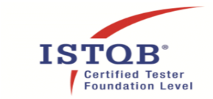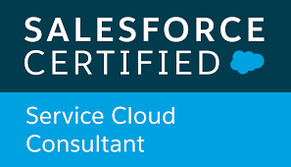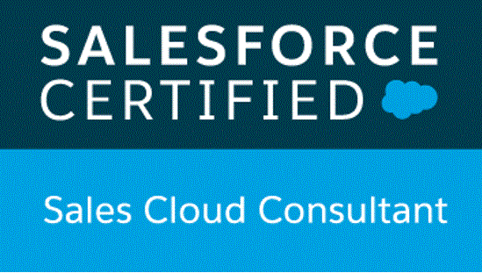

**Sagar Chawla**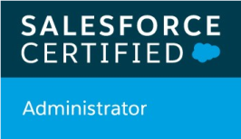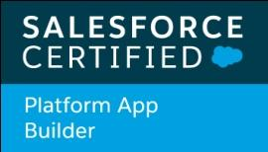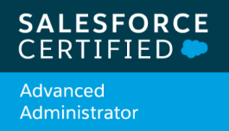

Email: sagarchawla92@gmail.com

Phone: +91-9896226365

*Looking forward to associate myself with an organization where there is an opportunity to share challenging avenues so as to make a niche in the industry and contribute to organizational growth*

**Career Precise**

* A result oriented **5x** certified Salesforce.com professional with **7.5 years** of qualitative experience with around **2 years** of **Onsite** experience in Australia in Salesforce Administration and testing.
* Support the maintenance of the CRM structure in Salesforce.com: User Roles, Permission sets, Profiles, OWDs, Sharing Rules, Role Hierarchy, Assignment rules, Workflows, Process Builders etc.
* Experience in generating Reports, Dashboards, Customized Reports and Analyzing the data in Salesforce.com.
* Extensive experience in Salesforce development which includes developing l**ightning web components**, wire methods, api decorators, usage of **apex classes** with wire and imperative calls in LWC and aura components.
* Extensive experience in creation of Data Raptors, **Vlocity Integration Procedures (VIP)** using Vlocity packages on top of Salesforce.
* Specialized in building frontend development in Salesforce using **HTML** and **bootstrap** components.
* Strong experience in business analysis for Siebel to Salesforce transformations and worked as Salesforce functional consultant in the telecom domain.
* In-depth knowledge of testing the different phases of software development life-cycle.
* Proficiency in creating Test Cases and Test Scripts, Defect Management and Test Exit Reports.
* Proficient in the various testing phases like: E2E testing, Functional Testing, System Integration Testing, API Testing, Regression Testing, Automation Testing.
* Specialized in building automation frameworks based on Node.js, JEST and integrating them with Salesforce using streaming api.
* Specialized in implementing **hybrid frameworks** and data driven frameworks by using Java, Selenium WebDriver, Maven, JUnit, TestNG based upon Page Object Model(POM) pattern.
* Experience in API Automation testing using **RestAssured** and enhancing existing UI automation frameworks with API support to achieve e2e automation goals.
* Strong experience in BDD(Behavior driven development) using **Cucumber** and **CI/CD** process with tools like Bamboo, Jenkins, GitHub etc.
* Expertise in creating CI/CD pipeline using **AWS** linux servers, **Dockers**, **Ansible**, Github Web hooks.
* Involved in the integration of selenium test cases with performance testing tool using Jmeter.
* Good at Understanding the Manual test case for the product and deriving automation Test scripts.

**Technical Skills**

|  |  |
| --- | --- |
| Programming Languages | Core Java, Javascript, Apex |
| CRM Tool(s) | Salesforce.com |
| Test Management Tool(s) | JIRA, ALM, MS SharePoint, Rally, CMC |
| Automation Testing Tool(s) | Selenium Webdriver, JEST |
| Build/CI Tool(s) | Maven, Jenkins, Bamboo |
| Performance Testing Tool | JMeter |
| Other(s) | Vlocity, TestNG, JUnit, Serenity, Cucumber, RestAssured |

**Professional Experience**



**Organisation#3: Salesforce February 2021 till present**

**Project #6**: Internal product development

**Role:** Salesforce Automation Engineer

**Tools used**: Salesforce LWC, Javascript

* Working on building reusable LWC components being utilized for building UI for test automation within Salesforce.
* Responsible for creating apex classes, custom metadata, custom labels, SOQL queries which are being consumed by javascript framework.
* Responsible for integrating Salesforce UI with javascript based automation framework using streaming api’s.
* Involved in running the automation regression suite from Salesforce UI in dockerzied containers hosted on Heroku.
* Involved in the creation of unmanaged package being offered as a ready to market solution for doing automation on Salesforce applications.
* Responsible for the code-merge process for the entire team using different tools like BitBucket etc.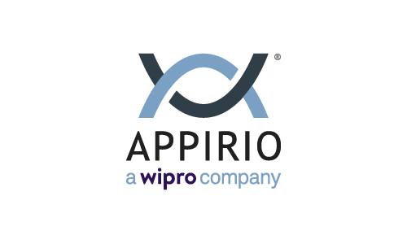

**Organisation#2: Wipro Technologies January 2017 till present**

**Project #5**: Telstra- Agent Console- Australia

**Role:** Salesforce Automation QA Engineer

**Software/Platform**: Salesforce B2C Service cloud lightning console, Vlocity

* Working on Behavior driven development with Cucumber automation using a hybrid framework.
* Responsible for the code-merge process for the entire team using different tools like BitBucket etc.
* Involved in running the automation regression suite using Selenium grid on cross browsers like chrome, firefox etc.
* Involved in the automation of pre/post deployment steps to speed up the process of deployment in salesforce.
* Enhanced the current framework with support of API using RestAssured libraries, serialization/deserialization of the XML/JSON responses and creating POJO classes.
* Strong experience in CI/CD process using Bamboo tool and scheduling the test cases after every deployment.
* Transforming UI tests into API tests using VIP’s and data raptors of Vlocity.
* Worked in Agile development environment which involves various ceremonies like Sprint planning, Grooming, Showcases, Retrospectives etc.
* Involved in testing multiple integrations with downstream systems like Natama, Siebel etc.
* Involved In the handover of environment from SIT to UAT by verifying the readiness for UAT environment and report discrepancies

**Project #4:** FACSChildStory- Australia

**Role:** Salesforce Automation Test Lead

**Software/Platform**: Salesforce Service cloud console & Communities

* Experience in leading a Team to Test End-to-End Sales & Service Cloud
* Follow-up with the team on individual testing tasks progress, preparation of system test cases and execution, Validation of the Test Results
* Worked in Agile development environment with frequently changing requirements
* Involved in the automation of Service Cloud salesforce application using keyword driven framework in Selenium Webdriver
* Involved in creating the complete regression suite through automation and running after every deployment and release.
* Involved in the configuration of SFDC applications like Process Builders, User setup, FLS , page layouts etc.
* Involved in testing multiple integrations between Salesforce.com and external systems like OCG, Conga Composer



**Organisation#1: Cognizant November 2013 till January 2017**

**Project #3:** Barclays - Strategic Introducers Solution

**Role:** Sr. Salesforce Test Analyst

**Software/Platform**: Salesforce Sales cloud & Communities

* Worked in Agile development environment with frequently changing requirements
* Involved in the estimation of user stories with Agile planning poker sessions
* Performed REST- API testing to send the xml through third party system and verifying the response in SFDC
* Involved in database testing to verify the integration between Salesforce.com and Teradata
* Involved in the configuration of SFDC applications like user setup, FLS , page layouts etc.
* Checking the flow of data between Teradata and SFDC by running shell script in Putty
* Involved In the handover of environment from SIT to UAT by verifying the readiness for UAT environment and report discrepancies
* Involved in the automation of community portal application using data driven framework in Selenium Webdriver

**Project #2:** CPQ- SALES CLOUD

**Role:** Salesforce Test Analyst

**Software/Platform**: Salesforce Sales Cloud

* Worked in Agile development environment with frequently changing requirements
* Test Case Design,Analyzing and Execution of Test Cases
* Running the batch jobs and validating the data accordingly
* Loading the data after every data refresh through Data Loader
* Involved in the testing of integration between Salesforce.com and SharePoint
* Mentoring new joiner and making sure that they are delivering work to the expected quality standards
* Execution of test scripts using Selenium-Web driver

**Project #1:** ADC (ABBOTT DIABETES CARE)

**Role**: QA MEMBER

**Software/Platform**: Salesforce Sales Cloud

* Responsible for the full cycle of the testing (understanding the requirement, Test case design, Test execution and test result validation
* Hands-on experience on SFDC standard Objects such as Accounts, Contacts, Opportunity etc.
* Involved in Test Case Designing, Analyzing and Execution of Test Cases.
* Involved in testing the new enhancements and coordinated with the development team in fixing the issues.
* Involved in Defect-Tracking and Peer reviews to ensure a defect free deliverable of the Enhancement.
* Participate in daily status calls with on-site teams for Requirements Analysis and technical discussions.

**Academic Credentials**

|  |  |  |  |
| --- | --- | --- | --- |
| **Course** | **Institution** | **Board/University** | **%** |
| B- TECH  (E.C.E) | Haryana Engineering College | Kurukshetra University | 75 |
| Class XII | S.D Public School | C.B.S.E | 79 |
| Class X | S.D Public School | C.B.S.E | 79 |

**Declaration**

I hereby declare that the information furnished above is true to the best of my knowledge.

**Date: - June 11, 2021 Sagar Chawla**

**Place: - Hyderabad, India** [linkedin.com/SC-☁](http://www.linkedin.com/in/sagar-chawla-%E2%98%81)

**Notice Period: - 1 Month**