C:\Users\vsraviteja\Downloads\sf_cert_plt_dev_1\Platform Developer I Badge\SFU_CRT_BDG_Pltfrm_Dev_I_RGB.jpg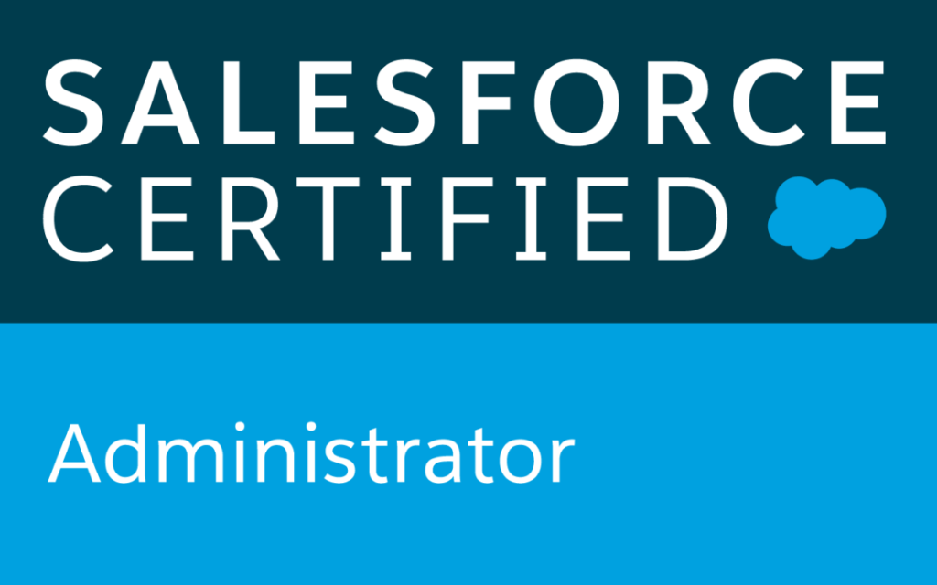 **Singamsetti Sri Poojitha**

**Email:sripoojithasingamsetti@gmail.com**

**Mobile: +91-9491548424**

**Salesforce Developer**

Objective:

To work in an organization which provides dynamic growth and where I can exploit my knowledge for growth of organization.

Professional Summary:

****Having 1.4 years of experience in Salesforce.com in Application Development.****

* Proficiency in SFDC Administrative tasks like creating **Profiles, Roles and Users.**
* Experience in designing **Custom Objects, Custom Fields, Page Layouts, and Record Types.**
* Good knowledge of understanding **Profiles and Sharing Settings** for the security purpose**.**
* Experience in **Workflow Rules** to automate **Tasks, Email Alerts, Field Updates, time-dependent actions and Outbound API Messages.**
* Experience in **Validation Rules** and **Process Builder**.
* Experience in creating **Reports** and **Dashboards** as per business requirement.
* Knowledge in **Lead, Case Management, Web-to-lead, Web-to case**.
* Effective work of Data Migration using Import/Export wizard and **Apex Data Loader** for bulk import or export of data from Salesforce.com objects.
* Experience in creating **Apex Controllers** and Controller extensions.
* Knowledge in writing **Triggers**, **Apex classes** and **Visual Force Page**.
* Knowledge in **Asynchronous Apex.**
* Experience in **Lightning Components.**
* Experience in creating Responsive components for **Lightning Pages.**
* Experienced using Salesforce Lightning UI. Created Components and Apps in Salesforce Lightning and Salesforce1 Mobile Experience.
* Created multiple Lightning Components, added CSS, Design Parameters that makes the Lightning component look and feel better.
* Analyzing business requirements, Entity Relationship diagram and implementing them to Salesforce custom objects, Junction objects, master-detail relationships and lookup and Master detail relationships.
* Ability to meet deadlines and handle pressure in coordinating multiple tasks in a work/project environment.

**Technical Skills:**

|  |  |
| --- | --- |
| **Languages** | Apex, SOQL |
| **Databases** | Salesforce.com |
| **Markup Language** | Visual Force, HTML. |
| **Automation Tools** | Workflow, Process Builder and Approval Process. |
| **Script Language** | Java Script |
| **Web Related** | HTML, JavaScript |
| **Tools & Utilities** | MS Office, Apex Data Loader, Workbench. |

Certifications:

* Salesforce Trailhead Ranger
* Salesforce Administrator.
* Salesforce Platform Developer 1.

Education Summary:

# Bachelors in Information Technology from Gudlavalleru Engineering College, Gudalvalleru.

Career Summary:

* Worked as Associate Software Engineer in Piersoft Technologies, Hyderabad.

**WORK EXPERIENCE:**

Project 2:

**Project:** Property Management.

**Industry Vertical :** Real Estate.

**Database:** Force.com

**Role:** Salesforce Developer.

**Project Description:** Client is a One of the leading Property leasing agents. The requirement is to capture Property Information and transfer into their Website. The applications should be captured in different ways either through website or manually. When the application is approved by the Property Owner, the applicant will be getting a Lease Form as PDF through email. If the Applicant accepts the Lease form, then he will be converted into Tenant for that Property. The Tenant will get a Website and their Own Login Credentials to raise their issues, Repairs. They can also check the rental payment information, Cases raised by them, Dashboards about the Property.

**Responsibilities:**

* Performed the roles of Administrator in the organization.
* Created Custom objects, Tabs, Workflows, Reports, and validation rules.
* Customized Property, applicant, Lease, Tenant Creation
* Implemented Reports and Dashboards.
* Used Data loader for all data inserting, deleting and exporting data.
* Created lightning components.

Project 1:

**Project: Online Skin Consultant.**

**Client: Nerd Skinnard.**

**Database:** Force.com

**Role:** Salesforce Developer.

**Project Description:** Client project is regarding service cloud as the customer used to book appointment for consultation and customer service person used to contact the person who booked the appointment from salesforce and follow-up with the customer.

**Responsibilities:**

* Worked on various standard objects and creation of customized business objects, fields.
* Involved in Validation Rules, Workflows and Process Buider.
* Involved in Creating Reports and Dashboards as per user requirement.
* Migrate the data in excel sheets into System using Data Loader.
* Created Responsive components for Lightning pages.

**(S.Sri Poojitha)**