Sayooj Surendran [](https://www.credential.net/4grnu7zy)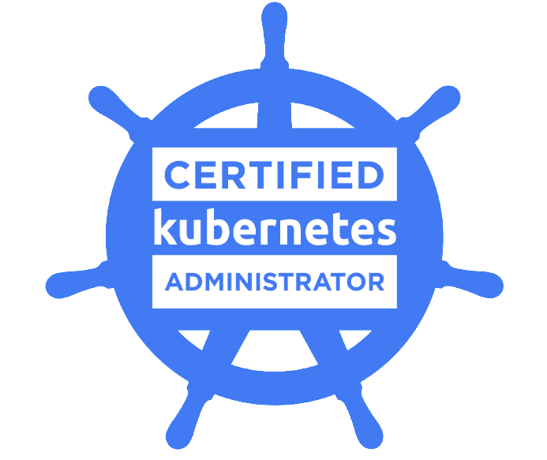

Linux Expert | Cloud Engineer.

Ph: +91 9036020308 | Email: Sayooj.surendran1@gmail.com

**Accomplished Linux administrator** with 10+ Total years of experience in managing server infrastructures and data-center operations across multiple platforms (Unix, Linux) and 3 years of experience in Cloud. Effectively plan, install, configure and optimize the IT infrastructure to consistently achieve high availability and performance.

#### HIGHLIGHTS OF IT SKILLS

**LINUX:**

* RHEL and Suse Administration.
* Systems Installation, Configuration.
* Filesystem & Storage Management.
* Root cause analysis.
* KVM & Xen virtualization
* Project Planning and Support.
* Security Hardening.
* Shell scripting.
* Data Migration and DR drills.
* RHEL Cluster Administration.

**Google Cloud :**

* Planning Deploying and managing Virtual Machines.
* Instance Group Creation and Management.
* Deploying and Manging Kubernetes Clusters.
* App Engine version management.
* Cloud Storage management.
* IAM management.
* Knowledge in Cloud Sql,Data Store,Big query,Big table,Pub/Sub.
* Configuring VPN and Firewall.
* Stack Driver Monitor and Logging.
* Billing Account Management.

**Azure Cloud:**

* Taking VM backup and enabling replication using Azure site recovery.
* Migrating workload to Azure from AWS/Physical Server/Hyper-V
* Creating and managed Azure VM's, Storage accounts, Databases etc.
* DB migration from On-premise Microsoft SQL to AzureSQL.
* Azure Monitoring to raise alerts for Infra failure.
* Creating NSG, Virtual Networking, Subnets, DHCP and IP addressing
* Understanding Azure point-to-site (P2S) and site-to-site (S2S) VPN
* Understand availability sets, fault domains and update domains in Azure
* Configuring and managing Azure Storage Accounts (File, Table, Blob, Queue), Azure Storage explorer and Managed disks
* Hands on experience in realizing architecture using Azure CLI.
* Creating and managing VM Scale set, Azure load balancer
* Better understanding about Azure load balancing including Traffic Manager
* Moderate knowledge about ARM template creation.
* Understanding about Azure Active Directory
* Better Understanding about Azure Kubernetes service .

**Container (Docker)**

* Better understanding about docker architecture
* Having experience in creating custom Docker Images using Docker file
* Having knowledge on Docker Networking and docker volumes
* Better understanding about Namespaces and C-Groups concept for docker
* Better understanding about Underlay and Overlay network concept
* Better understanding about Docker image layering concept
* Working Knowledge of Docker Containers and Orchestrations.

**Orchestration (Swarm/Kubernetes)**

* Building/Maintaining Docker container clusters managed by Kubernetes
* Installed and configured Kubernetes cluster using Kubeadm
* Deep understanding about Kubernetes Master and nodes architecture
* Understanding about tight coupling, Loose coupling models
* Hands on experience in creating PODS, Service, Replicaset and Deployments
* Writing YAML file for POD, Service, Replication Controller and Deployment creation

**Configuration Management (Ansible)**

* Installation and configuration of Ansible Control server and Linux/Windows Nodes
* Better understanding about writing YAML Playbooks for deployments
* Better understanding about Ansible Modules
* Using the ansible commands for adhoc issues troubleshooting
* Automating regular Linux/DB/Backup tasks using ansible
* Integrating and making use of Ansible with Jenkins.
* Creating roles, familiar with Jinja2 templates, Ansible vault and Ansible galaxy.

#### PROFESSIONAL EXPERIENCE:

Working as Technical Support Specialist (January 2015 to Present ) in **IBM INDIA PVT LTD**, Bangalore

Worked as Principal Infrastructure Engineer (March 2013 to January 2015 ) in **MPHASIS LTD** Bangalore

Worked as IT Analyst (September 2010 to March 2013) in **TATA CONSULTANCY SERVICES**, Mumbai

Worked as Customer support engineer (January 2007 to August 2010) in **HCL Infosystems ltd**, Mumbai

#### EDUCATION:

Board of Technical Education— Kerala .

**Diploma in Electronic and Instrumentation,2006**

Kerala Secondary Board

**SSLC,2003**

#### TECHNICAL CERTIFICATIONS & IBM BADGES

* RHCE (Red hat Certified Engineer ) ( <https://www.redhat.com/rhtapps/services/verify?certId=110-156-205> )
* Google Coud Certified Associate Engineer ( <https://www.credential.net/4grnu7zy>)
* Certified Kubernetes Administrator . Certificate id: CKA-2000-008958-0100 Last name: s

( <https://training.linuxfoundation.org/certification/verify/> )

* Docker Essentials ( <https://www.youracclaim.com/badges/c88a8d52-8f92-4752-8ae9-6a62e6143ec5>)
* IBM Mentor ( <https://www.youracclaim.com/badges/fbe2ca25-9138-4440-b6f8-8d7686c42183>)

#### Personal Details:

* Date of Birth : 10/5/1988
* Nationality : Indian
* Marital Status : Married
* Languages : English,Malayalam,Hindi
* Hobbies : Listening Song,Reading
* Permanent Address : Rajees PO.Eranholy,Chungam, Thalassery,Kerala-670107

|  |  |  |
| --- | --- | --- |
|  | **Declaration** |  |

I hereby declare that the above furnished details are true to my knowledge.

Place: Bangalore Sayooj.Surendran

Date:

Mobile: 9036020308 ◼ Email: sayooj.surendran1@gmail.com