**Sidramareddy**

**EDUCATION HISTORY**

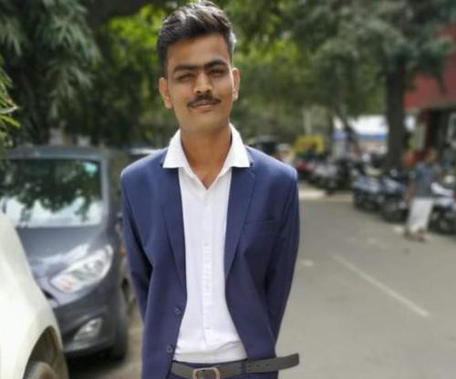

**GET IN CONTACT**

Mobile: 9686039108

Email: siddugoudadodamani@gmail.com

**PERSONAL DETAILS**

Current Location Bangalore/Bengaluru

Date of Birth May 25, 1998

Gender Male

Marital Status Single / Unmarried

**SKILLS**

Search Engine Marketing Social Media Optimization Google AdWords

SEO

**TECHNICAL SKILLS**

Digital Marketing

Search Engine Optimization

Pay Per Click Link Building Online Marketing Internet Marketing

Search Engine Marketing Social Media Optimization SEO

**LANGUAGES KNOWN**

English kannada Hindi

**COURSES & CERTIFICATIONS**

Skill Diploma In Digital Marketing

**Graduation**

Course B.Com( Commerce )

College Bangalore City College, Bangalore

Year of Passing 2021

Grade Pass

**Class XII**

Board CISCE(ICSE/ISC) Medium English

Year of Passing 2018

Grade 70-74.9%

**Class X**

Board Karnataka Medium Kannada Year of Passing 2016

Grade 65-69.9%

**WORK EXPERIENCE**

Jul 2022 to 2022

**Digital Marketing Intern at Webi7 digital marketing agency**

**SOCIAL LINKS**

http://sreddypatil.online

As intern I have experience in

SEO

Social media marketing

Content marketing

Search engine marketing (Google ads) PPC

WordPress developing

Graphic design

Email marketing

Google analytics and Google tag manager