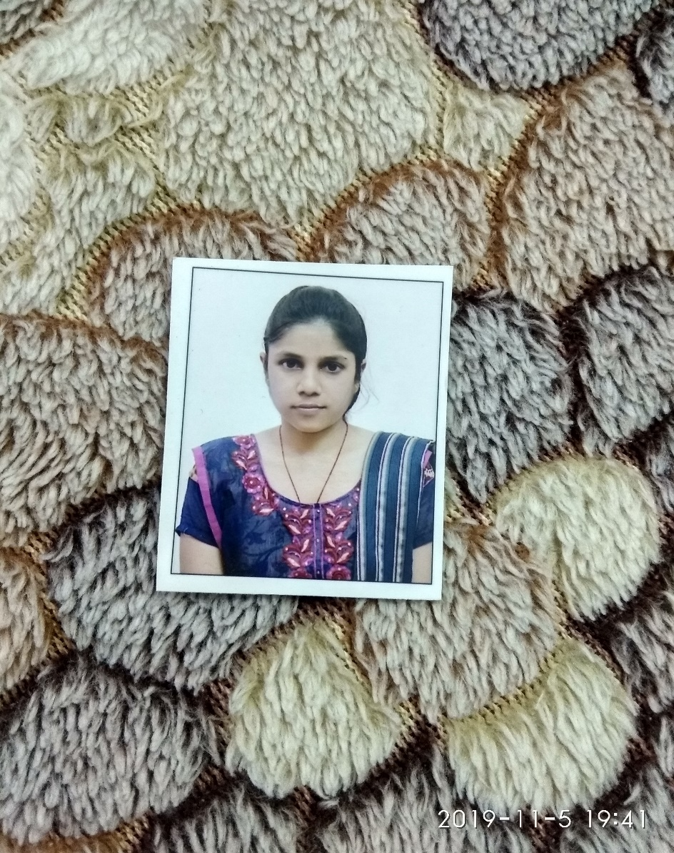**AKSHITA RAI**

E-MAIL: [akshita0919@gmail.com](mailto:akshita0919@gmail.com)

CONTACT NO:8574904336

LinkedIn Id: <https://www.linkedin.com/in/akshita-rai-30a10b174>

**CAREER OBJECTIVE:**

To secure a challenging position in a reputed company that enables me to contribute my knowledge and skills for a mutually beneficial association.

**EXPERIENCE:**

1 year of experience as an Associate Analyst in BERKADIA.

8 months experience as a content writer and proof reader in Chanakya Achievers Educational Pvt Ltd.

**SPECIALISATION :**

1. Finance
2. Marketing

**ACHIEVEMENTS:**

1.Stood 1st in Entrepreneurial Development Program organized by ICBM-SBE, Hyderabad.

2.Bagged various prizes in Speech Competition and other college fest organized by college and various other Institutes.

3.Reached a level of 10.9 /12 in STEP (Standardized Test for English Proficiency) conducted by The Hindu Group.

4.Awarded with a certificate of BEC (B1 level) in the assessment done by Cambridge University.

5.Received participation certificate of Marketing Genius Contest held in 2019.

6.Awarded with a Certificate of Appreciation for volunteering to organize “International Conference on HRM Practices” held in 2018.

7.Certified by NSDC in Retail Marketing.

**INTERNSHIP AND ACADEMIC PROJECT:**

* Successfully completed internship at KARVY STOCK BROKING LIMITED by working as a Financial Advisor for 2 months.
* PROJECT TITLE: ‘A study on the Effects of Unanticipated Incidents like Terrorism, Trade Wars and Natural Calamities on the Stock Market’.

**STRENGTHS:**

* Very enthusiastic and a quick learner
* Adaptable
* Optimistic and goal oriented
* Creative and Tremendous in teamwork
* Ready to acquire new skills and knowledge

**KEY TECHNICAL SKILLS:**

* Diploma in Computer Applications
* CCC

**ACADEMIC PROFILE:**

|  |  |  |  |  |
| --- | --- | --- | --- | --- |
| STREAM | NAME OF INSTITUTION | BOARD/UNIVERSITY | YEAR | PERFORMANCE(GPA) (%) |
| PGDM | **ICBM-SBE, HYDERABAD, TELANGANA** | **AICTE** | **2020** | **80** |
| M.COM | **HRPG, KHALILABAD, U.P.** | **SIDDHARTH**  **UNIVERSITY** | **2017** | **65** |
| B.COM | **MPPG, GORAKHPUR, U.P.** | **DDU UNIVERSITY** | **2014** | **59.27** |
| INTERMEDIATE | **NAVAL’S NATIONAL ACADEMY, GORAKHPUR, U.P.** | **CBSE** | **2011** | **66** |
| HIGH SCHOOL | **PRAKASH VIDYALAYA BACHELI, DANTEWADA, C.G.** | **ICSE** | **2009** | **71** |

**SPECIAL INTERESTS:**

* Browsing internet
* Reading blogs
* Exploring sites

**PERSONAL INFORMATION:**

Father’s Name Late Mr. Ashok Kumar Rai

Mother’s Name Mrs. Kusum Rai

Date of Birth 9th June ,1994

Languages known English, Hindi and Bhojpuri

Address Shiv Shakti Nagar,

Padri Bazar,

Near Latif Nagar,

Gorakhpur, U.P.

**DECLARATION:**

I hereby declare that the details furnished above are true and correct to the best of my knowledge and belief.

Place: Hyderabad SIGNATURE

Date: **AKSHITA RAI**