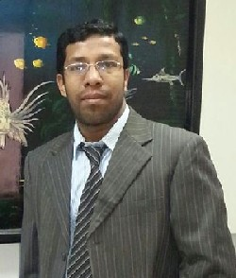 | 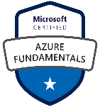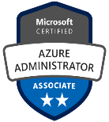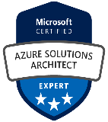  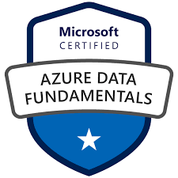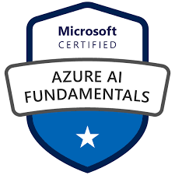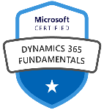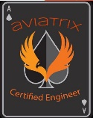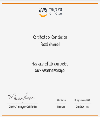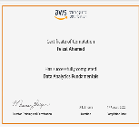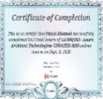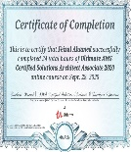 | feizalahamed@yahoo.com  India Mobile/WA: +91 8870547038  UAE Mobile/WA: +971 50 4102519  Oman Mobile/WA: +968 94120024
Feizal Ahamed abdul kader

Career Objective

A highly professional and dedicated personnel with 20 years expertise as IT Manager, Azure Solution Architect, ERP & HRMS Implementation. An able administrator, proficient working Knowledge in Managing the team, On-prem/Cloud Infrastructure solutions, ERP & HCM product evaluation, Implementation, Training & Technical support to ensure maximum efficiency and trouble free system performance and reliability. Can work independently and a quick learner ensuring high Standards is maintained in all aspects of IT Management.
Total 20 years of experience in UAE, KSA, Oman, India.
Microsoft Azure Certified (Total – 7) :
- Microsoft Certified Solutions Architect Expert
- Microsoft Certified Azure Architect Design
- Microsoft Certified Azure Architect Technologies
- Microsoft Certified Azure Administrator Associate
- Microsoft Certified Azure Security Associate
- Microsoft Certified Azure Fundamentals
- Microsoft Certified Azure Data Fundamentals
- Microsoft Certified Azure AI Fundamentals
 | Areas Of Expertise
- Designing and implementing solutions leveraging Cloud Computing, Storage Networking, Security and cost optimizations.  - Define cloud strategy, roadmap and business case for cloud adoption by assessing and analyzing on premise applications  - Implement proof of concepts to validate cloud concepts, architecture and requirements.  - Designed Azure VMs, Vnet’s, storage, database architecture for IaaS and PaaS; implements availability sets, availability zones, virtual scale sets, NSG’s in Azure.  - Azure point-to-site (P2S) and site-to-site (S2S) VPN, Azure Load balancing options Traffic Manager, Front Door Service, CDN, Firewall, Application Gateway, WAF.  - IAM: On-premises Active Directory, deploy Azure Active Directory, AD Connect Synchronization, SSO, MFA, Conditional Access Policies, SSPR, Azure privileged Identity Management & Access Reviews,  - Azure Data studio, Factory, Data bricks Azure SQL Replication, failover & Failback strategy.  - Securing the hybrid cloud with Azure Security Centre and Azure Sentinel. |  | - Design and implement complex hybrid migrations of VM’s, Database & Active Directory Forest environments,  - Desgined highly availability, business continuity and disaster recovery (BCDR) solutions in Azure to meet the customer SLA requirements  - Implement CI/CD based application development methodology using automation tools  - Designed and implement advanced functions of Office 365 and/or Azure AD Premium including security, governance and compliance.  - Implemented ERP/HCM Enterprise Applications HO/Branches and e-procurement & warehouse management solutions both On-premises and Cloud Infrastructures.  - Establish and Maintain key relationships with strategic software vendors.  - Responsible for technology roadmap achieving IT Divisional goals and ROI  - Select and build strong teams through formal training, diverse assignments, coaching, mentoring, and other team development techniques, along with regular individual and group meetings  - Keep all stakeholders/steering committee informed on progress and proactively addressing any critical issues/roadblocks.
 | Technical Proficiencies
Operating Systems : Windows Server 2019, 2016 (Standard & Datacentre), 2012/08/03
Windows 10, 8,7, vista, XP
Linux, Ubuntu, Mac OS

RDBMS: SQL Server 2008, SQL Server
2008R2, SQL Server 2012

ERP Enterprise Applications : Sage X3 & People HRMS
Oracle Enterprise Business Suite/Fusion
Microsoft Dynamics 365
Ezware Business Systems
Focus 6.0, 8 & RT

Education

Master of Business Administration – Bharathiyar University

Bachelor of Computer Science – Madras University
Other Certifications & Course Completion:
Microsoft Certified Dynamics 365 Fundamentals
Microsoft Certified Power Platform Fundamentals
Aviatrix Certified Multi Cloud Network Associate.
Azure Architect Design by Alan Rodrigues – Udemy Certification
AWS Certified Cloud Practitioner by Stephene Maarek – Udemy Certification
AWS Certified Solution Architect by Stephene Maarek – Udemy Certification
AWS System Manager – Amazon Web Services
AWS Saas Business Transformation – Amazon Web Services
AWS Cloud Audit Academy - Amazon Web Services
AWS Data Analytics - Amazon Web Services
Google Associate Cloud Engineer by Dan Sullivan – Udemy Certification
Cloud Fundamentals by CISCO
Jenkins Beginner Tutorial – Udemy Certification
Agile Scrum Fundamentals + Scrum Master – Udemy Certification
Project Management Foundations – Linkedin Learning
Data Centre Architecture by Huwaei
Red Hat Linux System Administration – Udemy Certification
ITIL/ITSM Certification Training by Edurekha
Prince2 Foundation Training by Simplilearn

Employment History

Company : Promotas
Client : Mazoon Dairy Co. SAOC, Oman
Period : Since Jun”2019
Designation : IT Specialist (PMO)

ERP Implementation (Live)
HCM Implementation (Live)
HHT Integration Van Sales (Live)
Tetrapack Production Integration
Hybrid Cloud Migration.

Mazoon Dairy is a RO 100 Million Green field project and Promatas is an appointed IT Advisory Company, we the PM Consultants are managing all their IT Infrastructure/ERP projects ensuring all the projects are sourced, scheduled and executed on time with all the preset milestones are achieved with best standards. Users Training and signoff’s are done during every milestone, phase by phase implementation.

Company : Delta Food Industries – Sharjah Free Zone Company
Period : Dec”2017 – May 2019
Designation : IT Manager/ ERP & HCM Implementation

Delta Food Industries FZC is a leading food and beverage manufacturing company in UAE. Delta Food manufactures and packages a variety of products including tomato paste, tomato ketchup, hot sauce, milk powder, evaporated milk, custard powder, cream and oats. It is a major player in the canned food industry and holds a sizable market share in 20 countries in the GCC, Middle East and Africa. Today, the multimillion dollar company has a production capacity of around four containers a day across its product lines and exports have crossed 300 containers a month.
www.deltafood.ae

As an IT Manager, totally responsible for the all Group’s IT requirements, Infrastructure development, Procurement, Installation, Trouble shooting, Firewall & Security, Users training & Desktop Support. Managing a network of 3 Enterprise Servers, 70+ workstations, Cyberoam Firewall, Hemidal Ransomware, Unifi Wave 2 MU-MIMO technology for Mobiles/Laptops/Tablets Connectivity, CCTV’s Installation & administering all Offices, Production & Warehouse Sites.

Heading Sage X3 ERP & People Implementation for all their 3 production units of Tomato, Dairy & Can Manufacturing plants. The Modules under implementation are Sales & Distribution, Purchase, Accounts & Financials, HRMS, Business Intelligence, Manufacturing, Inventory & Warehouse Management. Reporting directly to CEO, Stage by Stage Implementation of Life cycle from planning, GAP Analysis, Strategy, Timeframe, Testing, End User Training, Going Live & Post Implementation Administration & Support.

Milestones Achieved : Sage X3 is Live starting 1/1/19 - for 4 Companies
: Sage People - Live

Company : Spark Establishment Maintenance & Oilfield Services
Period : Since Jul'2004 – Jul 2016
Designation : IT Manager/ Senior System Administrator/ ERP
Implementation & Administration

SPARK Est is one of the leading and prestigious company in Abu Dhabi for Recruitment & Manpower Services, Specialized Technical Services and Project Management Consultancy providing services to ADNOC & its Group of Oil Companies.

Fully Responsible for all IT & Systems Requirements study, Infrastructure development, Procurement, Installation, Administration &, User training & Support.

Managed a network of 2 DELL Servers and 100 workstations, softwares, printers, scanners, CCTV, Door Access system. Also extended IT Consultancy & Support for all other Group Companies.

Implemented FOCUS6 for Spark Est for a total no of 1400+ employees in all key areas of Recruitment, HR, Payroll & Finance have solely administered network setup of 100 workstations. Worked as a Deputy MR in ISO 9001:2008 certification, annual surveillance audits and recertification for 9 years. Project Manager in the development of Group website www.spark.ae, www.sparkmos.com. Coordinates with GM, EM, Finance & Accounts department in HR, Receivables, Payables, Banking, Payroll, Internal/External Auditor up to Finalization of Accounts.

Recently involved in EZWARE Business Sytems ERP implementation in Contract Management, HR & Payroll, Accounts, Finance & System Admin Modules. The project is complete and live.

Involved in the process of IT Recruitment & Outsourcing for Oil & Government sectors for the position of IT & Telecom Engineers, Technicians and Call Centre representatives.

Company : Al Lokrit International Group – Dubai/Sharjah
Period : Since Nov2001 – June 2004
Designation : System Implementation Engineer

Al Lokrit International Group – UAE is one of the giant in the Fresh Flower industries having its subsidiaries in Malaysia, Muscat & India also deals with floral accessories, Pots, Tiles, Lucky Bamboos, Furnitures & Landscaping. Major Customers are prestigious hotels 7/5/3 * hotels in emirates like Burj Al Arab, JBH, ET, Ajman Kempenski, Sheraton, Royal Sheik Palaces & floral shops all over the UAE.

Have trained & implemented FOCUS for Al Lokrit Intl in all major areas of Inventory, Finance & Payroll Module and handled Petty Cash, Book Keeping, Overseas & Local Payables, Banking & Receivables Management individually for the their Group. Have also been to Muscat - Oman for their Branch Office Implementation.

Company : K-International Group - Chennai
Period : Since Aug 1999 – Aug 2001
Designation : System Administrator

K-International Group is one of the leading yarn manufacturers with 2 production units in Pondicherry & Overseas office in Malaysia also deals with Textiles & Fabrics.

Have trained & implemented FOCUS4.8/5 for K-International Group HO & interlinked with 2 production units in Pondicherry all the major Modules. Under IT Division, Have undergone exclusive program in implementation of MAKESS on the NET for Pondicherry Units & PRONTO ERP evaluation for Malaysian Market. Have also involved in developing website portals for Malaysian Companies.
Personal Details

Date Of Birth | 21 Feb 1979
Marital Status | Married, 2 Children
Languages Known | English, Tamil, Urdu, Hindi, Malayalam
Nationality | Indian
Passport Details | R3493627 expiry 13/7/2027
Visa Status | Residence Visa expiry 31/12/2020
Driving License | Light Motor Vehicle
Linkedin  Skype | https://ae.linkedin.com/in/feizal-ahamed-abdul-kader-611691b8  faisalahamed  References and Contact No.s will be provided on request.

******

