**RESUME**

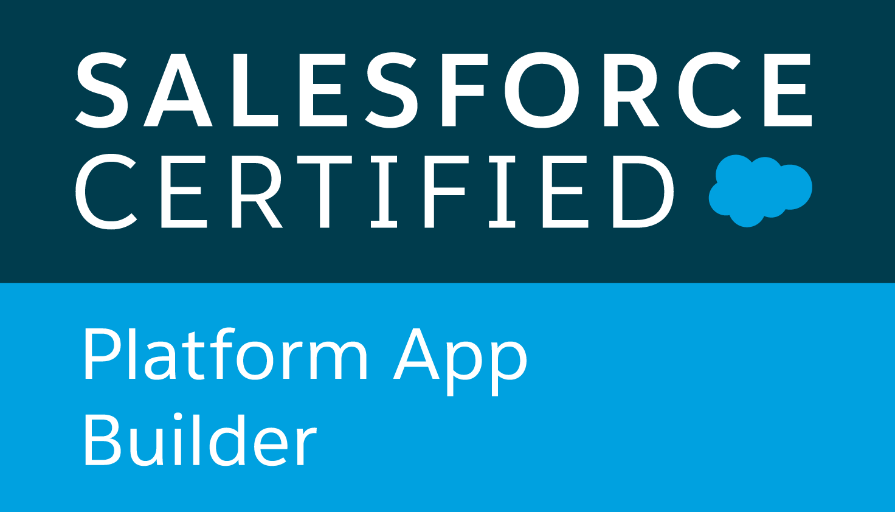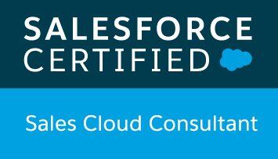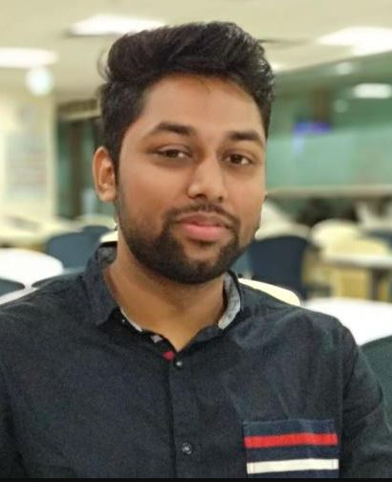

***Nitesh Manoj Jaju***

Pashan, Pune, Maharshtra – INDIA

Contact: +91-9404007401

Email: [NJAJU021@GMAIL.COM](mailto:NJAJU021@GMAIL.COM)

**CAREER OBJECTIVE**

Looking for an opportunity from a growth oriented organization where I get to hone my skills and knowledge for their application in the forthcoming business enterprises.

**SUMMARY**

* Extensive experience on working with custom objects, custom fields, Pick-list, page layouts,**Workflow Alerts and Actions, Approval Process, Validation Rules**, custom Tabs, custom reports, report folders, report extractions to various formats.
* **6x Salesforce Certified** along with that earned highest badge ‘***RANGER*’** on trailhead.
* Proficient in **security and sharing rules** at object, field, and record level for different users at different levels of organization.
* Extensive experience in configurations in **Sales Cloud, Service Cloud, Community Cloud**.
* Expertise in maintaining the Functional areas of Data Management ,**Forecasting,** Accounts, Contacts, Leads, Campaigns, Opportunities, **Quotes**, Activities, **Live Agent, Omni channel**, Reports and Dashboards.
* Experience in using Developer Console for checking **SOQL Queries**.
* Knowledge **Apex Classes, Triggers**, Visualforce Pages, **Lighitning Components, integration**.
* Knowledge on **Einstein Analytic** and successfully completed **Salesforce Einstien Analytics and discovery consultant certification** & superbadges on trailhead.
* Ability to meet deadlines and handle pressure in coordinating multiple tasks in a work/project environment. Versatile team player with excellent analytical, presentation and inter-personal skills.
* Experince on working & following **Agile methodology** for SDLC.
* Strong communication, organizational and interpersonal competencies along with detail oriented and problem solving skills in the technology arena.

**Work Expierence :**

* **Salesforce Consultant** (Capgemini – April 2019 *till current )*

I am working as Salesforce Consultant and responsible for configuration & development for client who have 6000+ salesforce user gloabally. My responsibility includes enhancements withing SFDC CRM as per bussiness requirement by following Agile methodology.

* Providing Level 3 application support for users where my responsibilties are debugging Lightning components & Apex classes, complex business automation processes and integrations.
* Provide hotfixes for production orgs and delivering workstrories.
* Deploying configuration user stories as per sprints.
* Experience on manging UP2GO manged package which uses ***RASIC user*** model and supporting customization around it.
* Managing & configuring Lightning communities.
* **Sr. Salesforce Administrator** (Cognizant Technology Solutions – Dec 2016 *till April 2019)*

I was working as Salesforce Administrator for ***Salesforce.com***. I was responsible for all configuration related tasks. Also, I was playing role of ***Subject matter expert*** for Sales, Service, Community Cloud support teams.

* Implement and debugging **Lighitng Process Builder**, Validation Rules, Workflow & **Approval Process**, **Teritaroy manegment**, Permission sets, Sandboxes, Change Set, Role Hierarchy related changes.
* Worked on SFDC Objects, Apex Triggers, Workflows, Outbound messaging, Email2Case, Web2Lead, Live Agent, Omni channel, Lightning Communities.
* Resolved more than 1500 cases raised by premier clients of salesforce.com.

**Education Detail**

* B.E in **Computer Science Engineering** (2016) from Savitribai Phule Pune University with 62%.
* 10+2 with Maths, Electronices (2011) from Maharashtra board with 63.50% marks.
* High School (2009) from Maharashtra with 83.69% marks.

**Tranning and Certification**

* ***Salesforce Certified Platform Developer I***
* ***Salesforce Certified Sales Consultant***
* ***Salesforce Certified Einstein Analytics & Discovery Consultant***
* ***Salesforce Certified Platform App Builder***
* ***Salesforce Certified Advance Administrator***
* ***Salesforce Certified Administrator***
* ***Trailhead RANGER & Complete Einstein Analytics & Discovery Super Set.***

**Technical Skills**

* **Programming Languages:** JAVA, Apex, HTML
* **Tools**: Workbench, Apex Data Loader, Visual Studio
* **Others:** SDLC, OOP, UML

**Strengths**

* Good oral, written & presentation skills
* Lead & work as a team in an organized way
* Action-oriented and result-focused
* Quick learner with good grasping ability
* Good time management skill
* A high tolerance of stress and enjoys responsibilities

**Extra Curricular**

* Participated in organizing & anchoring for farewell events of tectonic 2015
* Cricket team player of College 2012-2014
* Participated in Drama Surbhi-Anuual event 2013
* Lead team member to organize Microsoft DreamSpark yatra 2012

**Personal Information**

* **Date of Birth:** 15th Nov 1993
* **Sex & Status:** Male & Single
* **Nationality:** INDIAN
* **Languages Known:** English, Hindi, Marathi and Marwari

**Date:** **Nitesh Jaju**