**Lakshmi P**

: [p.lakshmi2901@gmail.com](mailto:p.lakshmi2901@gmail.com) : +91-9642189233

## Professional Summary

A **Salesforce Administrator-201** certified, with an ambitious professional overall 2.9 years of IT experience which includes **2.5 years of expertise across multiple projects in Salesforce,** Currently working in **Cognizant Technologies** (Payroll - Scorg International Consulting Pvt. Ltd) as Salesforce Developer.

## Skill Set

* Diverse experience on the salesforce platform and a good understanding of the CRM (Sales & Service Cloud) and Development life cycles.
* Experience in Development, Configuration, Implementation, Lightning, and Support of Salesforce platform.
* Experienced in SFDC Development **using Aura Components, Apex Classes, Triggers, SOQL, SOSL, Batch Apex, Future Method, Schedule Apex, and Queueable Apex.**
* Having Good Understanding and experience in Managing Users, Apps, and Security Settings Like Object Level Permissions (Profiles, Permission Sets), Field Level Permission, and Record Level Permissions (OWD, Role hierarchy, Sharing Rules).
* Communicate & collaborate with clients, project managers, and colleagues throughout all phases of analysis, development, testing, and deployment.
* Created and managed standard/custom objects, standard/custom fields, object relationships, validation rules, record types, and page layouts.
* Created new and maintain existing workflow rules, approval processes, flows, and process builder processes.
* Handled data migrations across Salesforce org using Import/Export Wizard and Data Loader.
* Created dashboards, reports, and custom report types based on Client requirements.
* Scheduled, planned, and executed deployments by effectively collaborating with development teams using change sets/Copado migration tools.
* Good Understanding of Software Development Life Cycle and Software Testing Life cycle.
* Having knowledge of Application life cycle management (ALM) and Project Management Tools like Rally, and Jira.

## Project Profile

**Project** 1 – Lead Migration

**Client**: **Manulife**

**Project Description**

Manulife Financial Corporation is a Canadian multinational insurance company and financial services provider.

This project involves migrating two applications as a single application in Salesforce.

**Role & Responsibilities**

* Manage all processes that impact / relate to Salesforce.com. Working Closely with Business side Architects to get their requirements and drafting the raw data to comprehensive information which helps while projecting whole understanding to business. Manage new releases of SFDC and efficiently roll out new features.
* Implementing the Client Application using Aura Components and Lightning Events. Developed Apex Classes, Apex Trigger, and Batch classes as per client requirements.
* Create and maintain Objects, Tabs, Fields, List Views, Page Layouts, reports, dashboards, and other salesforce.com functions. Key role in grooming User Stories and a bridge between Business and Associate and As a QA to complete the assigned task. Prior skills of issue resolution by understanding the requirement, discussing with related users, suggesting workarounds, and complete resolution in salesforce application.
* Handle ongoing configuration/ alteration of Salesforce.com. Maintain, enhance and create workflows, functions, process builders, approval processes, and configurations within the Salesforce.com environment.
* Grant/ remove and maintain user licenses. Maintain security including sharing rules and security levels. Design, Create and maintain user roles, profiles, and hierarchies. Monitor application storage usage and archive data as needed.

**Project**: 2 –Orgmerge

**Client**: **Manulife**

**Project Description :**

This Project involves resolving the defects and to work on enhancements of existing all Salesforce applications under the Manulife Client.

**Role & Responsibilities**

* Implementing the Client Application using Aura Components and Lightning Events. Developed Apex Classes, Apex Trigger, and Batch classes as per client requirements.
* Involved in the analysis requirement and Implementing security measures.
* Created &customize the objects, fields and page layouts as per the requirement.

**Project**: 3 –Dealer CRM

**Client**: **Manulife**

**Role & Responsibilities**

* Implementing the Client Application using Aura Components and Lightning Events. Developed Apex Classes, Apex Trigger, and Batch classes as per client requirements.
* Grant/ remove and maintain user licenses. Maintain security including sharing rules and security levels. Design, Create and maintain user roles, profiles, and hierarchies. Monitor application storage usage and archive data as needed.
* Effectively manage customer expectations and communicate status updates of projects to various stakeholders, i.e., internal management, and external customers of varying levels of management
* Managing multiple Salesforce environments and the deployments between those environments.
* Data management -Auditing data, managing data, and editing records in salesforce.
* Administering Salesforce environment including customizing and implementing profiles, roles, security settings, sharing rules, custom applications, custom objects, custom fields, page layouts, workflow, validation rules, sharing rules, and so on.
* Build and maintain Salesforce reports and dashboards to track KPIs and develop actionable intelligence and metrics.

**Project 4**: Sanofi Aventis Support and Enhancement

**Roles Responsibility:**

* Designed and developed Apex classes and Apex Triggers for various functional needs in the application.
* Developed validation rules, workflow rules and Process Builder.
* Deploying data using Changesets.
* Developed test classes for custom controllers and apex triggers.
* Implemented Data migration using Apex data loader.
* Attend the Team Meetings, Involved in Review Meetings.

## Achievements

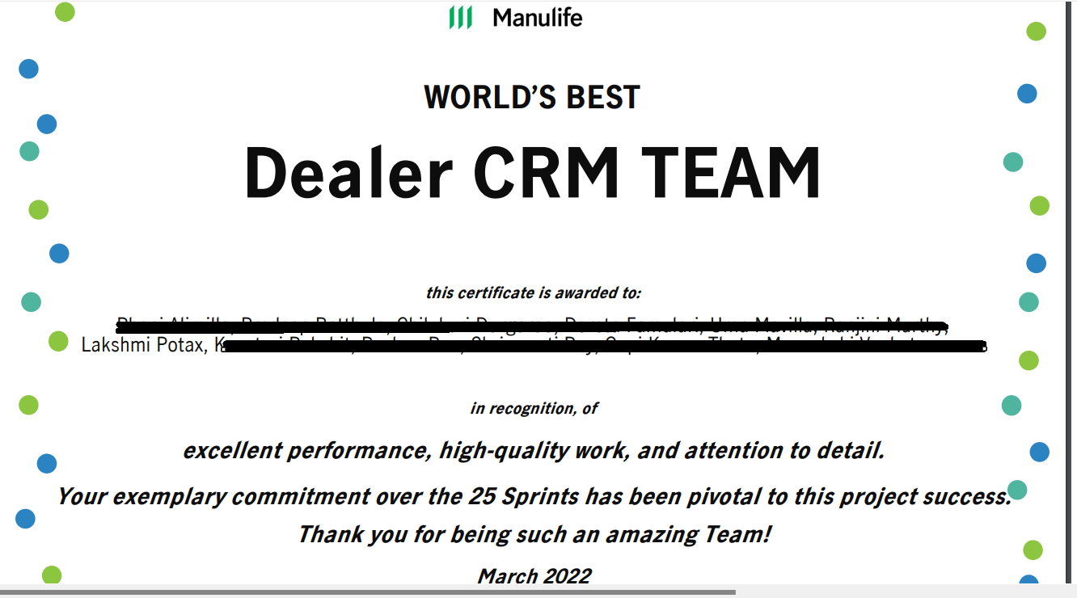

## Work History

|  |  |  |
| --- | --- | --- |
| **Organization** | **Designation** | **Duration** |
| Cognizant Technologies | Salesforce Developer | April 2021 – Till Date |
| QLIKEN Technologies | Salesforce Configuration Specialist | Nov 2019 - Mar 2021 |

## Education

|  |  |  |
| --- | --- | --- |
| **Qualification** | **School / University** | **CGPA** |
| **BSC Computers** | **Ambedhkar University** | **8.6** |