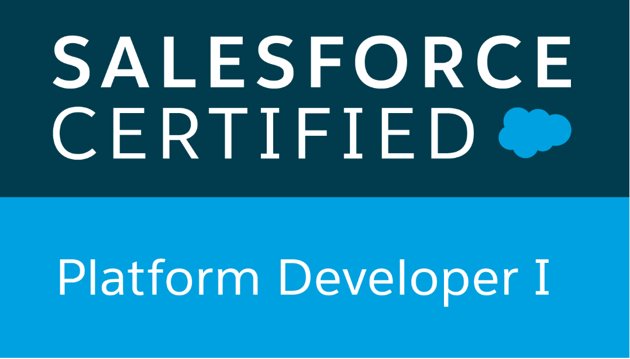

**SUMIT VIJAY TAKALE**

**+91-8793339996**

[sumittakale@gmail.com](mailto:sumittakale@gmail.com)

**PROFESSIONAL SUMMARY**

* Overall 2.9+ year of experience in IT.
* 2​.5+ years of experience in Salesforce
* ​Platform Developer-1 Certified
* ​Have good Analytical and Problem Solving skills
* ​Have skills in Salesforce CRM as Developer & Admin
* Have worked on Sales and Service clouds.
* ​Have good knowledge of Configuration and Customization in Salesforce
* ​Have good Debugging skills

**PROFESSIONAL EXPERIENCE**

* **Atos Syntel India Limited, Pune** Dec 2017 to Apr 2020​ Role – SFDC Developer
* **REI Systems India Pvt Ltd, Pune** Apr 2020 to Present

Role – Associate Software Engineer (SFDC Developer)

# EDUCATION

● Information Technology Engineer **|** ​B.E. **|** Shivaji University ​ **|**​ 2017​ **|**​ 67%

# SKILLS

Primary Skill: SFDC Developer Other Skills: Java

# PROJECTS

1. **Development Project:** (​Apr 2020 – Till now)

**Client: GovGrants - LCTCS – (REI Systems Pvt Ltd)**

It is Development and support project. This project is mainly based on Sales and Service cloud (kind of hybrid cloud). In this project we have to enhance the functionality as well as need to resolve production issues as per the requirements. Faced challenges in adding new template records in the child object and updating it in the existing parent record using script. For example: Application is having Submission checklist records as a child record. And these records are created by fetching and copying the value from records present on template object. So there were few records already present at application but needed to update the old few records and also needed to add the new records at same application. Similar challenges faced for Validation Rules, Process Builders, Workflows.

​**In this project worked on:** Profiles, Field level security, Picklist Value sets, Custom settings, Triggers, Test classes, Batch Class, Change Set, Workflows, Validation Rules, Role hierarchies, Apex Sharing, Uploading bulk records (Data Loader).

​**Role & Responsibilities**:I am working as a Developer in this project. As this project falls under development support project, my responsibilities are – To connect with the client for the better understanding of issue and resolving them on priority. Also analyzing the requirement and making

a plan to fulfill that requirement is my another responsibility. I am working as a primary point of contact for this project.

1. **Development Project / Migration Project:** (​ Jan 2019 - Apr2020)

**Client:** **American Express - (Atos Syntel Pvt Ltd)**

This project is based on Service cloud. This project consist of migration of one Salesforce org to another org. Migrating objects and their functionality to another org in such a way that it doesn’t break existing functionality of that org. Faced challenges in merging of code. For example: Opportunity Trigger was available in both orgs thus needs to merge so that both the functionality should work as required. Similar challenges faced for Validation Rules, Process Builders, Workflows.

​**In this project worked on:** Triggers, Test classes, Batch Class, Change Set, Process Builders, Workflows, Validation Rules, Role hierarchies, Uploading bulk records (Data Loader),web-to-case.

​**Role & Responsibilities**:I have worked as a Developer in this project. My responsibilities were understanding the requirements, attending sprint grooming sessions for refining and finalizing the user stories, Implementing the user stories, attending scrum call for clearing doubts, do unit testing for user stories, get the user stories delivered before the sprint ends.

1. **Support Project:**  (Oct 2018 - Jan 2019)

**Client: American Express - (Atos Syntel Pvt Ltd)**

Solved Service Request (SRs) mostly related to configuration like making page layout proper, creating users, give required permissions to users, fixing access related issues, fixing issues related to reports / dashboards, uploading / updating records using data loader, Refreshing orgs.

​**In this Project worked on**​: Profiles, Permission Sets, Page layouts, Reports, Dashboards, Data Loader.

​**Role & Responsibilities:**​​I mostly worked as an Admin in this project. My responsibilities were to resolve the Service Requests (SRs) before deadlines, communicating with the users who raised SRs to understand the issue if SR is not clear, attending daily status call.

**Declaration:** I hereby certify that the above mentioned facts are true to the best of my knowledge and belief.

**Sumit Takale Date:**