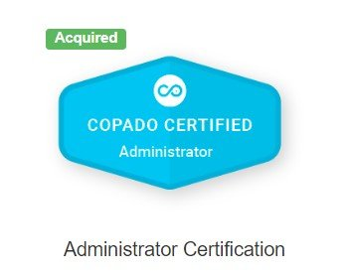 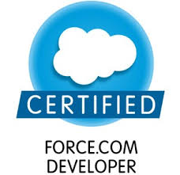

**Ankit Teotia Contact**: 7387656665;

H.No. 107/A, Bulandshahr, UP,203001; **Email:** [ateotias@gmail.com](mailto:%20ateotias@gmail.com) ;



**OBJECTIVE**

Seeking a challenging and rewarding opportunity with an organization of repute which recognizes & utilizes my true potential while nurturing my skills**.**



**SUMMARY OF SKILLS**

* Dynamic and goal-oriented individual with a professional experience of 6 years 11 month.
* Knowledge of Analytics, Database Management and Salesforce. Understanding of programming languages and operating systems.
* Understanding of all phases of Software Development Life Cycle with concentration on design, development and implementation of various applications.
* **PD1** certified professional with hands on experience in Salesforce Lightning.
* **COAPDO Admin** certified with hands on experience

**Technical Skills**

|  |  |
| --- | --- |
| Programming Languages  CRM | Java, Apex  Salesforce |



**PROFESSIONAL EXPERIENCE**

**Cignex**  **Sept 2019- Current**

**Senior Salesforce Developer**

* Hands on experience with **Lightning communities**
* Hands on experience with **Lightning Components** and exposure to **Lightning User Interface**
* Exposure to Git, Deployment, Version control, coding techniques, **VS CODE**
* Deft in Out of the Box functionality, optimization of current automations/processes.
* Version control using GIT and did deployments using **COPADO**
* Working with **LWC**

**Tech Mahindra** **Oct 2018- Sept 2019**

**Senior Salesforce Developer**

* Developed POC in Salesforce and then developed full application with changes received from client
* Worked on Lightning Components and exposure to Lightning User Interface
* Exposure to SFDC workflow rules, Approval process, Custom Objects, Automations and custom functionality to meet the new requirements
* Deft in Out of the Box functionality, optimization of current automations/processes.
* Working on Apex Classes, Apex Triggers, Reports, Lightning Pages, Dashboards, App Builder and declarative and programmatic development in salesforce

**CloudExperts Technologies** **Aug 2017- Sept 2018**

**Salesforce Developer**

* Developed POC in Salesforce and then developed full application with changes received from client
* Deft with Apex Classes, Apex Triggers, Reports, Dashboards, App Builder and declarative and programmatic development in salesforce
* Configured SFDC workflow rules, Approval process, Custom Objects, Automations and custom coding to meet the new requirements
* Added methods that can be called from Visualforce pages to Controller Extensions, good knowledge of Visualforce
* Working with Apex to access sObjects and Field, execute SOQL and DML queries.
* Worked on batch apex along with best practices in salesforce

**Alacrity Ecommerce Solutions Mar 2014 –Mar 2016**

**Business Analytics and Reporting in Affiliate Role: Team Lead and SFDC Admin**

* Create reports on Salesforce for the client that helped in decision making.
* Performing client interactions, requirement management (requirement gathering, change requests) and conducting analysis for scope management, work plan management and providing technical solution as per the requirements
* Configuration for automation like Approval Processes, Escalation Rules, Workflows, ProcessBuilder in Salesforce environment

**Sales Data Analysis(Ecommerce channels)**

* Developed SQL reports on different levels and dimensions for different channels
* Reporting for different ecommerce portals Ebay, Newegg, Walmart

**Infocepts Pvt. Ltd Jan 2013 – Jan 2014 (BI Associate)**

Location: Nagpur

Role: Business Intelligence and Data Warehousing Associate

**Job responsibilities:**

* Coordinating with development team whenever if any new release/off cycle release going on in respective application and sync up with the team members
* ETL of the source data, creation of reports and dashboards for end client.



**Date of Birth**: 09 Sept, 1991

**Bachelors of Technology** : UPTU (65%) 2012 graduate