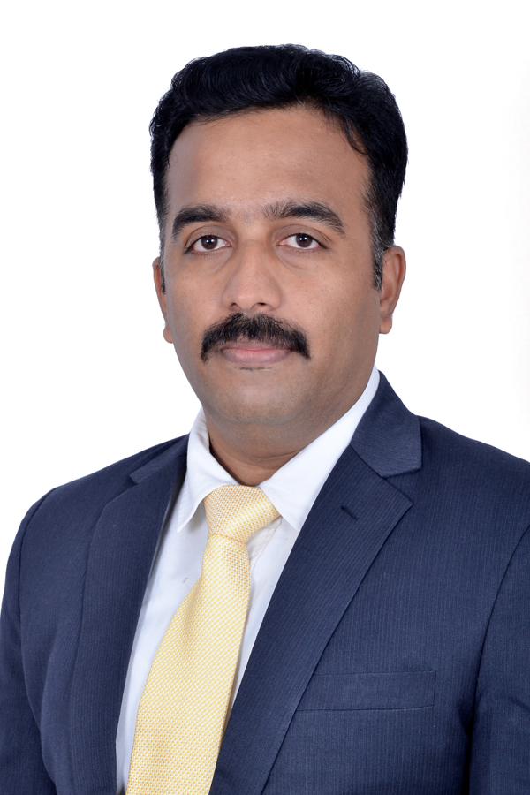

**VENKATAKRISHNA**

9619422718

[Krishy.hari@gmail.com](mailto:Krishy.hari@gmail.com)

Hyderabad (INDIA)

<https://www.linkedin.com/in/venkata-krishnap/>

**PROFESSIONAL SUMMARY**

* A Visionary & ingenious Leader in creating robust hiring strategy plans for Products and Services based companies, established & proven various hiring strategies with a Cost effective model
* Managing (INDIA) and previously managed International Recruitment (**Middle East, APAC, US)**
* Exceptional Onsite/Offshore Client Management experience: Served Clients in the field of IT Products, IT services, Telecom, Financial Services.
* TA professional with excellent track record in sourcing as well as end to end recruitment
* Recruitment Tools (ATS) – Taleo, SAP Success Factors, Clear Company
* Job Boards – LinkedIn Recruiter, Naukri, Monster, IIM Jobs
* Passive Channels – LinkedIn, GitHub, Stack overflow, Kaggle, Behance, Twitter, etc.
* Chrome Extensions - Nymeria, Lusha, Amazing Hiring, Hiretual, Discoverly, GlossaryTech, etc.
* Proficient with Diversity & Inclusive hiring, new age hiring methods like X-ray search, Social Media hiring, targeting developer communities like meetup.com and LinkedIn groups

**CORE COMPETENCIES**

* Leadership hiring
* Strategic Delivery
* Talent Mapping
* Sourcing Platforms & techniques
* Metrics & Dashboard Management
* Team Management
* Vendor Management

**EDUCATION- AWARDS**

* Masters In Labour Management (Human Resources) – Specialized in Personnel Management, Industrial Relations and Labour Welfare- TILS- May 2004.
* Bachelor of Corporate Secretaryship – University of Madras – May 2002.
* Best TA Lead – GPTS – ROLTA – 2013-2014, Best TAG Team Performance– 2018 – ALTIMETRIK
* LinkedIn Certification – Niche Hiring, Performance- Based Hiring, Technical Recruiting.

**KEY ACHIEVEMENTS**

Sundry domain experience like (EPC, Energy, Utilities, Manufacturing & Industrial, BFSI) predominantly and Lead some of the revenue generated accounts for PAN INDIA hiring.

* Reduced the revenue leakage from 47% to 18%
* Restructured the recruitment organization from a regional level orientation to Pan India Horizontal / Vertical level, which resulted in:

# Reduced cost of hiring by 28%

# Increased availability of qualified candidates by 23%

# Increased customer satisfaction. Improved CSR rating to 4.6/5

* On boarded more than 20+ Directors level positions with span of 12 months.
  + Contributed significantly in reducing the vendor cost from 80% to 19 % for closing all Leadership positions in
* Streamlined the Employee Referral process, communication and tracking system which increased the employee referral hires from 7% to 21%
* Introduced the Profile Sourcing Team which reduced the vendor hiring from 40% to 21%
* Ensured 100% compliance in the recruitment process in the CMMI & ISO audits.
* Increased the average joining ratio to with various interventions 82%. Negotiated with senior management to release buffer offers by 10% - 20% as risk mitigation.

**ALTIMETRIK INDIA PVT LTD Dec 2017- Apr 2020**

**Lead- Talent Advisor Hyderabad, TL**

* Managing a team of 2 for Niche/Leadership hiring (entire recruitment cycle) for the new centre @ HYD.
* Successfully closed **200+** Low – Mid Technology roles in **DBS- Digital Transformation- Asia Hub D2.**
* Handled other major accounts **like CITI, NOVARTIS and MASTERCARD** – PAN INDIA HIRING
* Helped India/US business leaders to decide on hiring location for new teams by providing Market Intelligence reports.
* Lead the utilization management of souring platforms (LinkedIn, Job portals, etc.) for India, trained hiring managers and technical teams in optimizing LinkedIn platform and build eco-system for more referrals.
* SPOC - Intelligent Product Solutions horizontal –across India (**worth 18.5 billion),** PAN INDIA hiring.

**COGNIZANT TECHNOLOGY SOLUTIONS Dec 2015- Dec 2017**

**Manager –TAG Advisor Hyderabad, TL**

* Responsible for delivering niche and specialized skills hiring from external market for 4 SBU’s

(**Schneider Electric, Product Engineering, Industrial Operations and Commercial Solutions**).

* Sourcing Lead handling APAC and US hiring, skills like Microsoft Technologies: C#.net Windows and Web Developers, Team center PLM, Chemical engineering, CAD, DCS, Coded UI, VSTS, Test complete , LabVIEW.
* Good knowledge of US and Canada Visa/work authorization and hired consultants on (W2, Corp-to-Corp, 1099 for U.S. Citizens, GC, H1-B, TN-1, and EAD holders.

**ROLTA INDIA, JAN 2013- Dec 2015**

**Lead – Recruitment & Sourcing Mumbai, MH**

* Received Best performer award – **GPTS Division within 7 months** from the joining for closing SME (Process Industry) positions and **hired 20+ Directors.**
* Mapped organizations like **Shell, Essar Oil & Gas, Infosys, Reliance and other Refining & Petro chemicals** Industries.
* Hired Process Design Engineer, HSE Manager, Operation Engineer, Marine Engineer for Middle East and India based projects.
* Hiring for EPC projects, Power Grid, GIS Sales support, GIS Project Engineering, Simulation Tools- MATLAB
* Successfully Hired Young Talent of **200 +resources for GIS and Defence project @ Mumbai.**

**eBay, INDIA MAR - NOV 2012**

**Lead – Recruitment Chennai, TN**

* Focused on hiring Technical engineers and Leads for the org (Staff Engineers, Architects, Principal Engineers, Product Managers) - **eBay Market places.**
* Hired extremely 50+ Smart team of Software Engineers with Design and development in SOA services and framework enhancements
* Generating active & pro-active Talent pipeline for ongoing requirements like **Mobile Applications, Application Development for Core platform** and Experimentation Learning group.

**COMPUTER SCIENCE CORPORATION APR 2007- MAR 2012**

**Lead – Recruitment & Sourcing Chennai, TN**

* SPOC for Client - eBay, Market places and other Critical projects in PayPal, Chennai and Bangalore.
* As a lead and resource coordinator for **PayPal & eBay, ramped up 300 resources.**
* 80% of the resources are from Premier Colleges and Top University.
* Received Pal Bonus recently for **Q2 hiring – eBay& PayPal**
* Hired Architects and Product Managers from **DELL Inc, Google in** a short notice*.*

**OTHER REAL TIME EXPERIENCES**

|  |  |  |
| --- | --- | --- |
| HCL Technologies, Chennai | Executive | Oct 2004-Mar 2007 |
| Blue Bird Technologies, Chennai | Management Trainee | Jun 2004- Oct 2004 |

**INDUSTRY REFERENCES**

* **Rajesh Ramachandran** – Chief Digital Officer, ABB
* **Abhimanyu P**- MD- JPMC