# ABOUT ME

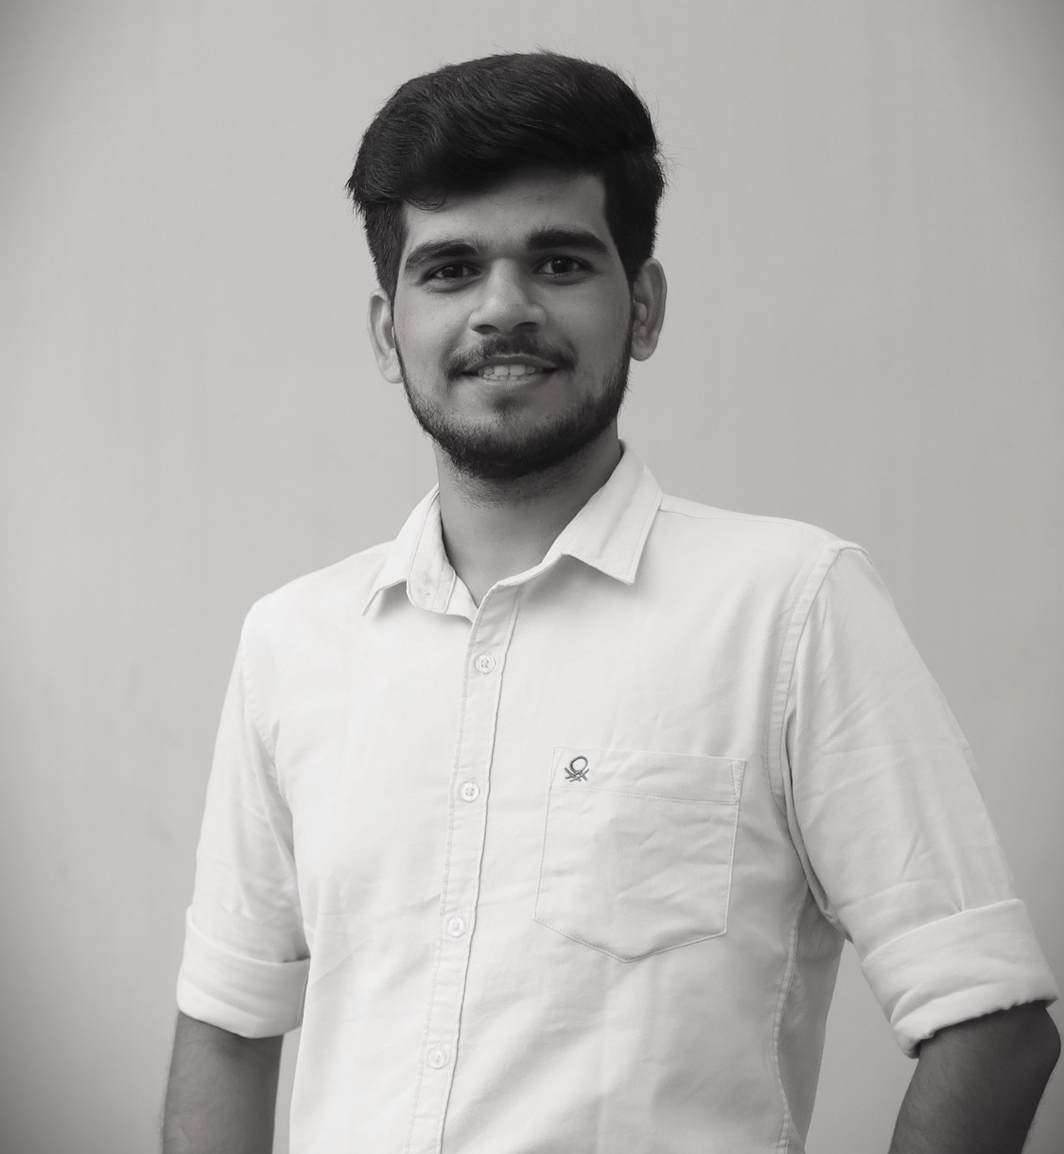

**Ashok**

Support Engineer & Data Analyst

An aspiring data analyst who is enthusiastic to learn and passionate to decipher the complexities of data science. Seeking to leverage data analytical skills to improve corporate performance as a data analyst.

# EXPERIENCE

## SKILL LYNC

**Technical Support Engineer _Data Science**

Handling online classes

One to one doubt clearing session’s Content creation

**PROJECTS**

# CONTACT

 **Address**

Ejipura, Koramangala, Bangalore-560095.

 **Phone**

+91 8072108615

[ashokvravindran@gmail.com](mailto:ashokvravindran@gmail.com)

 **Web**

GITHUB: <http://github.com/ashok-35> LINKEDIN; @ashok-r-958108212

# SKILLS

Machine learning Python

Deep learning R language Power BI

My SQL

Tableau

Data Preprocessing Statistics

Microsoft Office

**85%**

**70%**

**40%**

**80%**

**70%**

**65%**

**90%**

**80%**

**85%**

### Advanced house sales prediction

The project is about regression analysis, the data source contained different levels of data and the dataset consist of 80 predictor variables. EDA techniques and data visualizations were used for clear understanding of the dataset and the data was converted into meaningful form. Various regression models and ensemble techniques were implemented in order to find the best predicting model to this data.

### Breast cancer prediction

In this classification model, different ensemble techniques such as Bagging Classifier, AdaBoost, XG Boost were used. Correlation between predictor variables were checked and after feature selection, various models were built on it. With the help of AUC curve and F1 score, the best model for cancer prediction was found.

### Comparative sales analysis dashboard

This is an visualization project done with help of Power BI. Here, an interactive dashboard for sales performance was created using multiple graphs (scatter chart, area chart, line graph, donut chart) and matrix table for clear understanding for the viewer. Various measures for parameters were created and with the help of tooltips precise dashboard was created which displays details on the click of the user.

### Digit recognizer using Neural network

The problem statement here is to predict the digits (0-9) from the handwritten images and the dataset contained 42k images. Implemented different techniques from both sklearn (Single layer perceptron, Multi- layer perceptron) and keras (Sequential model with dense layers) and with help of optimizers (SGD, Adam) and loss function (categorical loss entropy) the best fit model is found.

# EDUCATION

## DATA ANALYTICS

**IMARTICUS LEARNING INSTITUTE**

Post Graduate Diploma in Data Analytics at Imarticus Institute.

## MACHINE LEARNING

**DECODR TECHNOLOGIES**

Machine Learning course with Python at Decodr Technologies.

## MECHANICAL ENGINEERING

**KPR INSTITUTE OF ENGINEERING AND TECHNOLOGY**

Completed Mechanical Engineering with 72.3%

## SCHOOLING

**INFANT JESUS MATRICULATION HIGHER SECONDARY SCHOOL**

Completed HSC with 84.6% and SSLC with 87.8%