Name:Prajnya Mandala 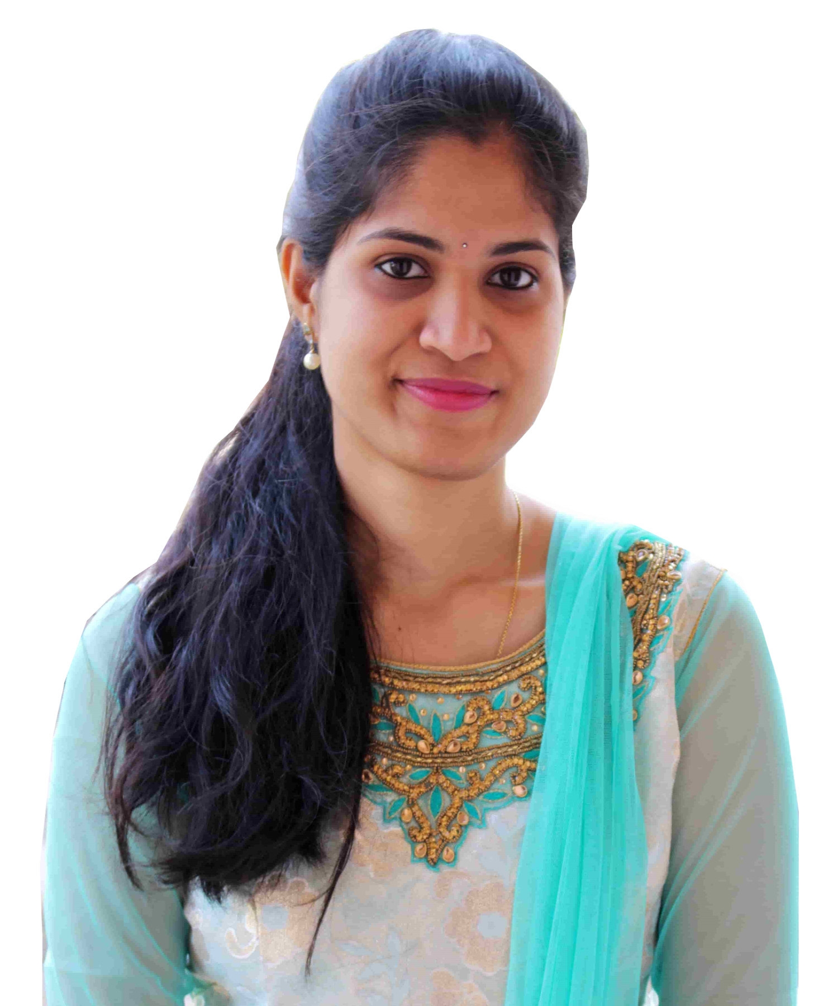
Phone: 7013008724
Email:mprajnya2895@gmail.com
mprajnya6@gmail.com

Objective:
To be a part of a challenging environment where I can continuously learn, upgrade my skill set and contribute towards organizational goals.

My Contributions :
- SFDC customizations( in classic and lightning)
- configurations(workflows,email templates,approval process)
- creating flows and saving the data in the backend fields in Vlocity
(Omniscripts,Dataraptots,cards,Actions)
I worked in pure Agile process oriented projects with deep understanding of Jira,Flosum, Auto Rabit tools with Devops deployments (GIT concepts ) in Salesforce and Salesforce Vlocity projects.
Certifications :
VLOCITY PLATFORM DEVELOPER ESSENTIALS
SALESFORCE ADMINISTRATOR (ADM 201)
SALESFORCE CERTIFIED PLATFORM DEVELOPER 1
OMNISTUDIO VLOCITY CONSULTANT

Experience Summary
- Having 4.2 years of Experience in Salesforce.com
- Extensive experience in activities related to SFDC, Saleforce.com setup, Configuration, customization, Administration, Apex Data Loader etc.
- Extensive experience in creating Roles, Profiles, Page Layouts, Record Type, and Assignment rule, Workflow Alerts and Actions, Reports, Dashboards and Approval process.
- Proficient in designing of Custom objects, Custom fields, Role based page layouts, Custom Tabs.
- Implemented Security and Sharing rules at object, field, and record level for different users at different levels of organization.
- Having Experience on Triggers, Workflows, and Validation Rules.
- Good in Creating Sharing Rules and permission sets for the User level and Profile Level.
- Good in writing code for database related operations such as SOQL, SOSL
- Having Experience on Designing of Visualforce Pages and coding business logic using Apex.
- Having good experience with formulas, Apex data loader.
- Good development experience with Apex Language, Apex Scheduler, Batch Apex.
- Having experience in building Lightning components with both client side and server side controllers.
- Having knowledge on creating Vlocity Omniscipt Designers, Vlocity Cards and Actions.

- Having good experience in building Dataraptors of Extract, Transform, Load.

- Having experience in writing Remote methods in Vlocity Omniscript Designer and on the action functions in it.
- Having knowledge in creating Vlocity Integration Procedures and Vlocity UI templates and Docusign.
- Passionate in learning LWC and in its implementation.

- Done the certifications in ADM 201 and Vlocity Platform Developer Essentials, Omnistudio Vlocity Consultant.

- Self-motivated and quick learner. Ready to explore and learn new technologies.

Technical Expertise
Elements | Particulars
Primary Skills | Salesforce CRM, Lightning, Salesforce Vlocity.
Operating Systems | Windows
Languages | C,Java, Apex, Visualforce,
Development Tools | Force.com Platform (Sandbox and Production) Developer Console, Workbench.
Scripts | JavaScript
Databases | Oracle
Configuration Tools | Data Loader
Documentation | Microsoft Office
Client / Server Technologies | JavaScript, CSS, Html, Visualforce
Deployment Tools | Auto Rabit ,change sets

Experience Details (Starting from the Current Employer)
Dextara Digital: (2021– Present)
Sl. No. | Name Of The Organization | Joining Date | Relieving Date
1 | Dextara Digital | November 2021 | Till now

Project 1 | Philippines Long Distance Telecommunication (PLDT)
Project Description | This is a Telecom project where Decomposition followed by orchestration will be(OM) done to the products selected by users in the cart while request and response will be come handled through mulesoft.
Environment | Salesforce.com, Portals,Vlocity CMT industries
Role / Responsibility | Salesforce/Vlocity Developer
Contributions | - Involved creating Decomposition Relationships on Decomposition Page.  - Involved in creating Integration Procedures and Omniscripts that are to be invoked on some vlocity Quick Actions.  - Created Apex classes for object record creations which are used in Remote Actions.  - Designed record triggered flows to avoid over customization.  - Involved in creating Vlocity scheduled Jobs that invoke Integration Procedures.  - Involved creating small LWC components.

Legato Healthcare Technologies: (2020-2021)
Sl. No. | Name Of The Organization | Joining Date | Relieving Date
1 | Legato Healthcare Technologies | October 2020 | Nov 2021

Project 2 | Bumblebee – Anthem Project
Project Description | This Anthem Project is to create a medical insurance for 14 states in US based on the lines of Business.
Environment | Salesforce.com, Portals
Role / Responsibility | Salesforce / Vlocity developer
Contributions | - Worked on the Apex classes, Triggers.  - Worked on Process builder using custom metadata.  - Worked on Apex webservice classes.  - Involved in writing formulas, Integration Procedures, DataRaptors.  - Worked in DocuSign Templates (pre populating the data).
Team Size | 9

Accenture(2019-2020):

Project 3 | Blue cross Blue Shield -Michigan
Project Name | BCBSM Health Insurance portals
Project Description | BCBSM portal lets the agents to enroll an employee and his/her dependents for an insurance based on multiple health streams and premium plans.
Environment | Salesforce.com, Vlocity Managed packages, Community Portals
Role / Responsibility | Sales force/ Vlocity Developer
Contributions | - Involved in creation of salesforce setup activities and creation of Vlocity Omni script Designer Flows.  - Involved in creation of Dataraptors of Extract, Post and Transform  - Involved in developing Remote Action methods in Omniscripts.  - Created Vlocity Cards and Vlocity Actions to display on the community portals.  - Worked on Lightning components and the Controllers to achieve the UI and backend functionality as per business requirements.  - Worked on multiple Input, Display, action functions in the Vlocity Omni script Designer.  - Involved in the Devops Deployments among multiple orgs using  Auto Rabit Tool.
Team Size | 10

NTT DATA: (2016 – 2019)

Sl. No. | Name Of The Organization | Joining Date | Relieving Date
2 | NTT-Data | 28-09-2016 | July 2019

Project Details

Project 2 | Rapid Development Project - Honeywell
Project Description | This project takes care of all the enhancements, customizations to be done at various support groups always coming in . Team members interact with different customers of different support groups based on the business they work for every sprint. Team gives demo to the customers at intermediate levels for the UAT and ends the sprint.
Environment | Salesforce.com, Portals
Role / Responsibility | Junior Salesforce Developer
Contributions | - Involved in Salesforce setup activities and customizations by writing apex classes, triggers mainly meeting the functional requirements.  - Created workflows and process builders to meet the business requirement.  - Based on the business requirement created appropriate relationships among various objects that helps in making many user stories feasible.  - Developed several formula fields with proper logic and maintained the logic with help of various fields in particular objects.  - Helped in designing and adding / changing the functionality in various business portals by developing apex classes, controller classes, controller extensions in the Visualforce pages.  - Created the Document checklists for every sprint.  - Took the responsibility of deployment and fixing the issues.
Team Size | 2

Project 1 | Contractor Portal
Project Description | The Honeywell Dealer Portal is aimed at bridging the gap between Honeywell contractors and customers. The portal will provide contractors with a centralized location to manage customers, track cases from initiation to resolution, analyze company performance, and uphold customer satisfaction. This project will help improve productivity and build healthy relationships between contractors and customers.
Environment | Salesforce.com,Portals
Role / Responsibility | Junior Sales force Developer
Contributions | • Involved in Salesforce.com application setup activities and customized the app to meet the functional requirements.  • Implemented pick lists, dependent pick lists, lookups, junction objects, master detail relationships, validation rules and formula fields.  • Designed and developed Apex classes, controller classes, controller extensions, Visual force pages and Apex triggers.  • Providing ongoing salesforce.com maintenance and administration services including periodic customizations, code fixes.  - Worked on customer portal.  - Implemented web to lead, functionalities to provide a better support to the contractors.  - Developed workflow rules, tasks, emails and alerts to track customer related tasks and activities.  - Designed various types email templates for auto response to customers.  - Helped in writing test cases for functional, integration testing and UAT testing.  - Used the sandbox for testing and migrated the code to the deployment instance after testing by using Change sets.
Team Size | 3

Qualification Details (Highest Degree on Top)
Sl. No. | Degree | Branch | Year of Passing | Name of the College / Institute | Percentage / cgpa / Grade
1 | B.Tech | CSE | 2016 | G.Pulla Reddy Engineering College | 7.2
2 | Intermediate | MPC | 2012 | Narayana Junior College | 91.2%
3 | SSC | SSC | 2010 | Bhashyam Public School | 88.0%

Personal Details:
- Date of Birth : 28th August 1995
- Gender : Female
- Marital Status : Single
- Languages known : English, Hindi and Telugu.
- Alternate Contact number : 8297218540

Declaration:

I do here by declare that the facts mentioned above are true to the best of my knowledge and belief.

PRAJNYA MANDALA
Contact : 7013008724

