**Sumit Kumar** 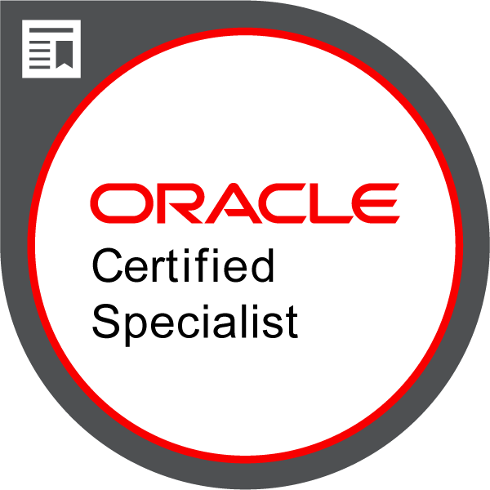

Certified Oracle CX Cloud Implementation Specialist

Sumit Kumar

## Senior Consultant – Oracle Financials Cloud

Summary

6 years of progressive experience in Oracle CX Cloud consulting as a Techno Functional Consultant, exhibiting excellence in managing multiple Implementation, Application Development and Support projects with major focus in CRM/Sales Cloud, HCM. I have effectively handled expectations of clients in accordance with scope, time and effort in order to comprehend business objectives while working in agile methodology. Key focus areas are requirement gathering, solution designing, implementation, and support.

# Work Experience

**Filix Consulting Pvt ltd.**

**Implementation Consultant** – 6th June 2019 to Present

* Developed various Custom objects and fields as per business requirement.
* Established a smooth and convenient application setup to fulfill the client’s requirement.
* Prepared As Is and To Be documents.
* Organized User Acceptance Testing (UAT) sessions.
* Created multiple custom GL Balances reports using FRS.
* Handled Data Import and Export Activities.
* Developed many BI ad OTBI reports as per business requirement.
* Carried out bursting as well as chunking in BI Publisher reports.
* Created a Hierarchy report for all COAs like balancing segment, business unit, natural account, product, project etc.
* Worked in 2 end to end implementation project Oracle sales Cloud.
* Organized and provided training to end Users.
* Support Activities: Resolving day to day issues faced by users.

Projects

**a) Aurobindo Realty & Infrastructure Private Limited, Hyderabad**: Aurobindo Realty & Infrastructure Pvt Ltd is an upcoming name in Indian Real Estate. They represent a new breed of Real Estate Developers, who are emerging as a response to the challenges of today’s realty market, increasingly driven by Technology, Professionalism, Performance and Evolving Customer Needs, to deliver an unforgettable buyer experience in a RERA regulated environment.

Role: Oracle CRM Functional Consultant.

Details: Oracle Sales Cloud Implementation for Commercial and Residential Projects.

**b) Jaquar & Company Private limited:** The Jaquar Group, established in 1960, is a company that sells faucets, showers, shower enclosures, sanitary ware, flushing systems, wellness products, concealed cisterns, water heaters, and varied lighting products.

Role: Oracle CRM Functional Consultant.

Details: Oracle Sales Cloud Implementation with CPQ implementation for products range.

* Lead management with integration of Eloqua.
* Opportunity Management with the integration of CPQ.
* Contact ad Account management.
* Custom Objects creation as per requirements.
* Data import and export activities.
* Report development.
* User Manual and Training.

**Key Stroke Pro India Pvt. India ltd,**

**Assistant Team Leader –** April 2013 – December 2018.

* Assist with ongoing day to day Workday compensation support, creation of Job Profiles, Grade Profiles and Compensation plans.
* Generated custom Workday reports and modified the existing custom reports.Worked on generation of QR code for invoice numbers in a custom BIP report.
* Created test scenarios for testing all in scope many Business Processes like Hire, Job Change, Promote, Transfer, Terminate, Compensation changes, Employee Self Service process, Manager Self-service processes, etc.
* Built and managed integration using Calculated Fields, EIB.
* Maintain/Assign security role assignments. Configured Workday security roles and groups to the required level of confidentially and segregation of duties.

Projects at Keystroke pro India pvt Ltd.

a)Client:SAI Global Pty Limited.

Role: Workday HCM Functional Consultant.

Duration: January 2016 – Decmber2017

Project Description:

SAI Global is a Sydney (Australia) based Risk management company.SAI Global helps organizations proactively manage risk to create trust and achieve business confidence, growth, and sustainability. SAI Global is the largest provider of property information and settlement services in Australia and is leading the electronic settlements evolution. They are a trusted and established partner for businesses involved in all stages of the property life cycle.

Roles & Responsibilities:

* Dealing with incidents/SRs status from assignment till closing.
* Analyzing the issues and providing clarifications/resolutions reported by the user.
* Tickets need to be created after providing Analysis.
* Conduct knowledge sharing sessions for new team members.
* Worked on functional enhancements manually in the tenant.
* Documenting the Test cases and Functional specification documents.
* Coordinate with other team members for defect deliveries and production support activities

b) Project:Oracle database support.

Client: SAI Global Pty Limited (U.K)

Role: Project Engineer

Duration: January 2014 to December 2016.

Roles & Responsibilities:

* Analyzing the issues and providing clarifications/resolutions reported by clients.
* Creating and assigning roles to users.
* Running SQL queries to resolve problems in database.
* Coordinate with other team members for defect deliveries and production support activities.

Achievements

* Despite of some technical issues in database completed the project within stipulated deadline.
* Trained new joiners and motivated them to grasp things faster and used their potential to achieve a record production while maintaining the quality.
* Got an opportunity to learn new things and use them to solve many technical issues on workplace

**Reliant engineering**

**Technical Advisor:** 1st March 2012 to 31 October 2012

* To inspect products to make sure that they are compliant with the technical and customer specifications.
* Responsible for achieving targets by creative & progressive environment.

Achievements

* Reduced production cost by minimizing the waste and emphasizing on quality which resulted in reduced rejection.
* Got associated with an NGO Deepak Jan Kalyan Seva Sansthan working for women empowerment and child care and worked as coordinator.

**Hindustan Aeronautics Ltd** Korwa, Uttar Pradesh.

**Graduate engineering trainee:** Since Feb. 2011 to Feb. 2012

* Got a thorough knowledge of machine design and mechanical drawings and process layouts.
* Participated in a technical translation competition held in HAL and won first prize for the same.

**Radiant Engineers and Galvanizers.**

**Technical advisor:** 1st July 2010 to 31st Dec 2010.

# Skills

**Industry Domain** Information Technology - Oracle ERP,Oracle CX Cloud, Oracle HCM Cloud, Oracle Fusion.

### Moduls

Lead and Opportunity Management, Account and Contact Management, Inventory (INV), Application Composer, BI Publisher, OTBI, Data Import and Export, Purchasing (PO), Order Management (OM).

### Primary Skill Set

Oracle Cloud, FBDI, PL/SQL, Oracle EBS (R12), BI Publisher Reports, OTBI Reports, Financial Reporting studio (FRS) and Smart View Reports Dashboard Reports, Fusion, Data Migration, Consulting.

Groovy Scripting,Oracle CX Cloud Setup, Application Customization.

# Education

# Bachelor of Technology: **Mechanical Engineering** – 2010

* + - **A.P.J. Abdul Kalam Technical University**
  + Higher Secondary(12th): **Science Stream** – 2005

Licenses & Certifications

* **Oracle CX Sales 2020 Certified Implementation Specialist**
  + - Oracle Issued Nov 2020 - Expires May 2022

Extracurricular

✓ Part of creative team of NOJOTO. -Year 2017-present

✓ Won first prize in Inter College Volleyball Tournament at NIFT Raebareli.

✓ Winner of Inter School Volleyball Tournament in Sultanpur in Oct’ 04.

✓ Active member of cultural committee of college

✓ Directed and wrote various skits & dramas at cultural programs organized in the college Fests & at NIFT, Raebareli.

✓ Worked as a head of coordinating team for cultural programmes.

✓ Won first prize in technical translation competition at Hindustan Aeronautics Ltd.