Saif Siddiqui 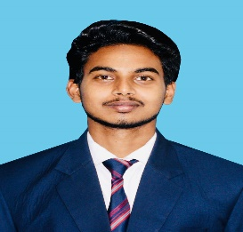
Mobile: - +91-8917751362
E-mail: saif.siddiqui16061997@gmail.com

-------------------------------------------------------------------------------------------------------------------------------------------

Objective
To get in a working environment where I can use my knowledge and skills which can beneficial for both organization and me.

Wo r k- E x p e r i e n c e
Salesforce Developer Sept 2019 To Till Date
KMC Solutions PVT Limited
Noida

- Meeting with project managers to determine CRM needs
- Developing customized solutions within the Salesforce platform.
- Designing, coding, and implementing with Salesforce Lightning using MYSQL, Apex, JavaScript, Native, Visual Force.
- Creating timelines and development goals.
- Testing the stability and functionality of the application.
- Troubleshooting and fixing bugs.

S k i l l s
  - Apex
  - Triggers
  - Aura Component
  - SOSL & SOQL
  - Apex Batch
  - Salesforce Web Services
  - HTML
  - CSS
  - Java-Script
E d u c a t i o n
Bachelor of Technology from Computer Science & Engineering Department
PSIT-College of Engineering Kanpur, Uttar-Pradesh (July-2019)

Senior Secondary
Swami Harsewanand Public School (2015)

Secondary School
Sacred Heart Convent School (2013)

Summer Training
- Certified from IBM-WebTek Labs Pvt. LTD in Object Oriented Programming with Java.
- Certified from IBM-WebTek Labs Pvt. LTD in Big Data with Hadoop.
- Certified from NIIT-Kanpur in Core-Java Development

College Projects

- Automated Question Paper Generator (Major Project)

- Uses fuzzy logic to ensure non-repetitive question papers and generates a marking scheme.
- Technology: Java and Artificial Intelligence
- Role: Front End Developer
- Team Size: 3 Members

- LAN Chat and File Transfer using (MINOR Project)
- Description: Transfer of ﬁles and having chat using LAN instead of Internet
- Technology: PHP and My-SQL
- Role: Front end developer
- Team Size: 4 Members

Personal Details

Fathers Name: S. Siddiqui
Date of Birth: 16-June-1997
Marital Status: Single

Declaration

I hereby declare that the information furnishes above is true to the best of my knowledge.

Place: New Delhi
Date ( Saif Siddiqui )

