Poojitha M  Salesforce consultant | Hyderabad, TG  +91-98809 35333  ContactPoojitha@gmail.com  http://linkedin.com/in/m-poojitha
career summary
Certified Salesforce Administrator and Platform Developer with around 4 years of experience overall. In-depth knowledge of business across domains with specialized skills in designing highly efficient end-to-end CRM solutions especially Sales cloud and Service cloud. Strong technical and functional expertise in leveraging the Salesforce platform to provide organizations with capabilities, functionality, process builder automation, flows and reports. Experience in designing, developing, and implementing applications like Sales, Marketing, Partner Portal, and Service and Support modules. Worked on various Salesforce.com standard objects like Accounts, Contacts, Opportunities, Products, Cases, Leads, Reports and Dashboards.
Salesforce Projects & Live Projects
• Designed and developed multiple complex solutions.
• Worked on IT service Management System Salesforce Project.
• Worked on Sales cloud, Marketing Cloud, Service cloud and Customer Community cloud Salesforce Project.

Salesforce CERTIFICATIONS & SUPER BADGES

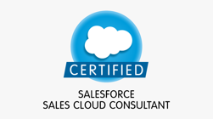  - Salesforce Certified Administrator  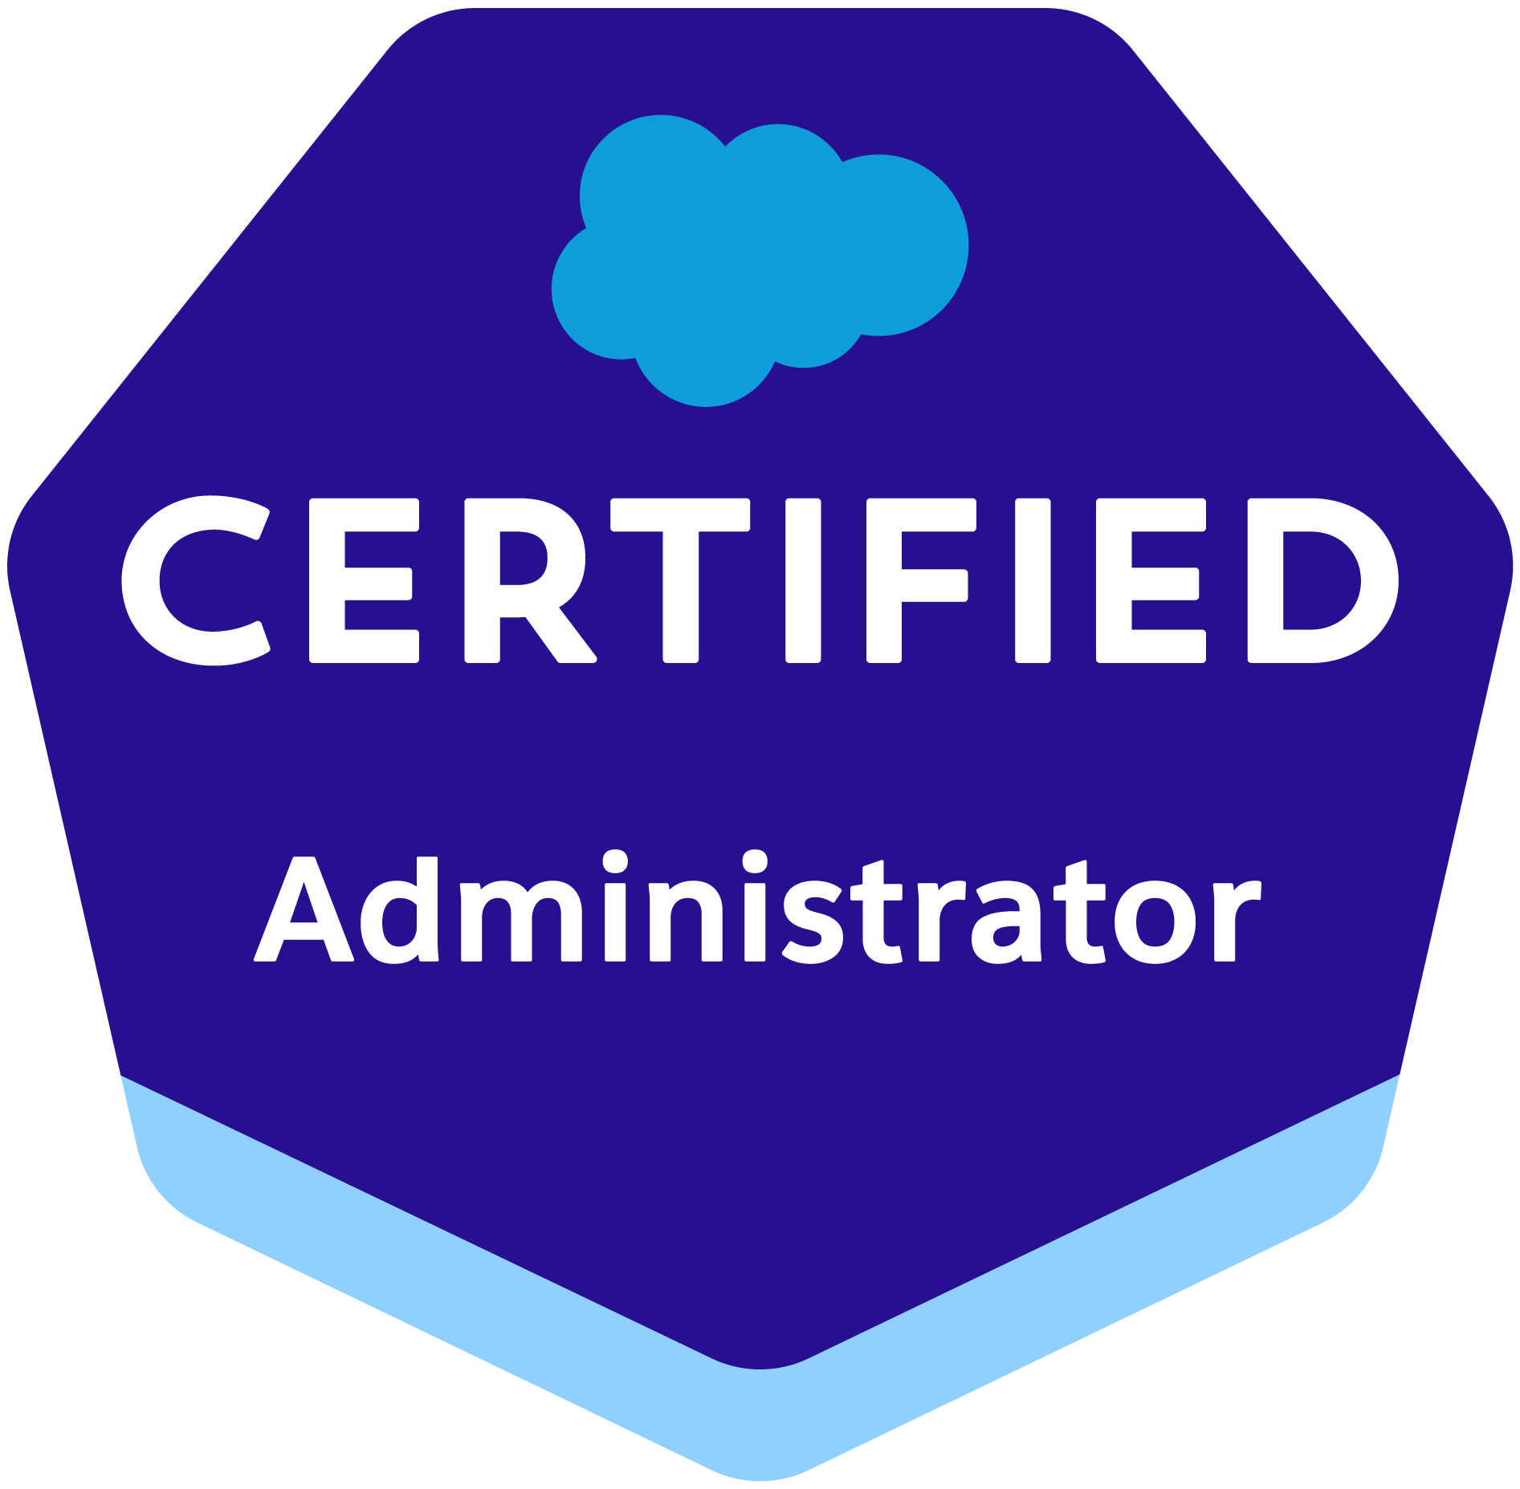  - Salesforce Platform Developer I  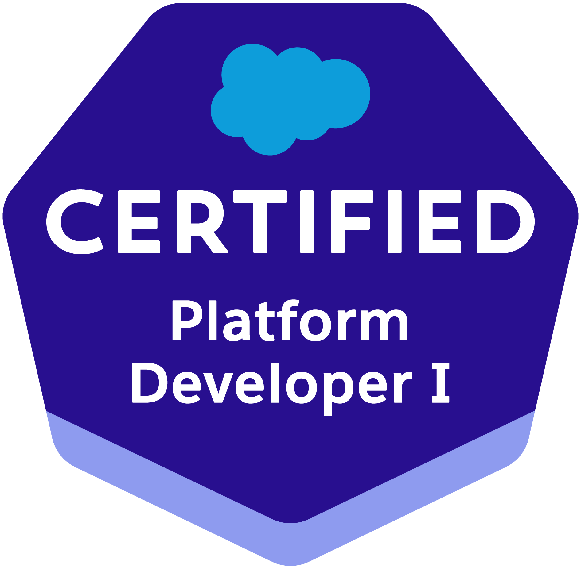 |   - Apex Specialist  - Security Specialist  - App Customization Specialist  - Process Automation Specialist  - Business Administration Specialist  - Lightning Web Components Specialist  - Lightning Experience Reports & Dashboards Specialist

Salesforce Experience

Salesforce Consultant | Stratos Studios

December 2021 – Present

- Responsible for the set-up, configuration, and maintenance of the company’s Salesforce application.
- Conga CLM to provide a comprehensive contract management solution for sales teams.
- Introduced improvement implementations to the existing system.
- Experience in Contract Creation, Collaboration and Negotiation, Approval workflows, Compliance Tracking, Analytic and Reporting
- Designed and developed custom solutions on the Salesforce platform by utilizing Apex, Visual Force, and initiated data migration and application integration.
- Implementing ChangeSets to manage and deploy customizations to move changes from one Org to Other.
- Designed and implemented custom business solutions that are based on cloud-based business applications, specifically on Salesforce platform.
- Proactively took part in documenting business requirements, process flows, specifications, application design, configuration, testing and deployment.
- Collaborated with clients to lead projects, developed, and delivered any crucial components of Salesforce technology solutions and facilitated business process analysis sessions.
- Uses Agile approach for project management to prioritize the tasks through Jira stories by following Kanban and Scrum methodologies.

Senior Associate | Wipro

August 2019 – December 2021

Started as a Salesforce trainee which is a pay-per-click online advertising platform that allows advertisers to display their ads on Google's search engine results page

- Created page layouts, search layouts, custom links, and related lists.
- Configured pick lists, dependent pick lists, lookups, junction objects, master-detail relationships, validation rules, and formula fields.
- Creating dashboards, reports, setting up email schedules,
- Maintaining workflows, user profiles, setting permissions for users
- Assigning Licenses and permission sets
- Providing sample cases, flow recommendations, macros & Knowledge articles Utilizing data-loader for huge data, created custom buttons and links
- Mass update & mass delete records
- Managed forms, templates, page layout workflows and approvals & object relationships
- Writing apex classes to provide functionality to the visual force pages
- Implemented customization requests including creating triggers, workflow alerts & email responses etc.,

OTHER EXPERIENCE

Salesforce Intern | AMG Innovation India Pvt Ltd.

may 2019 – August 2019

- Initiated requirement gathering and facilitated reviews throughout the project lifecycle.
- Performed requirements analysis, and documented system specifications, business requirements and design using requirements inventory.

TechStack  - Lightning Web Components  - Apex, VisualForce  - Aura  - Conga CLM  - Salsefoce CLI, ChangeSets  - Integration – REST/SOAP  - SOQL/SOSL  - Flows/process builder  - Data Loader  - Authentication, SSO/Auth Provider  - Github, Jira, Scrum tools, VScode | professional Skills  - CRM Business processes re-engineering and solution designing  - Requirement gathering and gap analysis  - Exceptional time management  - Team management  - Problem Solving  - Project Management  - Methodologies: Agile, Scrum, SDLC  - Data management and data modelling  - Effective communication skills

Education qualification

Specialization: |  | B. Tech in CSE
College/Institute: |  | Vaagdevi Engineering College (JNTUH)

