Anjali Parmar
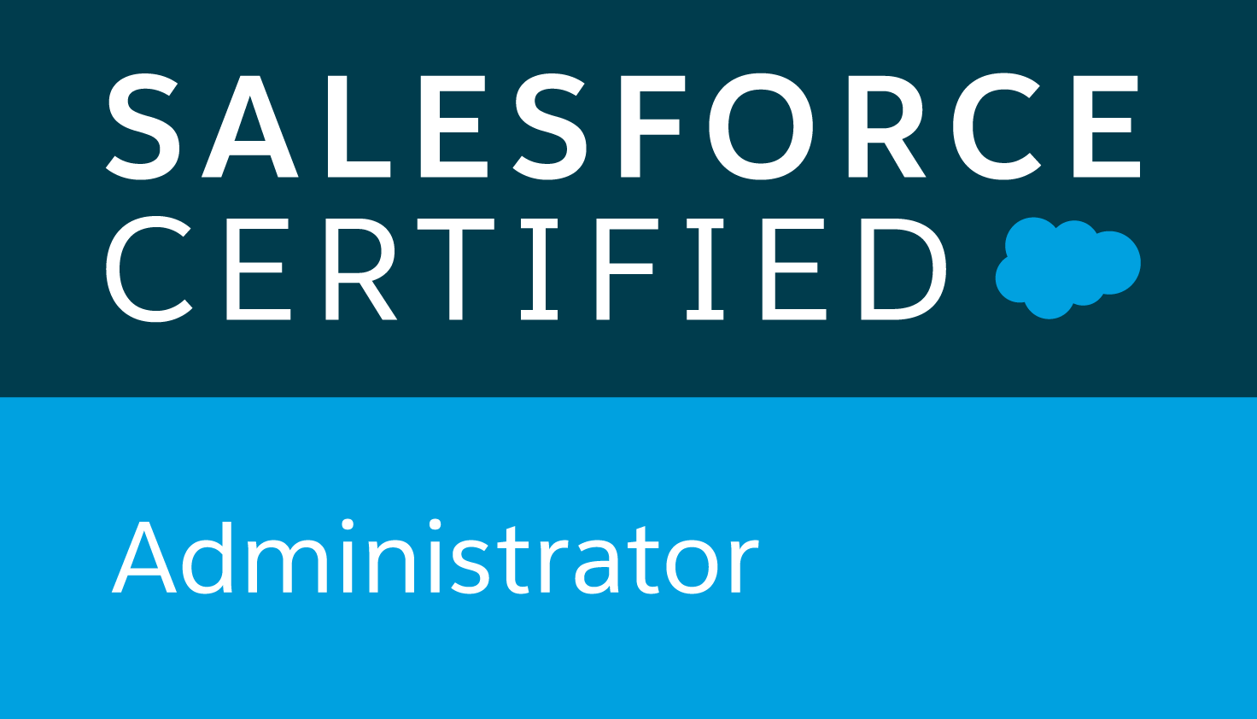

+91-7568307225
anjaliparmar96@gmail.com

Executive Summary

- A professional with 2.8 years of experience in Salesforce.com as Developer and Administrator in Sales Cloud.
- Presently working with Accenture Solutions Private Limited, as Salesforce Lightning Admin/ Developer.
- Experience to analyse the customer requirements and provide the solution accordingly.
- Skilled in swiftly ramping up projects with competent skills and ensuring on time deliverables with quality assurance.
- Accountable for full end-to-end process for the user acceptance testing phases of the project, executing testing and working within deadlines.
- Excellent problem-solving skills, good communication and interpersonal skills.
- Experience to interact with various stakeholders at diverse geographies.

Certifications

- Salesforce Certified Administrator - ADM 201
- Certified Copado Admin
- Certified Developer Admin

Employment History

Accenture Solutions Private Limited. Senior Engineer Oct’ 17 till present

Technical Skills

Configuration Skills

- Proficiency in SFDC Administrative tasks like creating Object, Field, Relationships.
- Proficient with security models and techniques, Profiles, Roles, users, page Layouts, Record Types.
- Proficiency in creating Automation tasks like Approval Process, Workflows, Process Builders, Flows, Assignment Rules, Auto response and Escalation Rules.
- Hands on experience with Reports and Dashboards.
- Experience in SFDC deployment with Copado, Change Sets, Salesforce Package, Force.com IDE, Eclipse, SVN.
- Proficient in Data Loading activities Using Data Loader, Import Wizard, Workbench
- Proficiency in debugging and finding the root cause of SFDC related issues/ defects and fixing them

Customization Skills

- Experience in SFDC development using Lightning Components, Apex classes, Batch Class , Apex Triggers ,Visual Force
- Hands on experience with lightning components, controller, events .
- Proficiency with Apex Language, Apex Trigger, Apex Class , Apex Test Classes and methods.
- Strong experience in SOQL and SOSL Queries
- Proficiency in test-driven, agile development.
- Ability to follow an agile or iterative software development methodology.

Project Skills

- Experience in both Waterfall and Agile
- Experience in Force.com
- Experience in Sales and Services Cloud

Languages: Apex, HTML, CSS, JAVA, SQL, SOQL.

Tools: Workbench, Data Loader, Import Wizard, Eclipse, Rally, SVN, GIT, COPADO, Visual Studio Code, Cisco Webex

Languages: Windows, Linux, Mac OS.

Projects Undertaken
1. Resource Profile (RP)

Type : Development
Role : Developer & Designer
Platform : Salesforce Classic

Responsibilities:
• Responsible to analyze functional and technical requirements.
• Document and develop code according to specifications and standards.
• Prepare test data and plan and conduct basic unit or module testing.
• Provide support for quality assurance testing and defect resolution.
• Writing Test classes for the Controllers
• Responsible for deploying/moving code between development stage and QA stage.
• Responsible for giving KT to the end users.

Achievements:
Was awarded with CMT APEX Awards for FY18Q4 for the contributions I made while being in this project. This is a big honor to have for junior resources.

2. CRMDB Project

Type : Development
Role : Developer & Admin & Architect
Platform : Salesforce Lightning

Responsibilities:
• Designing the Architecture.
• Taking the requirement directly from the clients.
• Developing Apex classes and Test Classes.
• Developing Apex Triggers and Batch Classes.
• Deploy using Eclipse
• Data Loading

Achievements:
Was awarded with PAT on the back certificate for handling the Clients alone.

3. Opportunity Management

Type : Development
Role : Developer & Admin
Platform : Salesforce Lightning

Responsibilities:
• Taking the requirement directly from the clients.
• Developing Apex Class, Triggers, Test Classes
• Process builder, Assignment Rules, Workflows
• Visual force Page, lightning Components
• Data Loading

Achievements:
Awarded with make a difference and with the highest band in current appraisal cycle.

4. Case Management

Type : Development
Role : Developer & Admin
Platform : Salesforce Lightning

Responsibilities:
• Taking the requirement directly from the clients.
• Developing Apex Class, Triggers, Test Classes
• Process builder, Assignment Rules, Workflows
• Visual force Page, lightning Components
• Data Loading
• Integration, Web callouts and API
• Deployment Using Copado ,VS Code and GIT

Academic Credentials

2017 Bachelor of Technology from Banasthali Vidyapeeth, Jaipur.
2013 Secondary School from Kendriya Vidyalaya No.2 , New Delhi.
2011 High School from Kendriya Vidyalaya No.2 , New Delhi.

Trainings & Extras

- Awarded with CLIENT AND CUSTOMER AWARD for outstanding contribution to client’s business outcomes.
- Awarded with make a difference and with the highest band in current appraisal
cycle.

Personal Information

Date of Birth: 22nd March 1996.
Hobbies: Teaching, Dancing, Singing.
Interests: Technology.
Marital status: Single.

Declaration

I hereby declare that all the information provided above is true to the best of my knowledge.

Bengaluru Anjali Parmar

