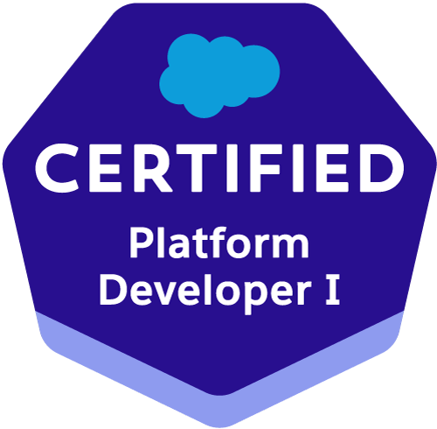
SIRIPURAM DINESH
Contact: +91 9849497506 E-mail: dineshsiripuram@gmail.com
EXPERIENCE SUMMARY

- Has a total of 5.1 years of IT experience and 4.1 years of salesforce experience as a salesforce developer. Good understanding and hands-on experience on Salesforce Architecture, Apex, Force.com Platform, Sales Cloud, Lightning Components, LWC, Visual Studio Code, Integration and Package.xml.

TECHNICAL COMPENTENCY

- Proficient in Salesforce developer toolkit including Apex Classes, Controllers , Triggers, Lightning Web Components and Integration.
- Designed and deployed Custom tabs, Custom Objects, Components, Visual Force Pages, Validation rules, Process Builder, Lightning Flows, Approval Processes and Auto-Response Rules for automating business logic.
- Developed and design custom Lightning Web Components using Standard API’s.
- Worked of Lightning Component -- Development Model on Aura Framework.
- Good experience in Integrating Salesforce with other internal/external applications using REST API.
- Having Knowledge on Connected APP, Oauth 2.0, Remote sites for the Integration with external systems.
- Having the experience in Postman, work bench to test the Integration API implementations.
- Work experience in providing security by using Profiles, Permission sets and at record level by using OWDs, sharing rules and manual sharing.
- Proficient knowledge of Governor limits and experienced in optimization of existing code in according to the governor limits.
- Successfully implemented Service Cloud - Case management, Email-to-case, and Knowledge Management.
- Working knowledge on development work including triggers, apex classes, Batch classes etc.
- Involved in Unit Testing and Test Coverage.
- Involved in Deployment and Worked on issues while deploying.
- Hands of experience in configuring and customizing the applications on Sales force platform.
- Thorough understanding and good experience on data migration by using Data Loader.
- Ability to write SOQL queries across multiple objects within the SFDC database.
- Having experience in migrating changes to Test and Production sandboxes from Developer sandbox by using change sets tool.
- Involving in Client meeting and implementing the process, based on the client requirements.
- Having good Analytical, Programming and Problem Solving Skills with excellent interpersonal skills, team player and good leadership qualities.
- Good Interpersonal skills, commitment, result oriented, hard working with a quest and zeal to learn new technologies.
WORK EXPERIENCE

- Worked as Software Engineer with Zealous Technology Services, from Nov 2017 – Feb 2020
- Working as Senior Engineer with Renault-Nissan Technology and Business Centre India Private Ltd, from April -2021 to till Date.

TECHNICAL EXPERTISE

Salesforce : Salesforce CRM, Lightning Application, Apex Classes, Apex Triggers,
Batch apex, Visualforce Pages/Components, SOQL, SOSL Workflow,
Process Builder, Flow Builder &amp; Validation rules, Aura Component,
Lightning Events, Integration REST API, Workbench, Postman and Change sets.
Sales, Service, Community.
Web Technologies : Visual Force, HTML, Java Script.
Languages : Apex, Visualforce, Aura, (LWC)JavaScript, CSS, Html.
Databases : SQL
Operating System : Windows 10,Windows Vista, 7, Windows XP,LINUX.

PROFESSIONAL PROJECTS

PROJECT – 3

Project Name - VMS – Variable Market Support

Description - The purpose of this project is to replace the current Variable Market Support (VMS) program and management solution called Variable Market System through a complete redesign of the VMS process, procedures and systems by replacing it with a new solution. To control and manage spend of Variable Marketing Expense (VME), To increase VME Effectiveness & Efficiency (RBU, Dealership), Improve visibility and reporting of incentives. Automate approval processes, integrate all VMS activities onto one system and generate an audit trail with accountability

Environment - Saleforce.com platform, Lightning Web Components, Force.com API, Reports, Custom Objects, Custom Tabs, Email Services, Salesforce.com Data Loader, Security Controls, Sandbox.

Roles and Responsibilities-
- Creating Workflows, Objects and Validation Rules inside Salesforce and Mapping them to the existing functionalities and Objects.
- Implementing complete Sales force CRM application based on the business requirements.
- Customizing records types, fields, tabs, column field and setup configuration.
- Custom Data imports/exports functionality using LWC and quality maintenance.
- Generating up to date Reports
- Worked on various salesforce.com standard objects like Accounts, Contacts, Campaigns, Dashboards and Reports.
- Created new custom objects, assigned fields, designed page layouts, custom tabs, components, custom reports.

PROJECT – 2

Project Name - Feet Management.

Description - Fleet Sales department is looking into automating their whole End-to-End business process on Salesforce to increase productivity. Currently Fleet Sales department runs their end to end business operations manually; they have no system application to support their daily activities. Information is captured on Excel by individual Key Account Managers and stored on their computers, as they don’t have centralized corporate customers sales database.

Environment - Saleforce.com platform, Apex Language, Visualforce, Pages, Data Loader, Workflow & Approvals, Reports, Custom Objects, Custom Tabs, Email Services, Security Controls.

Roles and Responsibilities-

- Implemented apex triggers, apex controllers, visual force pages and Email templates.
- Worked with standard Salesforce objects like Account, Contact, Opportunity, Product, Quote, Order and custom metadata.
- Implemented Email notification to group when governor limits recached.
- Implemented public Groups and Workflows, process builder.
- Involved in data migration process through Data Loader bulk API.
- Involved in code review optimization and fixing review comments.
- Creating and manage Users, Roles, Profiles, permissions, and renaming records.
PROJECT – 1
Project Name - Yodel - Sales Cloud Implementation.

Description - Yodel applications for customer relationship management (CRM). This is Call centre-based application used by Customer service representatives for better customer interaction. Ranging from sales force automation to partner relationship management, marketing, Yodel provides a robust technology platform that is based on an on-demand and shared, multi-tenant architecture. Yodel provides a robust technology platform that is based on an on-demand and shared, multi-tenant architecture.

Responsibilities
- Worked with standard Salesforce objects like Account, Opportunity, Lead, Product, Quote, and
Contact.
- Creating different Custom Validation Rules setup and Workflow Rule, Approval Processes that suit the needs of application.
- Implemented Global Picklists, dependent picklists, lookups, master detail relationships, and record Types to enforce data quality.
- Responsible for writing custom Apex classes, Lightning pages and Apex Triggers to track the flow of the business.
- Builds reports and dashboards to track Opportunity pipeline and Converted leads.

EDUCATION

- Completed Master of Technology from JAWAHARLAL NEHRU TECHNOLOGICAL UNIVERSITY, Hyderabad from 2016.

PERSONAL INFROMATION

- Date of birth – 18/03/1992
- Matrital status – Single
- Address – Hyderabad

DECLARATION

I hereby declare that the information given above is true & correct to the best of my knowledge.
SIRIPURAM DINESH

