**Lalit Khurana**

9822565740

Lalit_khurana_2003@yahoo.co.in

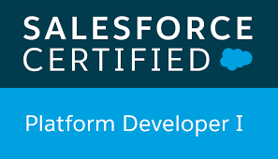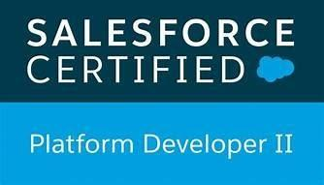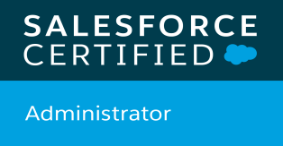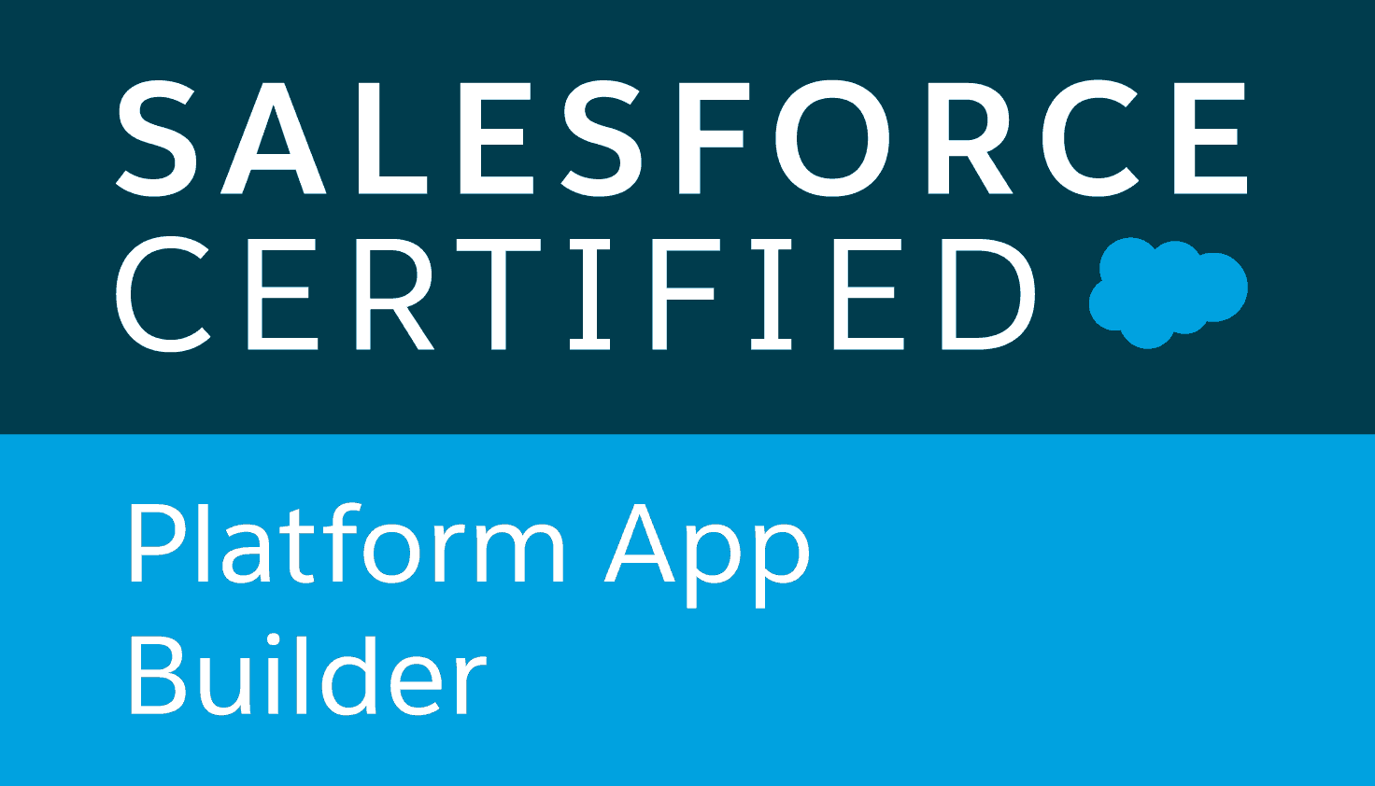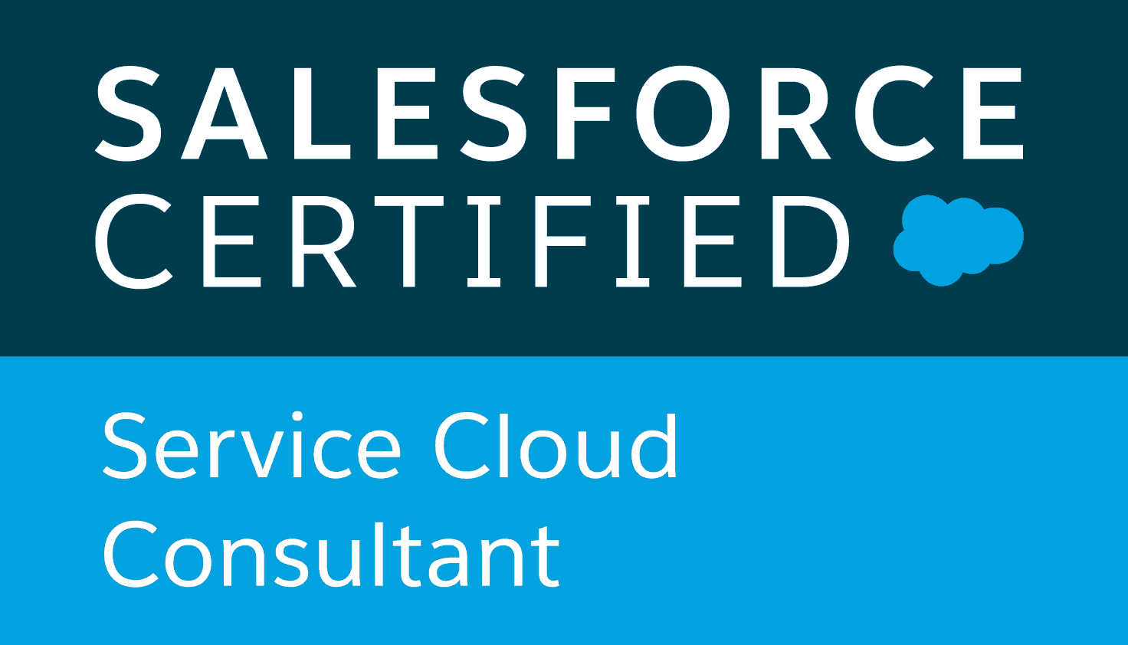 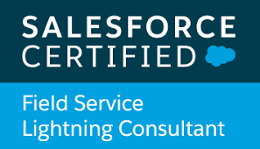 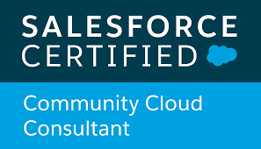

|  |  |
| --- | --- |
|  | |
| Profile overview | * IT professional with 12+ years of experience in Software Development, CRM consulting and implementation. * 6 Years’ Experience in Salesforce.com CRM and Force.com platform with proficiency as a Team Lead Developer. Experienced in developing business processes and system solutions based on Salesforce.com CRM, Force.com. * Experience in all phases of Software Development Life Cycle (SDLC) which involves requirement gathering, requirement analysis, design, development, implementation & enhancement of projects in SalesForce.com * Hands-on experience in SFDC development using the Lightning Component Framework, Apex classes, Visualforce, Triggers, Components, Metadata, SOAP and REST web services API, Reports, Force.com IDE, Eclipse with SOQL, SOSL etc. * Leading a team of Salesforce administrators/developers in delivering successful projects. * Experience in performing administrative and development related tasks like consigning Roles, creating Profiles, Visualforce pages, Validation Rules, Users, Custom Reports, workflow, Email Alerts and Page Layouts. * Project experience of designing Salesforce setups such as Permission Sets, Sharing Model, Roles, OWD, Object relationships. * Hands-on experience of a deployment with Salesforce.com migration tools using ANT, SVN and Jenkins * Hands-on experience in documentation as per processes/guidelines. * Good team player with excellent communication skills, analytical and problem solving, time management skills. * Have exposure in Customer Portal, Self-Service Portal, and also on salesforce communities. * Have good experience in Trigger, Test Methods, and writing SOQL and SOSL queries. * Have a good understanding and knowledge of the functionality of Web Services for REST API. * Have a good knowledge on Lightning Component on UI framework and also some basic knowledge on developing web applications. * Experience in translating business processes into Custom Objects and creating Look-up relationships and Master-detail relationships. * Experience in Salesforce Lightning and Process Builder. * Worked on Migration tools Force.com IDE, Eclipse and have knowledge of Changeset migration code and configuration from the Dev sandbox to Production. * Ability to adapt to any environment such as working with small or large groups or independently and excellent communication skills. |
| Experience | * IBM   + IBM June 2021 to till date * TCS.   + TCS from July 2019 to June 2021 * [Persistent](http://ccs.infospace.com/ClickHandler.ashx?ld=20141103&app=1&c=im.s1.row.df&s=ims1row&rc=im.s1.row&dc=&euip=223.196.139.47&pvaid=24a2e3d0c9084221afe114d5403562b2&dt=Desktop&fct.uid=1f195d43b757453d934b9632e7af9c56&en=8VQDhNXFIEv8W%2bsMzW%2bVu%2fTUmxACLlhqvaVN6VXuKOKZOM1ZvZphFg%3d%3d&du=http%3a%2f%2fwww.smartdatainc.com%2f&ru=http%3a%2f%2fwww.smartdatainc.com%2f&ap=1&coi=239138&cop=main-title&npp=1&p=0&pp=0&ep=1&mid=9&hash=28AECCCDBEC1B7EC4FFF2FC0829883C1) Systems Limited.   + [Persistent](http://ccs.infospace.com/ClickHandler.ashx?ld=20141103&app=1&c=im.s1.row.df&s=ims1row&rc=im.s1.row&dc=&euip=223.196.139.47&pvaid=24a2e3d0c9084221afe114d5403562b2&dt=Desktop&fct.uid=1f195d43b757453d934b9632e7af9c56&en=8VQDhNXFIEv8W%2bsMzW%2bVu%2fTUmxACLlhqvaVN6VXuKOKZOM1ZvZphFg%3d%3d&du=http%3a%2f%2fwww.smartdatainc.com%2f&ru=http%3a%2f%2fwww.smartdatainc.com%2f&ap=1&coi=239138&cop=main-title&npp=1&p=0&pp=0&ep=1&mid=9&hash=28AECCCDBEC1B7EC4FFF2FC0829883C1) Systems Limited from May 2015 to July 2019 * [SmartData Enterprises](http://ccs.infospace.com/ClickHandler.ashx?ld=20141103&app=1&c=im.s1.row.df&s=ims1row&rc=im.s1.row&dc=&euip=223.196.139.47&pvaid=24a2e3d0c9084221afe114d5403562b2&dt=Desktop&fct.uid=1f195d43b757453d934b9632e7af9c56&en=8VQDhNXFIEv8W%2bsMzW%2bVu%2fTUmxACLlhqvaVN6VXuKOKZOM1ZvZphFg%3d%3d&du=http%3a%2f%2fwww.smartdatainc.com%2f&ru=http%3a%2f%2fwww.smartdatainc.com%2f&ap=1&coi=239138&cop=main-title&npp=1&p=0&pp=0&ep=1&mid=9&hash=28AECCCDBEC1B7EC4FFF2FC0829883C1)   + [SmartData Enterprises](http://ccs.infospace.com/ClickHandler.ashx?ld=20141103&app=1&c=im.s1.row.df&s=ims1row&rc=im.s1.row&dc=&euip=223.196.139.47&pvaid=24a2e3d0c9084221afe114d5403562b2&dt=Desktop&fct.uid=1f195d43b757453d934b9632e7af9c56&en=8VQDhNXFIEv8W%2bsMzW%2bVu%2fTUmxACLlhqvaVN6VXuKOKZOM1ZvZphFg%3d%3d&du=http%3a%2f%2fwww.smartdatainc.com%2f&ru=http%3a%2f%2fwww.smartdatainc.com%2f&ap=1&coi=239138&cop=main-title&npp=1&p=0&pp=0&ep=1&mid=9&hash=28AECCCDBEC1B7EC4FFF2FC0829883C1) Nagpur from Oct 2014 to Mar 2015 * TrusSystem &Softtware Pvt. Ltd   + Trust Systems & Software Pvt. Ltd. Nagpur from July 2012 to till Oct 2014 * FastTrack Solution   + FastTrack Solution, Nagpur from 2011 Jan to 2012 July. |
| Responsibilties | * Salesforce Developer |
| certification | * Salesforce Admin * Salesforce Platform developer I * Salesforce Platform developer II * Salesforce App Builder * Salesforce Service Cloud Consultant * Salesforce Field Service Lightning Consultant * Salesforce Community Cloud Consultant * Salesforce Marketing Cloud Email Specialist |
| Technology expertise | * Salesforce.com: LWC, Lightning components,Apex, Visualforce, SOQL, SOSL, Apex Triggers, Workflows, Approvals, Email Templates, Formulas, Validation Rules, AppExchange, Eclipse, Salesforce.com, Force.com IDE, Apex Data-Loader, Roles & Profiles, Dashboard, Reports * Programming Languages: salesforce. * Web Technologies: JavaScript,apex,CSS. * Web services: REST API |
| Academics | * Bachelor of Science(B.Sc) – Institute of science.(Nagpur University) * Master In Computer Application(MCA) – V.M.V. (Nagpur University) |
| Projects | 1. PROJECT    Role : Salesforce Developer  Roles & Responsibilities:   * Worked on Salesforce.com Standard Object such as Task,Case and Custom Objects. * Created Page Layouts to organize fields, custom links, related lists, and other components on record pages. * Hands on experience in using the LWC and Salesforce lightning Design System (SLDS). * Implemented Lightning components and Apex class. * Implemented Events and Svg components. * Develop apex class and apex triggers. * develop rest API's. * Implemented email templates,Workflows,Validations.   2.PROJECT  Role : Salesforce Developer  Roles & Responsibilities:   * Worked as Senior Developer and Tech Lead * Worked on Salesforce.com Standard Objects such as Accounts, Contacts, Opportunities and Case. * Worked on Salesforce.com Custom Objects * Created Page Layouts to organize fields, custom links, related lists, and other components on record pages. * Hands on experience in using the Aura framework and Salesforce lightning Design System (SLDS). * Implemented Lightning components and Apex class. * Implemented Events and Svg components. * Develop apex class and apex triggers. * Developed Apex Batch and Scheduler classes to handle the bulk data processing. * Building SOQL & SOSL statements using APEX classes * Developed Test Method/Class.   3.PROJECT  Role : Heroku/Salesforce Developer  Roles & Responsibilities:   * Worked on the designing of custom objects, custom fields, role based page layouts, custom Tabs, custom reports, report folders, report extractions to various formats, Dashboards and various other components as per the client and application requirements. * Hands on experience on Triggers, Apex Classes, Lightning Pages and Aura Components. * Workflows Implementation with Objects, Custom Apps, Layouts, Tabs, Validation Rules, Workflow and Approva Experience as a Administration and Developer in Salesforce.com. Has good knowledge of the Technical and Functional aspects of Salesforce.com, on demand CRM package. * Successfully developed and tested stand-alone applications on Salesforce platform. * Performed various administrative tasks such as configuring profiles, files, object and permissions on Salesforce. * Extensive practical hands-on experience on visual force and lightning components. * Hands on experience on Heroku and Heroku connect frameworks. * Possess adept skills on building APIs in Node.js programming language. * Hands on experience on Postgres SQL database. * Managed SFDC version controlling, continuous integration and release management using Flosum . * Customizing the applications on Salesforce platform and Force.com. * Hands on experience on developing Triggers, Apex Classes and VF Pages. * Workflows Implementation with Objects, Custom Apps, Layouts, Tabs, Validation Rules. * Workflow and Approval processes, Sharing Rules. * Ability to learn and adapt to new technologies quickly. * Worked on the designing of custom objects, custom fields, role based page layouts, custom Tabs, custom reports, report folders, report extractions to various formats, design of Visual Force Pages, Dashboards and various other components as per the client and application requirements. * Good experience in implementing Object Oriented Programming concepts in Software Development.   4.PROJECT    Role : Salesforce Team Lead  Roles & Responsibilities:   * Working with management and end-users to create and manage workflow rules, data validation, processes and flows * Built APIs in Node.js programming language * Work with management, create and manage complex workflow rules, data validation, and triggers * Create and manage custom objects, fields, formulas, validation rules, custom workflow, and approval processes * Make recommendations for enhancements and modifications to improve system performance, efficiency, internal business process, and reporting * Work Closely with Team Lead or Project Manager to develop solution in accordance to the system design * Work with Manager to provide scope and timelines * Experience working within an Agile development framework * Salesforce Configurations/Customizations – User Interface, Page Layouts, Tabs, Custom Fields, Custom * Objects, Validation Rules, Triggers, Security Access (SSO preferred), Creating Profiles, Roles and Users * Extensive experience in creating workflows, approval processes, validation rules and sharing & security rules   5.PROJCT  Role : Salesforce Team Lead  Roles & Responsibilities:   * Lead the technical planning & requirements gathering phases for Salesforce projects * Lead Salesforce development team in developing solutions through collaboration and discussion, within our teams and with clients * Built multiple screens using Lightning Web Component * (LWC) & Aura. * Designed, developed Apex Classes, Controller Classes, * Extensions and Apex Triggers for various functional needs. * Worked on Triggers based on Business Requirement. * Worked on Custom settings. * Reports and dashboards. |