Samarendra Sethi
Netsuite Developer NFSuite Private Limited, Noida,India
Cell No : +91 - 7411228937
Email : sethi.samarendra1988@gmail.com
LinkedIn: https://in.linkedin.com/in/samarendra-sethi-97132174
Bangalore, India

To work sincerely, building a symbolic relationship with your organization where my effort will be complemented by career growth, higher degree of responsibility and to prove myself as a valuable asset of your organization.

Professional Experience:

Organization : Upaya Solution, USA | NFSuite Private Limited, Noida,India
Designation : Netsuite Technical Consultant
Period : May 2015 to August 2017
About the Company :

Upaya Solution is based in USA. It is a Netsuite Solution Provider and part of a Suite Cloude Developer Network and achieved Netsuite 3Star Award at 2014,2015 and 2016. Upaya has completed over 500+ successful NetSuite and NetSuite OneWorld implementations. NFSuite Private Limited is a partner and the offshore R&D centre of Upaya Solution based on Dlhi NCR ,India.

Organization : Adaa IT Solutions Private Limited,Bangalore,India
Role : Netsuite Developer
Period : May 2014 to May 2015
About the Company :

Adaa IT Solutions Pvt. Ltd is specialize in customization of NetSuite ,java and .NET based application development. It based in Bangalore, the Silicon Valley of India with direct access to a huge talent pool of the right people available readily and works on NS customizations with clients in the US, Europe and Australia

Summary of Experience:

- I'm a dedicated and result-driven individual having 3.6 Years Relevant Experience of Netsuite SuiteTalk,SuiteScript,Integration, customization and Salesforce.
- My skill set includes End-to-End Netsuite ERP,CRM Development with Extensive working & implementation knowledge on SuiteTalk,SuiteScript, Java, Web Services, JavaScript , HTML,C#, Salesforce Apex,Trigger and Apex Rest Web services Development.
- Developed more than 25 projects with challenging scenario in both SuiteTalk ,SuiteScript ,java and C# by integrating Netsuite with other legacy System like Amazon ,SalesForce ,Magento ,PinacleCart ,UPS ,Ingram Micro,GE ,Stripe,Moultan Logistic, etc by using their specified API.
- Developed Project by using Agile Methodologies and various tools like Eclipse,Netbeans,SOAP UI,Postman,SVN,Visual Studio,Work Bench.
- Expert in Salesforce Apex,trigger ,Apex Rest API and Test Class Development.
- Exporting data from Netsuite in different file format like CSV, TSV, Excel ,XML,TXT,JSON,XLS,XLSX,DAT and also Importing data into Netsuite using same file formats.
- Export/Import data of different files with FTP/SFTP/SSH Third Party Cloud application using specified API using (HTTP request/response method with XML,JSON,SOAP Messaging format) API,WSDL,SOAP.
- Develope “Netsuite -Salesforce Realtime Integration” by using Restllet Script,UserEvent Script And Salesforce Apex , Trigger and Apex Rest Webservices.
- Expert in both SOAP and Rest Web Service consumer and provider development and clear knowledge on Web Services Flow.
- Well versed in Net suite Functionality and flow. Good knowledge in creation of custom records, fields, Saved searches and SuiteBundle.
- Developed Restlet scripts to integrate NetSuite with other Legacy systems through https call by using both NLAuth and Oth Authentication.
- Have worked on triggering button using client script.PDF and Email Template Development.
- Have worked on calling suitelet script using client script and also call suitelet from another suitelet .

Technical Skils :

Netsuite,SuiteTalk,SuiteScript, Suiteflow,Java,J2EE,C#,JavaScript,Web Services,
Salesforce ,Apex,Trigger,Apex Web Service, Html,javascript,css

Educational Qualification:

Post Graduation |  | Degree : Master in Computer Application  College/University : Veer Surendra Sai University of Technology Pass Out Year : 2013
Graduation |  | Degree : BSc.  College /University : Utkal University  Pass Out Year : 2009
Intermidiate |  | Subject : PCMB  College /University : Brahmani College | CHSE,Odisha  Pass Out Year : 2006
10th | School : Ganesh Durga High School,Sanamanga  Board : Board of Secondary Education , Odisha  Pass Out year : 2003

Projects

Project # 1 | Netsuite- Salesforce Real time Connector | Netsuite SuiteScript Project

Real-Time bi-directional Integration - no waiting for third party schedules to transfer data,Secure data transfer and No intermediate server and data is never outside of NetSuite or Salesforce. Developed by Developing Rest Web service and Rest Client in both Netsuite and Salesforce by using SuiteScript and Salesforce Apex and Trigger Programming.

Client : Planet Lab
Technology Used : Netsuite Restlet Script, userevent Script , Apex,Trigger and Apex Rest Web Services.
Salesforce to NetSuite Data Transfer:
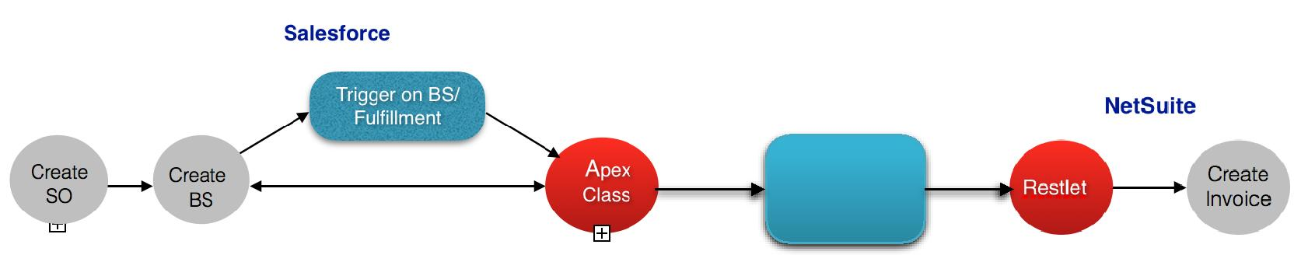

Web Service
Call

NetSuite to Salesforce Data Transfer:
Netsuite

Invoice
UserEvent Script
Invoice Approved by Finance team

Web Service Call

Salesforce
Apex Rest Class
Update BS
Close BS
Close So

Role & Responsibility :
- Develop the Restlet for Contcat,Customer,Invoice and Purchase Order Sync.
- Devloped User event Script on Contcat,Customer,Invoice ,CreditMemo and Customer Payment to send those details to SFDC on Create/Update.
- Developed Trigger and Apex Classes in SFDC on Account,Contact, Billing Schedule and Order and Salesforce Test Class Development for all.
- Developed Apex Rest Web Services for Account,Contact, Billing Schedule and Order.
- Develop Custom Setting and Test Classes for Production Deployment in SFDC.
- Create Bundle in Netsuite Sandbox and install that in Netsuite Production .
- Test the Whole process by implementing several possible Test case.

Project # 2 | NetSuite Bill Uploader | Netsuite SuiteTalk Project

This BillUploader Desktop Application includes Develop GUI based java desktop application to Read the CSV file and import Purchase Order and then Create VendorBill from that PO .
Client : Palantir
Technology | : | Netsuite SuiteTalk API,java.
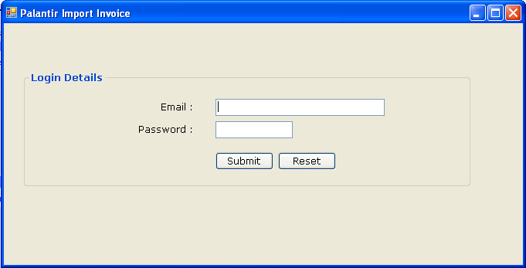
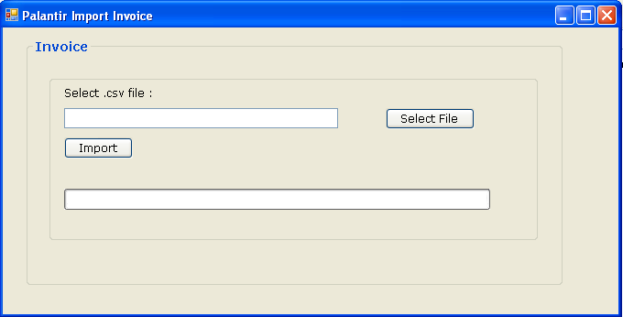
Responsibilities:
- Developed Login Page and Export page with file Browsing option.
- Read the Uploaded CSV file by using java
- Check the duplication by BillNo and Cerate Purchase Order and Create VendorBill From that PurchaseOrder ,In between operations like search Team,Seah Item,Customer also Perfermed..
- Deploy the Application exe file in Client System by scheduling to run once a day.

Project # 3 | Netsuite- Salesforce Integration for Sales and Services Processes
Leads, Opportunities and Accounts (Customers), and Sales Order will be created in Salesforce. Account ,Contact ,Opportunity will Sync to Netsuite .Items will sync from Netsuite to SFDC.Sales Order will still be managed in NetSuite and will be accessible through Salesforce via one click access. NetSuite and Salesforce will be kept in sync via two-way API connectors.
Client : Nextracker

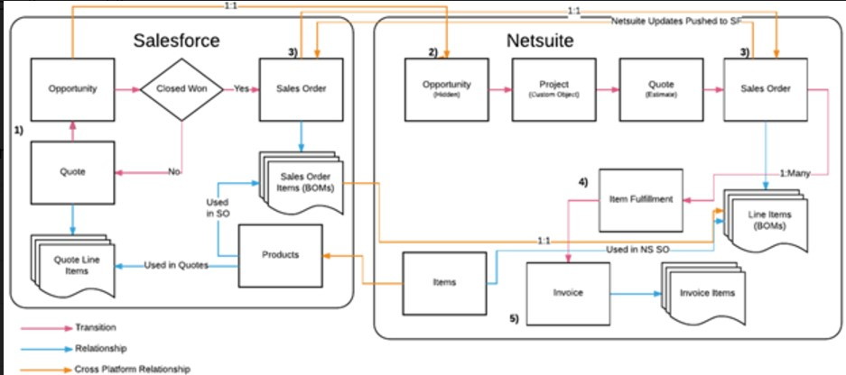

Technology Used : Netsuite SuiteScript , Salesforce Apex,Trigger and Apex Rest Web Services.
Role & Responsibility :
- Develop the Restlet for all operation and syncing data from SFDC to Netsuite
- Devloped User event Script for to send details to SFDC on Create/Update.
- Developed Trigger ,Apex Classes in SFDC and Test Class Development for all.
- Developed Apex Rest Web.
- Develop Custom Setting and Test Classes for Production Deployment in SFDC.
- Create Bundle in Netsuite Sandbox and install that in Netsuite Production .
- Test the Whole process by implementing several possible Test case.

Project # 4 | Ingram Micro Netsuite Integration | Netsuite SuiteTalk Project
Biderational data Transfer for Order to Cash, Fulfillment and Inventory Adjustment Process between Ingram Micro and Netsuite. This SuiteTalk windows java Application hourly schedule process will Fetch data from Netsuite Savesearch and send to Ingram for several Process and Accept Ingram Http call and Create Itemfulfillment, Return Authorization and Inventory Adjustment in Netsuite. Netsuite Token Based Authentication(TBA) used here for avoiding the Netsuite Password expiration at every 3 Month. Every execution details will monitor by log message and Error email.

Client : Eero Inc.
Technology Used : Netsuite SuiteTalk, Java,J2EE,Webservices, Rest Jersey framework.
Server Used : Apache Tomcat and Amazon Cloud Server.
Responsibility :
- Create Save Search ,Custom Fields in Netsuite for fetching Order, Invoice according to business requirement.
- Develop the Program to Authenticate Netsuite by using Netsuite SuiteTalk Token Based Authentication.
- Retrieve Records from Savesearch and Create XML Request Format.
- Develop Http Client to call Ingram Micro Endpoint and send those XML request to Ingram.What ever response Ingram will provide send email to Customer.
- Develop the Web Service by using Rest Jersey framework which will accept call from Ingram and Create corresponding Records in Netsuite.
- Deploy the Project in Client Remote Server.

Project # 5| Netsuite Export Import Application | Netsuite SuiteTalk Project

Using GUI in Java Swing to Login to Netsuite Import Sales order in to Netsuite using CSV file.Export CSV file for Item fulfillment records. After login window there is two radio buttons to select for which the Order is to Import for SPS Commerce OR for CommerecHub.After selecting the required option and select the corresponding CSV file from GUI and click on Import button. For Exporting the Fulfillment CSV files put the Startdate and End date in date fields in GUI and click on Export Fulfillment button

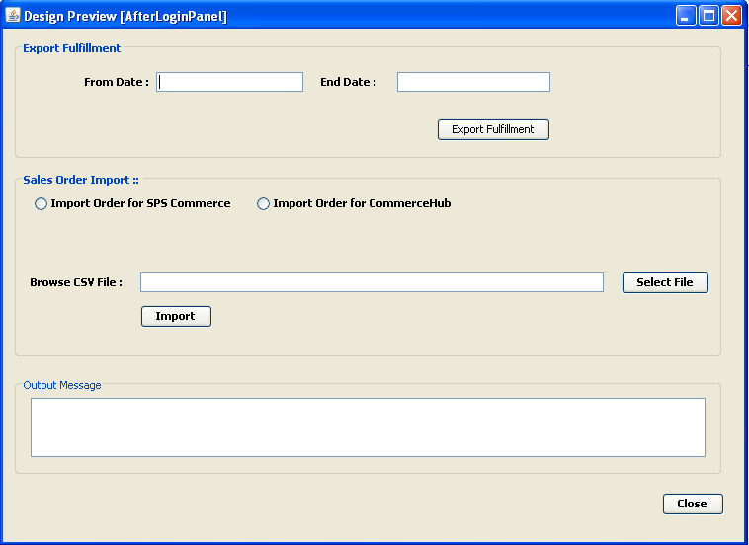

Client : NineStar
Technology | :Netsuite SuiteTalk API,Java,XML,Swing.
Responsibilities:

- Create Save Search on Item fulfilment according to the Customer requirement.
- Developed whole Java GUI based application for import and export operation.
- After Development Testing done by implementing required test cases.

Project # 6 | Netuite – Moultan Integration | Netsuite SuiteTalk Project

Netsuite- Moultan Connector Application is a bidirectional data Sync process through FTP.
This Connector will fetch Records from save searches and it will create flat file according to Moultan API and then Application will Upload file into FTP inbound Folder and again Application will Download file from Outbound Folder and Read that file and Create Item Fulfillment and Inventory Transfer in Netsuite.

Client : Sunglass
Technology Used : Netsuite SuiteTalk, Java, SOAP, FTP.
Responsibility :
- Develop the Save search in Netsuite According to Customer Requirement.
- Develop the SuiteTalk Program to Login Netsuite and Fetch Records from Savesearch.
- Create flat File According to Moultan API Documentation.
- Develop FTP Client for Upload and Download File into Moultan FTP.
- Develop logic to read file and Create Item fulfillment and inventory Transfer.
- Deploy Project on Customer remote Server.

Project # 7 | Netsuite –General Electronic Integration | Netsuite SuiteTalk Project

This Netsuite-GE Conector is a SuiteTalk Java winows Application which includes Create 3 save search on Invoice, CreditMemo and SalesOrder with some specific criteria . From that savesearch get the Transaction record and create 3 separate flat file for each record according to GE provided Documentation for File Layout and mapping and Post to GE SFTP and check the exported checkbox in NS so that the perticular Record will not come under Save search once again. After that GE will send Response file and Application will download that file From SFTP and perferm some update operation on NS.

Client : Klim
Technology : Netsuite SuiteTalk API,Java, SFTP.
Responsibilities:

- Create 3 SaveSearch in NetSuite according to specified criteria.
- Developed Java application which will Pull the Transaction record from the Search and create 3 separate flat file for each according to GE provided Documentation for File Layout and mapping and Post to GE SFTP and check the exported checkbox in NS so that the perticular record will not come under Save search once again.
- GE will send Response file so application will download that file From SFTP and perferm some update operation on NS.
- After Development Testing well by implementing required test cases.
- Deploy the Application on Client machine by scheduling in windows Task Scheduler for running the Application 2 times in a day.

Project # 8 | ACH File Export For Silicon Valley Bank | Netsuite SuiteTalk Project

Using GUI in java Swing Login to Netsuite and Create ACH file From NS Bill Payment (VendorPayment) to export ACH files under NACHA file format and upload to SFTP/SFTP-SSH/FTP/PGP key Encryption.When export Button will Click then Application will create ACH file from Bill Payment (VendorPayment) using Saved Search and Post to FTP .After that Application will check the Exported Button so that the perticular Bill Payment Record will not come under savesearch once again for processing.
Client : Palantir
Technology | : | Netsuite SuiteTalk API,Java,FTP.
Responsibilities:
- Developed Java GUI Page for Login to Netsuite and Export File.
- Create the ACH file According to the Silicon Valley Bank provided file layout and Mapping.
- After that Connect to FTP ,Encrypt the file and upload the ACH file into FTP.

Project # 9 | Netsuite-Amazon Integration | Netsuite SuiteTalk Project

This Amazon-Netsuite Connect includes Import Amazon orders in to Netsuite for US, Canada, Europe for FBA and Non-FBA orders Filters the orders by start date and order’s status(Unshipped or Partially Shipped).For Start date days, hours and minutes are set in config file. Buy Using Amazon API in Java.Export Item Fulfillment data back to Amazon from Netsuite for all three locations.
Client : Digistore
Technology | : | Netsuite SuiteTalk API,Java,Amazon Web Services API.
Responsibilities:
- Filters the orders by start date and order’s status (Unshipped or Partially Shipped). For Start date days, hours and minutes are set in config file according to which it pull the orders from Amazon .Passed the Seller ID, market Place ID, Filter Criteria in ListOrdersRequest object.
- Login process to Netsuite for Authentication.Load all States list from Netsuite which is used in setting the State Code in address details in customer and order record.
- Process for each Amazon order one by one.Search for already exist orders using Amazon order Id If order not found then process to import orders in to Netsuite.
- Get the Item list for Amazon Order from AmazonProcess to search customer using Buyer name, email id, Currency code.If customer not found then create new customer.If customer found the process to update the email id, phone, currency, address details.
- After that process to import sales order.When all Amazon orders imported in Netsuite then process to export Item Fulfillment data to Amazon.

Project # 10 | Netsuite-PinnacleCart Integration | Netsuite SuiteTalk Project

Netsuite PinnacleCart Connector Includes fetch order information from PinnacleCart using Pinnacle Restfull Api and import Orders into Netsuite .Duplication Checking and if Customer is not present then create new Customer according to PinnacleCart

_{Client : Click Shop & Run .}
Technology | : | Netsuite SuiteTalk API,PinnacleCart Restfull Api,Java
Responsibilities:
- Analysis done for PinnacleCart Rest Api for Fetching Order Information.
- Develop Application for Get Orders from PinnacleCart in XML Format.
- Read the XML Response and Create SalesOrder and Customer according to the PinnacleCart response.
- Deploy the Application exe file in Client System by scheduling to run once a day.

Project # 11 | NetSuite Data Sink into SQL Server | Netsuite SuiteTalk Project

Retrive all item detals and Some CustomRecord Details From Netsuite and Update the details in SQL DataBase generated specific Table on daily basic so that another SuiteScript application will look the table details and perferm the further operation.
Client : RubberCal
Technology | : | Netsuite SuiteTalk API,Java,SQL
Responsibilities:

- Develop the program to Conect Netsuite and SQL Server by JDBC Driver 4.
- Develop the Program to get Item Details and Customrecord Details from NS.
- Connect with database.
- Perform the CURD Operation.

Project # 12 | Print Item Receipt on Button Click | Netsuite SuiteScript Project

From Purchase Order click on RECEIPT Button then Item Receipt will Create . Before saving the Item Receipt Then Show Print button on every line Item on Receipt when Customer will create those Print Button then The CSV file for that item will create and Store in File Cabinet and it will print through printer.

Client : Lunada Biomedical.
Technology Used : Client Script, SuiteLet ,JavaScript.
Responsibility.

- Developed the Client Script on PageInit and develop logic to create Print Button on every line Item.
- When print button Create get the Line number and Item and Get the Item Details and call to a suitelet and pass those information through query parameter.
- Develop the Suitelet which will get those Item Details from Request and Generate CSV file and store that in File Cabinet.

Besides these i also developed more small Projects in SuiteScript and SuiteTalk by using Java and also paticipate in resolving critical issue in Other Live Project with Clients like Roku,Ninestar,Mentoring Minds,NexTracker,Biotab,CFRA,Tempo Automation,Nest, Dixie Paper,Bosch,Arista etc...

Personal Details:-

- Father Name : Mr. Maheswar Sethi
- Date of Birth : 10-07-1988
- Marital Statu : Single
- Language : English , Hindi,Odiya
- State : Odisha

Declaration:-

I hereby declare that all the information given above about me is true to the best of my knowledge.

Place: Bangalore,India
Date: Samarendra Sethi

