# **DEVENDRA ARUN KULKARNI**

# **B.E (ELECTRONICS AND TELECOMMUNICATION)**

**RHCSA, RHCE, RHCSOA**

**Email Id:** [devendrakulkarni138057@gmail.com](mailto:devendrakulkarni138057@gmail.com)

**Contact No: 8087992782**

**Address:** Plot No. 86-B, Ulka Nagari, Garkheda, Aurangabad (431001)

|  |
| --- |
| **CAREER OBJECTIVE** |

* To build my career under an esteemed organization which helps me to enhance my professional skills as well as personal skills.

|  |
| --- |
| **STRENGTHS** |

* Efficient team leader as well as player.
* Good verbal and written communication.
* Quick learner and always ready to learn new technologies.
* Good negotiation skills and punctual as well.

|  |
| --- |
| **CERTIFICATIONS** |

* Redhat Certified System Administrator.
* Redhat Certified Engineer.
* Redhat Certified Specialist in Openshift Administration

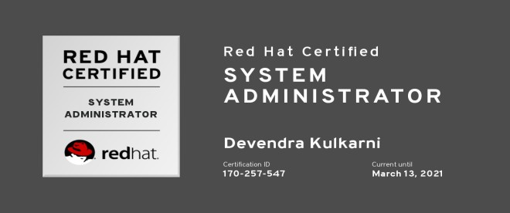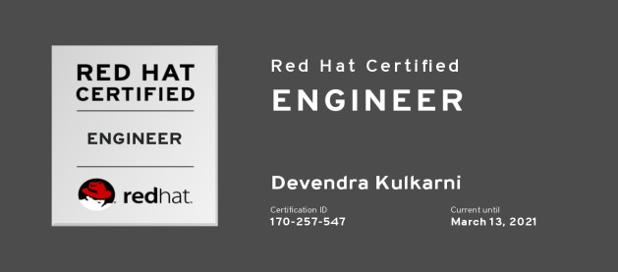



|  |  |  |  |  |  |
| --- | --- | --- | --- | --- | --- |
| **EDUCATIONAL QUALIFICATIONS** | | | | | |
| Sr no. | Degree/Exam | College/School | University/Board | Percentage | Year |
| 1 | B.E | Jawaharlal Nehru Engineering College, Aurangabad | Dr. Babasaheb Ambedkar Marathwada University | 71.7 | 2019 |
| 2 | Diploma | Government Polytechnic, Aurangabad | Autonomous | 81.42 | 2016 |
| 3 | SSC | Golden Kids English High School | Maharashtra State Board | 92.73 | 2013 |

|  |
| --- |
| **TECHNICAL QUALIFICATIONS** |

* **Operating Systems:** FEDORA, CentOS, RHEL, SUSE.
* **Scripting Languages:** Python (Intermediate) , Shell
* **Database:** MySQL
* **Currently learning :** Ansible (Basics)
* **Certifications:** RHCSA, RHCE**.** RHCSOA.

|  |
| --- |
| **TECHNICAL SKILLS** |

* **User Management**: Adding user, assigning password, modifying user permissions.
* Configuration of NFS, APACHE SERVER.
* Managing system processes.
* Basics of Docker, Kubernetes and Openshift.
* Deploying single tier and two-tier applications using docker, kubernetes and openshift.
* Attaching permanent storage to applications.

|  |
| --- |
| **ACADEMIC PROJECT** |

* **IOT BASED ENERGY MONITORING**

This system is used for monitoring and controlling the consumption of energy in homes, offices, hospitals, etc. This gives us real time analysis of day to day consumption of energy through internet, also the consumption is stored in a database which can be accessed through a web-page. We have used Raspberry-pi and python scripting for this system.

|  |
| --- |
| **CO-CURRICULAR ACTIVITIES** |

* Organised and delivered a seminar followed by a two-day workshop on Linux basics and opensource.
* Represented as “HOD NOMINEE” for my department in college and “HEAD” for Discipline committee of whole college.
* Participated in an OPENSOURCE CONFERENCE held in Aurangabad on 9th and 10th of February 2019.

|  |
| --- |
| **PERSONAL INFORMATION** |

* **DOB**: 26-September-1997
* **Languages Known**: English, Hindi, Marathi.
* **Hobbies**: Listening and singing bollywood songs, playing guitar and other musical instruments, and watching movies.
* **Nationality**: INDIAN.