Sravan Reddy 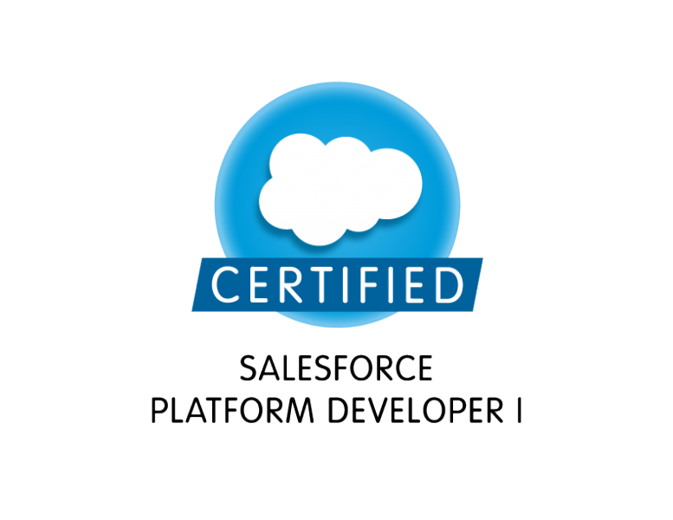
Mobile: +91 9573484630
Email: sravanreddy18.g@gmail.com

SUMMARY:
- Overall 3+ Years of IT experience in Salesforce.com CRM with various stages of Software Development Life Cycle (SDLC) including development, enhancements and testing enterprise applications.
- Experience on Salesforce.com Platform – CRM, Sales cloud and Service cloud.
- Hands on experience on Force.com, Apex, Triggers, Visual Force, Lightning Components, Test classes, Workflows and Approvals.
- Hands on experience in client side technologies like HTML and Java Script.
- Hands on experience on profiles, roles, permission sets, OWD and sharing rules.
- Hands on experience on Salesforce.com apps, tabs, objects, fields, relationships, page layouts, record types, list views, queues, groups, reports and dashboards.
- Hands on experience on Data migration using apex data loader.
- Hands on experience on custom settings, custom labels, debug logs and developer console.
- Good knowledge in Object Oriented Concepts.
- Roles performed include analyzing requirements, development and implementation using technologies like Apex, Visual force etc.
- Good analytical, communication and presentation skills.
EDUCATION QUALIFICATION
- B.Tech from Jawaharlal Nehru Technological University in 2015.
EXPERIENCE
- Working as a Software Engineer for HCL Technologies, Hyderabad from Oct 2016 to till date.
TECHNICAL SKILLS
CRM : Salesforce.com
Programming languages : C and Apex
Scripting languages : Java Script and jQuery
Web Technologies : HTML, Lightning, Visual force
Database : SOQL.
SFDC Tools : Workbench, Force.com IDE and Data loader
Software Packages : MS Office.

PROJECT EXPERIENCE:

PROJECT 1#: _____________________________
Dietitians of Canada

Client : Dietitians of Canada
Team Size : 4
Role : Software Engineer
Environment : Salesforce.com platform, Community, Apex classes, Lightning, Visual force.

Project Overview:

Dietitians of Canada community provide an option for users to enter their information including basic details address information, academic and professional details, all details will be stored in multiple objects. Enabled authentication for community users based on sales force community login plus profile. Users can select multiple products at a time and pay using the payment method. System will send auto notifications when order is placed and on payment success.

Responsibilities:

- Understanding and gathering business requirements from the client/onshore team.
- Development of the custom functionality using Lightning components, Apex classes and JavaScript.
- Developed batch classes for scheduling on daily basis to update data.
- Development of the test classes for unit level testing.
- Creation of process builders for sending notifications and update field values.
- Creation of Custom objects, Custom fields, Custom tabs, and Validation rules.
- Creation of custom settings and custom labels.
- Customization and configuration of Sales force data model as per requirement.

PROJECT 2#: _____________________________________________________________________

Nimble Support Provider

Client : Nimble Storage
Team Size : 10
Role : Software Engineer
Environment : Salesforce.com platform, Force.com explorer, Apex and Security.

Project Overview:

The scope of this project is to enable the current system to be able to create a Support provider account and this type of account should be able to access the data related to the customer accounts, contacts, assets, RMA records which are assigned to them, support provider account related users to support the assigned customer accounts through creating cases, solutions. Also provides the support provider account related users the ability to communicate with customers through emails, escalate if required, finally providing solutions to the customer issues.

Responsibilities:

- Analyzing and understanding the Business Requirements of the application to be developed.
- Development of the custom functionality using Apex classes, Triggers and JavaScript.
- Development of the test classes for unit level testing.
- Creation of custom JavaScript buttons to invoke apex classes.
- Creation of page layouts and record types.
- Creation of Validation Rules, Assignment rules, Email templates and Workflows.
- Customization and configuration of Salesforce data model as per requirement.

PROJECT 3#: _____________________________
Arista Support Contribution Model

Client : Arista Networks
Team Size : 6
Role : Software Engineer
Environment : Salesforce.com platform, Apex classes, Visual force and Security.

Project Overview:

Salesforce is Arista’s CRM system and holds the Customer support related information. Arista customer support organization has a spreadsheet based reporting process that combines data from many sources to create Customer Support Contribution Report. Data sources are Salesforce, Shoretel telephone system, Workday, Jive, Email, spreadsheet etc. This report will be designed and implemented using Salesforce system capabilities.

Responsibilities:

- Understanding and gathering business requirements from the client.
- Development of the custom functionality using Visual force pages, Apex classes and JavaScript.
- Creation of visual force charts using standard visual force components.
- Development and scheduling of batch classes on daily basis to update data.
- Development of the test classes for unit level testing.
- Creation of Custom objects, Custom fields, Custom tabs, and Validation rules.
- Creation of custom settings and custom labels.
- Customization and configuration of Salesforce data model as per requirement.

