Kartheek
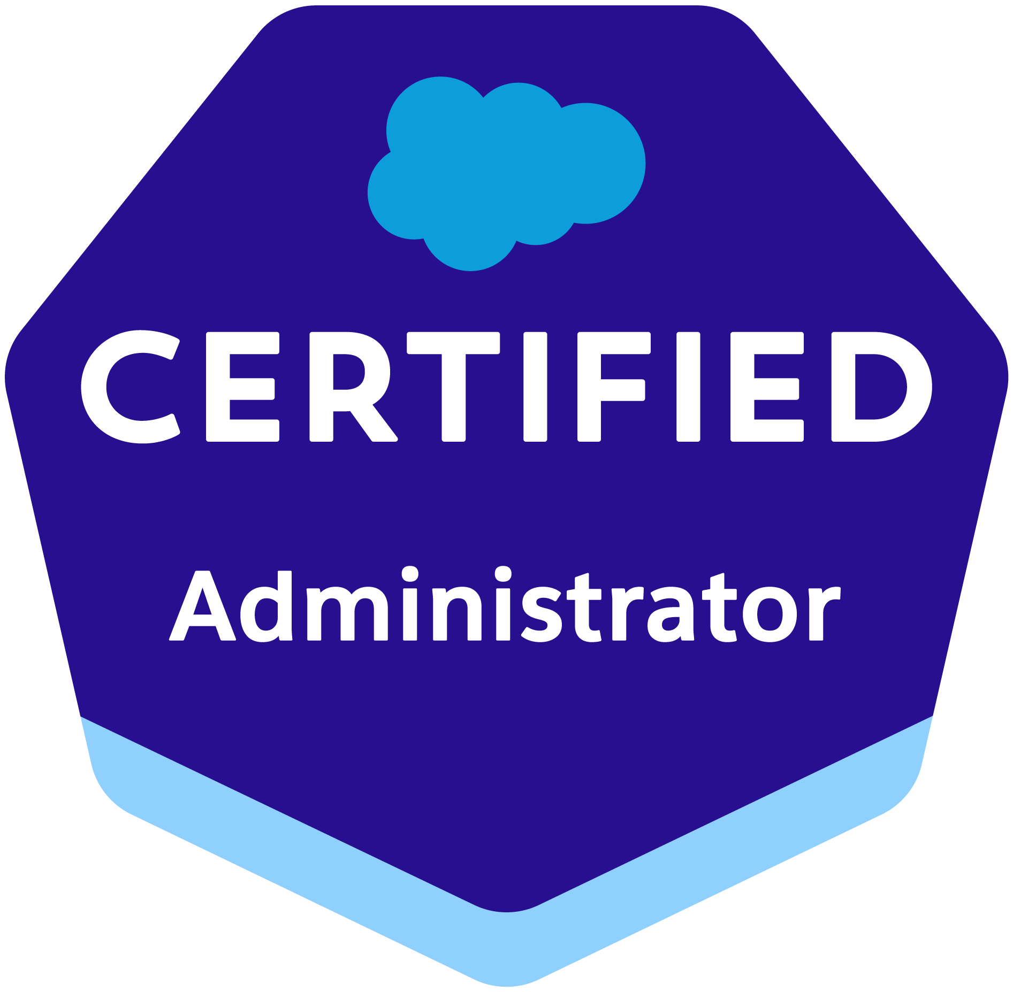
Email: kartheeksfdc09@gmail.com
Ph :+91 6303960135

Summary:

- 4.8 years of experience in IT with expertise handling the project across several SDLC phases (Analysis, Design, Development, Testing, Implementation, Maintenance).
- Hands on experience in Salesforce Components Integration, Development and Deployment of Custom Integration Solutions.
- Experience in implementing Sales Cloud and Service Cloud.
- Extensive Business Knowledge and Objects Customization experience objects such as Accounts, Contacts, Opportunities, Cases, Leads, and Campaigns.
- Proficiency in SFDC Administrative tasks such as Creation of Profiles, Roles, Users, Page Layouts, Email Services, Approvals, Workflows, Validation rules, Tasks and Actions.
- Experienced in developing custom Lightning components, Global actions, Process Builders, Object specific actions to meet business requirements.
- Developed SFDC Customized Reports, Dashboards and Processes to continuously monitor Data Quality and Integrity.
- Ability to meet deadlines and handle pressure by owning multiple tasks in the project.
- Experience in developing Apex classes and Triggers, Visual Force pages, Force.com IDE, SOQL, SOSL.
- Strong knowledge on Agile, Waterfall Project Execution Methodologies.
- Expertise in database querying with SOQL and SOSL using Force.com Explorer.
- Experience in Data Migration using Import Wizard and other integration tools such as Apex Data Loader.
- Detailed experience working on Eclipse IDE with Force.com Plug-in for writing Business Logic in Apex Experience in Web Technologies like HTML, JavaScript, REST and Bulk API's.
- Excellent Communication and Interpersonal Skills.
- Strong Technical, Analytical, Verbal and Written Communication Skills.

Technical Skills:

Salesforce.com: Apex, Visualforce, Lightning Application, SOQL, SOSL, Apex Triggers, Apex Classes, Apex Controllers, Workflows and Approvals, Email Templates, Formulas, Validation Rules, AppExchange, Eclipse, Salesforce.com, Force.com IDE, Apex Data Loader.
Programming Languages: Java, Apex
IDE: Eclipse, Apex Data Loader.
Operating Systems: Windows Family.

Education:

PG Diploma in CDAC, Embedded systems design/Chennai

B.Tech.(Electronics& Communication Engineering) in first class from JNTU Anantapur.

Certifications:

Salesforce Certified Administration.
Experience:
Working as Salesforce Developer at PeakSense Technologies Pvt Ltd, Bengaluru. Since May 2018.
Projects:

Project Name: Fuels US Retail Deal Management
Client: Shell USA
Role: Salesforce Developer

Responsibilities:
• Understanding business requirements, creating requirement document, Data Model.
• Design and Approval from Architect and Business
• Effort estimation & Development.
• Development using Visualforce, Apex class, Email template, Profiles, Reports, Approval Process, Triggers.
• Developing attributes and events for the controls with the help of Aura Framework
• Managed users, hierarchical roles, profiles, security controls
• Configuration of profile-based Authorization on Object/Fields/Pages/Controllers
• Unit Testing and Defect Fixing.
• Deployment for QA Testing Sandbox and making it ready for Production.

Environment: Salesforce.com, Force.com, Apex Classes, Triggers, Visual Force, Data Migration, Portal-Based Communities, HTML, Java Script, Web Services, REST API, Workflow& Approvals, Reports, Custom Objects.

Client : Seven Corners Inc, Carmel, IN
Role :Salesforce Developer

Responsibilities:
- Created a Lightning Component that aligns with Lightning SLDS standards and platform branding guidelines.
- Worked with Lightning design system, Lightning App builder, Lightning component Framework, Lightning customizations, Lightning CSS framework.
- Built customized Lightning components replacing the existing ones, using JavaScript on the client side and Apex on the other side to provide better and more interactive interfaces to the end users, which helps in sales enhancements.
- Working in the following: Salesforce.com areas, Sales Cloud, Service Cloud, Salesforce Integration and Data.com.
- Building custom data integrations between Salesforce and other applications.
- Use Apex, Visualforce, Lightning component frameworks, triggers, batch apex and Salesforce APIs and schedule the apex classes to send email alerts on daily/weekly basis.
- Salesforce point and click configuration using workflows, validation rules, sales process setup.
- Using salesforce Lightning UI. Created Lightning apps combining Lightning design system, Lightning App Builder and Lightning component features.
- Written SOQL, SOSL queries in Apex triggers and controllers, used salesforce workbench to generate queries.
- Designed and deployed Custom tabs, Custom objects, Components, VF pages, validation rules, Auto-response rules for automating business logic.
- Created custom Visual Force page as well as few extensions to standard page, Apex classes in accordance with the requirements that the standard page would not suffice.
- Created Profiles and configured Permissions based on organizational hierarchy requirements.
- Worked on writing the workflow rules and validation rules for email templates.

Environment: Saleforce.com Platform, Lightning Component, Apex Language, Classes, Triggers, Visualforce (Pages and Components), Custom Component, Custom Controllers, Workflow and Approvals, Custom Objects, Custom Tabs, Page Layouts, Email Services, Communities, Scheduled Apex jobs, Web Services, Reports, Dashboards, Sandbox.

