VAMSHI KRISHNA MANIKYARAO

Professional Summary: Mobile# 7995215454

Email: vamshi_k72@yahoo.com

* Having 13 years of IT industry experience encompassing a wide range of skillset, roles, industry verticals and CRM.
* Managing the day-to-day operational aspects of the Project and managing the Siebel offshore team for deliverables.
* Experience in Siebel Development and Maintenance Support of Siebel Applications.
* Develop and Support RPA solutions to improve customer experience in terms of quality of service. Focus on Service Delivery and Improvement activities such as ongoing responsibility for all aspects of in-scope L2 (RCA/Research), and L3 (Code fix/testing) support for all the business-related applications
* Constantly monitor and report on progress of the project to all stake holders.
* Facilitated issue resolution. Prepare and present timely status report to internal senior management.
* Adhere to QA and PMO Process. Extensive technical & Project Management experience in Siebel CRM implementations and support.
* Define & Facilitate project tasks, goals, tracking project deliverable and provide direction and support to Project team.
* Diligent and goal-oriented professional with around 11 years of experience in Siebel CRM applications and over 2 years of experience in Salesforce Administration and development.
* Extensive experience with analysis, design, development, customizations, and integrations of CRM applications.
* Proficient in analyzing, deploying, and supporting Siebel CRM and Possess excellent communication, problem-solving and interpersonal skills.
* Familiar with all phases of CRM implementation life cycle such as requirements gathering, GAP analysis.
* One and half year’s work experience at onshore and possessing B1/B2 visa.
* Certified Salesforce Consultant in Admin and Platform Developer 1.

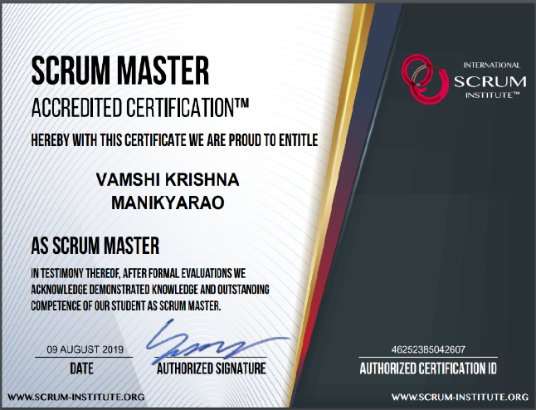

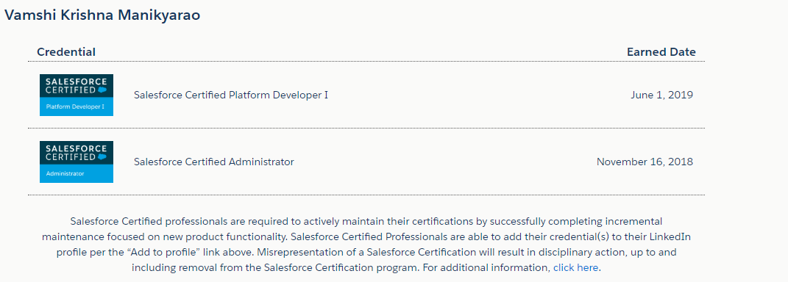

**PROJECT PROFILE:**

**NTT DATA Global Delivery Services Ltd., Hyderabad December 2014 – Present**

**ERP Senior Specialist**

Blue Cross and Blue Shield of North Carolina (BCBSNC) is a fully taxed, not-for-profit company that has served its customers since 1933 by offering health insurance at a competitive price. BCBSNC is the largest health insurer in the state with more than 4,800 employees and more than 3.9 million members, including approximately one million served on behalf of other Blue Plans. BCBSNC offers the largest provider network of any health insurer in North Carolina. Blue Cross and Blue Shield of North Carolina is an independent licensee of the Blue Cross and Blue Shield Association.

**Responsibilities:**

* Collaborating with client, third party and internal teams to complete the tasks and meeting common milestones.
* Responsible for offshore Siebel Project delivery and assigning tasks to the team members and release management.
* Interacting with the business users and propose the solutions on the existing problems.
* Providing estimation and high-level design documents for new projects and holding discussions and meeting within flight Project teams, discussing issues and concerns and coming up with solutions; Mentor the team to help them understand the business and functional aspects.
* Monitoring and identifying the root cause and rerunning scheduled EIM jobs in case the job fails.
* Prepared technical document to track the issues/solutions.
* Resolving User issues by verifying/updating user’s profile and modifying/creating workflows as per the new functionalities. Debugging workflows and verifying EAI, EIM logs to resolve integration issues.
* Get involved in all the major changes that have been made to the Siebel Product as part of the Upgrade to Innovation Pack 2015.
* Leading a team to work on production support issues and working closely with the business for the same. Works to remove all impediments and obstructions to the team’s progress
* Giving on call support during EST hours and resolving the issues and coordinating with other 9 Interface teams.
* Involved in the initial load/run (Batch Jobs) during QA env setup, break/fix fallouts identified by QMO team.
* Participated and provided guidance during planning meetings for Data Center Migration (DCM), Pstage DB Refresh sub projects and documented list of batch jobs to be addressed for all in scope applications during Data Center Migration (DCM).
* Analyzing Postproduction bugs/defects in Quality Center and Suggesting workarounds and implementing permanent code fixes for the same.
* Analyzing and fixing any break in existing functionality/ code and fine tuning it to regain the expected behavior.
* Liaising with the Oracle expert services, middle ware, data base administrators’ teams on various critical showstopper issues resulting in crunch down times of the production environment.
* Configure and test salesforce functionality: Creating Pages, tabs, views, filters, validation rules, workflows, process builder, profiles, role, security permissions, and other configure related activities.
* Salesforce development experience including good knowledge to code APEX (Classes, triggers).
* Good exposure on Data migration using Data loader.

**Environment:** Siebel Finance & Call center 8.1.1.8, Siebel Finance & Call center 15.6.0.0 SIA, **Oracle - 11g, Salesforce CRM**

**Birla Soft India Ltd., Hyderabad November 2011 – October 2014**

**Senior Software Engineer**

GE Healthcare offers financial and administrative, clinical, and service IT solutions that serve a broad range of organizations from small physician practices to large hospital systems.

GAMS Siebel PST is part of the GE Health care and it is a support project managing 5 instances such as Siebel International, Siebel Americas, HCIT, LS and UCM. Siebel INTL (CRM) is a strategic application used for the customer service delivery, marketing, and sales processes for released products. This system is an international system used across all P&L's. Quality records/data types maintained on the system include installation, install base, preventive maintenance, service history, measurements, and readings, contact information/facility. Users of the system include technical support, field engineers, call center, depot repair, contracts, data people, contract sales, sales reps, service manager, marketing, and finance.

**Responsibilities:**

* Involved in analysis, effort estimation, implementation, testing of code and configuration related Enhancements within the Siebel applications
* Implemented solutions using agile methodology.
* Analyzing Postproduction bugs/defects in Quality Center, suggesting workarounds and implementing permanent code fixes for the same
* Leading and participating in meetings and conference calls to co-ordinate testers and users in User Acceptance Testing (UAT)
* Leading a Siebel Production Support team for Service module.
* Involved in priority-based ticket analysis and overall region performance analysis
* Leading status review meetings and working on post release issues
* Understanding and documenting overlaps of processes between different project teams.
* Meeting with the Business and key users to understand existing processes, new process requirements and performance needs

**Environment: Siebel Life Sciences – 8.0.0.10 and Oracle - 10g, Agile**

**Tata Consultancy Services, Hyderabad February 2011 – April 2011**

**IT Analyst**

The Saudi Telecommunication Group provides integrated mobile, fixed and broadband communications services to over 160 million customers globally. The company is headquartered in Riyadh, Saudi Arabia. Saudi Telecom Company (STC) is the largest telecommunications company by market capitalization, total revenue and number of employees in the Arab State region. In the last few years, STC has gone beyond its local borders to the international markets, forming a network of businesses and investments in a number of GCC countries, Asia and Africa. The company is now present in Kuwait, India, Malaysia, Turkey, South Africa and Bahrain which has enabled STC to serve a larger number of customers internationally.

**Responsibilities:**

* Created and modified workflow processes for enhancements
* Involved in Admin related work (Creating Responsibilities, Positions and LOVs)
* Analyzed logs and checked the server components
* Understood Project Requirements and Writing and Reviewing LLDs
* Performed Troubleshooting (Debugging, Root Cause Analysis) of day-to-day production issues

**C3i Inc, Hyderabad October 2009 – February 2011**

**Siebel Configurator**

C3i is the leading provider of technology services for the life sciences industry. It has spread over three continents and delivers consistent, world-class solutions for over 300,000 life sciences professionals in 140 countries. C3i has grown into the leading provider of technology support services for the life sciences industry. C3i has a globally integrated management and operations team, led by an executive team hand-picked for their experience in commercial and clinical operations, information technology, finance and call center operations. Today, C3i serves over half of the world's largest pharmaceutical companies from global operations centers on three continents by implementing Siebel Call Center and Field Services for Customer Support and Ware House Management by name Horizon in order to support effective execution of Call Center, WMS and increase the user satisfaction by introducing improved functionality in Siebel 7.8 and 8.1 version.  
**Project Description**: C3i Horizon has different modules like Sites, Studies, Service Request, Orders, etc. Horizon is playing a vital role in increasing C3I Support Services worldwide.

**Responsibilities:**

* Created and modified workflow processes for enhancements
* Migrated the srf from one environment to other without bouncing the services
* Involved in Admin related work (Creating Responsibilities, Positions and LOVs)
* Analyzed logs and checked the server components
* Worked on Server Management side and business to make sure enhancements cover all possible business scenarios
* Understood Project Requirements and Writing and Reviewing LLDs
* Performed Troubleshooting (Debugging, Root Cause Analysis) of day-to-day production issues
* Used Siebel Tools to customize and configured the user interface according to client specifications
* Worked on Siebel Configuration, Scripting, Workflows and Siebel Admin related issues

**Environment:** Siebel Field Service 7.8.2 and Oracle 10g

**Capgemini Ltd., Mumbai November 2008 – May 2009**

**Consultant**

**Farmers Companies are the third-largest insurer of homes and automobiles in the United States. It is a strong position to be in and it enables them to provide the widest available range of insurance products and services for well everyone.**

**Responsibilities:**

* Understood Project Requirements.
* Wrote and reviewed LLDs.
* Implemented Applet, BC User properties and Haley Authority Rules to replace the scripts at Applet level and BC level.
* **Designed and developed new pick list components, MVG lists, Drilldowns, links, joins.**
* **Defined several other object definitions and linked to each of the objects defined in user interface layer.**

**Environment:** Siebel – 8.0 and Oracle 10g

**Other Work Experience**

**T.I.M.E. Pvt. Ltd.,** **Hyderabad** **June 2005 - Feb 2007**  
**Role: Associate Software Engineer**

Triumphant Institute of Management Education Pvt. Ltd. (T.I.M.E.) is India's leading test-prep institute with a pan-India presence and is headquartered in Hyderabad. Established in 1992, T.I.M.E. today operates out of 238 offices located in 119 towns and cities across the country. Over 40 IIT/IIM graduates form part of the core team at T.I.M.E.

**Responsibilities:**

* Creating eLearning modules for them after extensive study of existing portals and content.
* Designing content for teaching modules and maintaining the Organizational Portal.
* Doing SWOT analysis of competitors and their products

**Education**

Institution: Osmania University

Result/Degree: Bachelor of Computer Applications