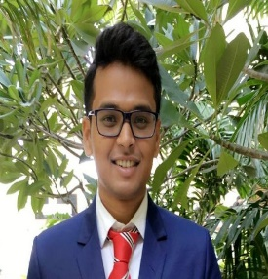

NAME- Dibyang Mangaraj

Contact No- 8374102614

Email – [dibyangmangaraj1997@gmail.com](mailto:dibyangmangaraj1997@gmail.com)

LinkedIn -<http://www.linkedin.com/in/dibyang-mangaraj-a25605171>

|  |  |  |  |
| --- | --- | --- | --- |
| *Career Objective: : To work in the finance field, learn new skills and translate my potential into performance in financial analysis & strategic implementation.* | | |  |
| QUALIFICATION | UNIVERSITY / BOARD | YEAR | % |
| PGDM | Institute of Public Enterprise | 2020 | 66 |
| Graduation | Kadi Sarva Vishwavidyalaya, Gandhinagar | 2018 | 73.5 |
| Intermediate | Hillwoods School, Gandhinagar | 2015 | 66.8 |
| X standard | Hillwoods School, Gandhinagar | 2013 | 79.8 |
| INTERNSHIP (Finance) | | | |
| TITLE: Vendor Performance Evaluation  COMPANY: ITC PSPD  PERIOD: May 2019-June 2019  DESCRIPTION: The project primarily focuses on performance of vendors supplying raw materials to ITC Paperboards & Specialty Paper Division. In the project, I performed ratio analysis, calculated weighted cost of capital (WACC) through CAPM model and peer comparison of the vendors. | | | |
| PROJECTS | | | |
| TITLE: Employee Engagement: Relevance and scope across organizations  COMPANY: ITC Limited  PERIOD: May 2017  DESCRIPTION: The project primarily focuses on types of employee engagement being practiced in select organization and provided suggestions on improving employee engagement at the workplace. | | | |
| EXTRA CURRICULAR /ACHIEVEMENTS | | | |
| * Won Khel Mahakumbh football 2016 in Gandhinagar district. * Runner-up in Business Standard Quiz inter college at Gandhinagar 2016. * Volunteered for the Tarang the Marketing Event at Sanskriti ,2020. | | | |
| SKILLS /CERTIFICATIONS | | | |
| * Equity Research and Financial Modelling * Trading Basics * Microsoft Excel and VBA. * Functional Principles of Oracle EBS (on Premise) and Oracle Cloud ERP(Saas) | | | |
| Languages Known: English, Hindi, Oriya | | | |
|  | | | |