Vijay P. Shinde

**Scrum Master**

Certified Scrum Master with 4 years of experience in improving processes and complex product deliveries. Total 12 years of experience in IT industry including Scrum Master and Software Testing. Ability to understand and focusing on removing impediments from teams and delivering customer-centric products and features.

Facilitating scrum ceremonies and help teams adopt Agile methodology.

**+91- 9822 900 987**

[**vijay4shinde@gmail.com**](mailto:vijay4shinde@gmail.com)

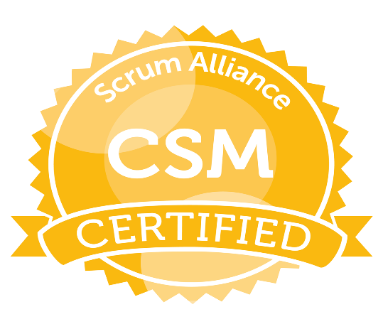

### EXPERIENCE

**E-bill Product Development (Mobile wallet)**

# Scrum Master

## April 2017 - Present

## Purpose is to deliver eBill to consumer by replacing paper bills in the form of Apple pass android card. Project comprises of Restful APIs which are integrated in Apple device, Apple Pay/Wallet (i.e. native app). Consumer can download pass through email that contains Account and DocSummary details. Periodically consumer will receive new bill and bill due notifications. Consume can manage accounts and can view bill.

* Co-ordinate & facilitate all scrum ceremonies including sprint planning, daily scrum, sprint review & sprint retrospective
* Responsible for ensuring Scrum is understood and the team adheres to Scrum values and principles
* Support Product Owner in Product Backlog prioritization, refinement and ensure Product Backlog items are clear and concise.
* Help team in removing impediments to achieve sprint goals
* Problem solving and conflict resolution ability
* Coaches the Scrum team to be self-organized
* Monitoring and measuring team's performance towards project goal

**Walk-In (Hosted Solutions and API Link)**

# QA Analyst

## 2012 – 2017

## CheckfreePay is Americas leading Walk-in Payment System. CheckfreePay offers products which cover whole billing workflow. Fiserv offers a cost-effective, no-hassle way to provide consumers the convenience and security of walk-in payments through CheckfreePay™ Walk-In Bill Payment Solutions.

## Hosted Solution is a web-based application. Agent can make a payment through hosted solutions and for successful transaction it will present receipts which is based on data returned in the response to a successful processed through the CFP Link API.

* Involved in requirement analysis, Functional testing, Regression testing, Database testing.
* Data integrity & Business rule conformance, Web service testing and API testing, Web application.
* Test Data generation & execution, Client Interaction and Production demonstration, Review and Audits.
* To take responsibility for reporting and monitoring, risk management, quality assurance and change management, Audits and Reviews.

### SKILLS

Agile Framework-Scrum,

Requirement Analysis,

Quality Assurance,

Process Improvement,

TFS, VSTS, PCF, SVN, SOAP UI, Postman, SQL, IBM Watson,

Software Development Life Cycle (SDLC).

### CERTIFICATIONS

**CSM** - Certified Scrum Master.

Diploma in S/w Testing.

### EDUCATION

**Pune University**

## Masters of Computer Sci.2007

## Bachelor of Computer Sci.2005

### WORK EXPERIENCE

## **Fiserv India Private Limited**

## (2012 -Present) as **SENIOR SPECIALIST**

## **Capgemini Private Limited** (2010 -2012) as **Associate Consultant**

## **Estel Conversion Lab**

## **(2008 -2010) as Consultant**

**SWH-OHCB-Bulk Input (Core Banking)**

# Associate Consultant

## 2010 – 2012

## Bulk Input is one of OHCB core components. Bulk Input component provides functionalities related to processing of Bulk Value and non-value Transaction coming from different sources and guiding to various destinations. Bulk input is one of the system utility components that provides services for the receipt and processing of transaction files.

* Involved in requirement analysis, Functional testing, Regression testing, Database testing and Mainframe Testing.
* Defect Management process
* Involved in responsibility for reporting and monitoring, quality assurance and Audits and Reviews.