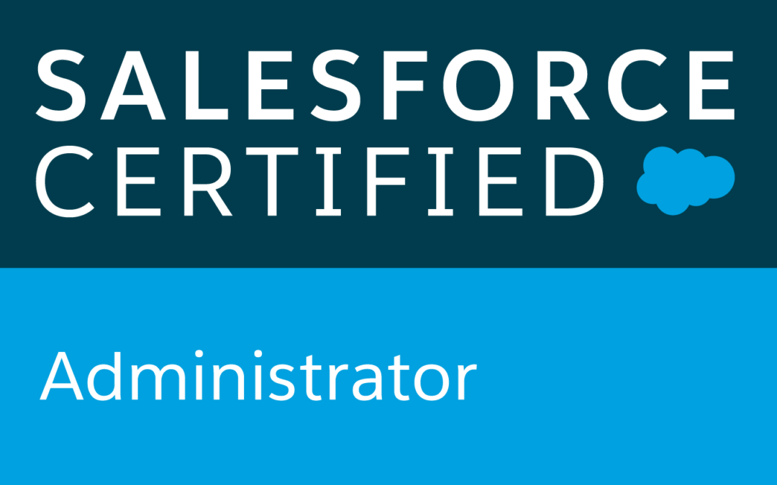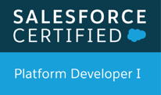
Himasri G
Email: himasrig9@gmail.com
Phone: +1 956-435-8009
https://www.linkedin.com/in/himasri-g-b42197133/

SUMMARY:

- Having 9 years of professional Software Development Experience with strong Object-Oriented Analysis, Designing and Programming skills with extensive experience including 5+ years in Salesforce.com CRM and Force.com platform with proficiency as a Developer and Administrator. 4 Years of experience in Java/J2EE Technologies.
- Experience in Administration, Configuration, Implementation, Lightning, and support experience with Salesforce platform.
- Customized existing Visualforce to align with Salesforce new Lightning UI experience.
- Created multiple Lightning Components, added CSS and Design Parameters that makes the Lightning component look and feel better.
- Used Salesforce Lightning Design System (SLDS) for developing Lightning Components, Actions, Event and Server-Side Controller.
- Creating Lightning Components and used Salesforce SLDS to convert existing Visualforce pages to lightning components.
- Created Apex methods for the lightning controller and helper methods to perform DML operations on the case records.
- Integrated CPQ system with multiple CRMs like Salesforce and CRM On Demand.
- Supported and improved sales cycles by implementing CPQ solutions effectively.
- Involved in end to end QA and UAT testing and validation of CPQ including Products, Pricing, Quoting etc.
- Customization of Apttus product by using Salesforce features like triggers, VF pages.
- Design, develop and implement solutions for the Apttus CPQ system deployed on the Salesforce platform.
- Developed Quote documents using X-Author for word, also developed customized login screen for community user and functionality to redirect user from Salesforce to Apttus CPQ Quote creation using APTTUS API's, apex, VF pages and trigger.
- Used refined global search in Lightning by developing Apex classes and Controllers.
- Hands on experience in developing and customizing Salesforce.com applications using Apex classes, Apex Triggers, Visualforce, Page Layouts, Sharing Rules, S-Controls and migration tools.
- Strong experience in SFDC development using Apex classes, Triggers, Components, Reports, Force.com IDE, Eclipse with SOQL and Force.com plug-in.
- Proficient in salesforce administrative and development related tasks creating Users, Roles, Profiles, Visualforce pages, Validation Rules, Custom Reports, Workflows, Email Alerts, Reports and Dashboards, Page Layouts and Business Processes.
- Good experience in Salesforce.com Development by developing the presentation layer in Visualforce and business login in the Apex Programming by creating/ using the Classes, Triggers, Standard Controllers, Custom Controllers, Controller Extensions, S-Controls and Web Services API.
- Experience in implementing Security/Sharing rules, Configured permission sets, Field level Security, Record level Security and resource monitoring.
- Good understanding of Software Development Life Cycle (SDLC) and Agile with expertise in Requirement gathering, Analysis, Designing, Development and Testing.
- Used SOQL & SOSL with consideration to Governor Limits to get the customer information from different accounts.
- Experience in deployments of Apex and Visualforce pages across DEV, Test/QA and Production instances.
- Experience in integration of Salesforce.com applications with other applications with an emphasis of the Web Services/XML and other integration tools.
- In-depth knowledge of CRM processes like Sales, Marketing, Customer Service and Customer Support, Business processes, Customer Portal, Partner Portal which were used improve the business processes using Salesforce.com.
- Effective employment of Apex Data Loader, Import Wizard and Data Manipulation Language for data migration and management in bulk.
- Development of Salesforce using Eclipse IDE with Force.com Plug-in, Data Loader, Force.com Explorer, Metadata, SOAP and Web Services API.
- Good programming skills in frameworks like Java, JavaScript, SQL, CSS and HTML.
- Excellent technical skills along with the ability to communicate effectively and confidently with users, and team- members.
- Strong ability to prioritize tasks effectively and good at meeting deadlines.

TECHNICAL SKILLS:

Salesforce API Technologies | Eclipse, Apex Explorer, Offline Edition, App Exchange Data Loader
SFDC | Apex classes, Apex Triggers, Test Classes, Apex Custom Controllers and Extension, Visualforce (Pages, Components &Controllers), Validation Rules, Dashboards, Reports, Workflows, Custom Objects, Apex Web Services, Force.com IDE Plug-in, Sandbox development and testing, Apex Data Loader, Connect Offline, S-controls, SOQL, SOSL, Ajax Toolkit.
Salesforce Tools | App Exchange Data Loader, Data Loader, REST, SOAP API
Web Development | XML, HTML, CSS, JSP, JavaScript, JSON, Python
Languages | Java, C, C++, SQL
GUI and Tools | Eclipse, Visual Studio, Force.com IDE, Apex Data Loader
Platforms | Windows/XP/Vista/7, UNIX

EDUCATION:
- Bachelor of Technology in EEE from JNTUH, INDIA – 2012.

CERTIFICATIONS:
- Certified Salesforce Platform Developer-1
- Certified Salesforce Administrator
- Certified Salesforce Platform App Builder
- Certified Salesforce Community Cloud Consultant

WORK EXPERIENCE:

Client: Spencers, Egg Harbor township, New Jersey Jan 2020 – Present
Role: Salesforce Lightning Developer

Responsibilities:
- Designed, developed and deployed Apex Classes, Controller Classes and Apex Triggers, packages for various functional needs in the application.
- Designed, developed and deployed Apex Classes Extension Classes to support Visualforce pages development, Test Classes for Unit testing and Apex Triggers for various functional needs in the application.
- I configured product and pricing setup using CPQ/Product consoles which include price ramps, Price Matrix, Price Rulesets, price list items, tiered pricing and asset pricing.
- Responsible for Apttus CPQ/CLM packages installations and data settings in Dev sandbox.
- Involved in CPQ (Configure, Price& Quote) design and mapped to the Salesforce custom objects and involved in Apttus Advanced Workflow Approvals.
- Experienced in leveraging Sales Cloud functionality including Account Planning, Sales Forecasting, Opportunity Management and Lead Management.
- Worked on the integration of SteelBrick to generate quotes, invoicing and discounting by sales reps along with CRM data.
- Created CPQ process using Apptus CPQ and CL AppExchange tool in Quote.
- Integrated Apptus CPQ and CLM applications and automating processes on Salesforce platform.
- Worked extensively in customization of Service Cloud Console by embedding Visualforce pages in custom console components, highlight panel and interaction log.
- Managed the implementation of single sign on for Salesforce and simplifying the login process and significantly improving user management.
- Experience in Salesforce.com data structures like Data Entry and usability, Reporting, Data Migration and App Integration.
- Involved in Setting up or create Admin options, User Interface, organization-wide defaults, role hierarchy, workflows and workflow rules.
- Experienced in working on a Lightning Component to create a My Licenses page where the customer can directly select their particular account and generate licenses without involving Customer Support.
- Proficient in Sales cloud implementation, Service cloud modules, Salesforce lightning and Chatter.
- Knowledge on new release of lightning components and Lightning App Builder.
- Experience in Importing leads and contacts, modifying price lists, particularly if there are a lot of promotions and limited-time offers and changing delegation and escalation paths to account for absences or extended travel.
- Developed Visualforce Pages, Visualforce Custom Controllers Components, Advanced Search Functionality, Custom Objects, Analytic Snapshots, Tabs, Tags and Components.
- Assist with project implementation and control monitoring process related to quality assurance (QA) and user assisted testing (UAT).
- Implemented Marketing Sales, Customer Service, Call Center & Support Administration with Service Cloud.
- Experienced in Salesforce Marketing Cloud in taking control of our marketing messages.
- Involved in coding for modules for all the Sub-Application of the CRM application which involves extending existing SFDC standard components using Apex, VisualForce and other utilities.
- Worked on various salesforce.com standard objects like Campaigns, Leads, Accounts, Contacts, Opportunity, Forecast, Cases, Reports and Dashboards.
- Designed, and developed the Custom objects, Validation rules, Page layouts, Custom tabs, Components, Visualforce Pages that suit to the needs of the application.
- Worked with AppExchange to use managed packaged apps for improving application features.
- Increase functionality by installing AppExchange apps to enable Customer Service Surveys.
- Integrated SFDC with Oracle Apps via fusion Middleware using SOAP based Integration on both Standard and Custom Objects.
- Performed detailed analysis of business and technical requirements and developed the Apex classes using other Platform based technologies like Visualforce, Force.com IDE.
- On the basis of the organizational needs, developed and configured various Reports for different user profiles.
- Maintained data cleanliness and accuracy by adding custom validation rules, custom formulas, reports and dashboards.

Environment: Salesforce.com platform, SAML 2.0, Service cloud, Quotes, Service Cloud, Marketing Cloud, Role Hierarchies, Sharing Rules, Email Templates, Oracle, Reports, Dashboards, Custom Objects, Custom Tabs, Email Service, Security Controls
Client: BNY Mellon, New Jersey Dec 2018 – Dec 2019
Role: Salesforce Developer

Responsibilities:
- Development, implementation and update focusing on Sales cloud and Service cloud.
- Implementation of Apex Triggers, Apex Class for automation of the business process on Account, Contact, Opportunity and Custom Objects.
- Performed the role of Salesforce developer, lightning developer and interacted with various business user groups for gathering the requirements for salesforce.com, Lightning and CRM implementation.
- Implementation of Batch Classes, Scheduled Classes as part of the Business Requirement.
- Wrote an Apex Trigger on Contact for cross-object field update for reporting purposes.
- Enhanced Apex Class and Visual Force Page to create a custom Related List, showing activities for selected contacts or clients.
- Integrated Salesforce.com with external systems like Oracle and SAP using SOAP API and REST API.
- Enhanced in Communities by adding new fields, field sets using Salesforce Lightning.
- Gained basic knowledge on Lightning App Builder to develop apps visually, without code using Custom-Built Lightning Components.
- Implemented Apttus CPQ to create quote, quote line items after submitting quote creating Sales orders.
- Implemented custom functionality on Apttus CPQ like uploading charges, charge line items, Offers and offer line items.
- Visual Force Pages using Standard Controllers, Custom Controllers, Extension Controllers &amp; Web Services API. Creating new User Interface using JavaScript, HTML and CSS in Visual Force Pages.
- Created Page Layouts to organize Fields, Custom Links, Related Lists &amp; other Components on Record Pages.
- As an Administrator implemented various advanced fields like Picklist Fields, Master-Detail Fields, Custom Formula Fields and defined Field Dependencies for Custom Picklist Fields.
- Expertise in using Eclipse IDE, Force.com and site.com, communities. Implementation of Salesforce.com Sales Cloud and Marketing Cloud.
- Customized Marketing Cloud Objects and Scheduled and managed marketing email sends with Salesforce Marketing Cloud.
- Implemented the Web-to-Lead functionality for the Marketing Campaign.
- Executed workbench and data loader to verify Product/Pricing staging data in SFDC/CPQ.
- Implemented Web service using Visualforce framework to promote the quotes from external systems to CPQ.
- Design solutions using the CPQ Cloud’s standard APIs to integrate with CRM, ERP or any backend system.
- Worked on Sales and Service Cloud communities sharing business process extend them across offices and departments, and outward to customers and partners.
- Used the Sandbox for testing and migrated the code to the deployment instances after testing using change sets.
- Worked on Agile/Scrum Methodology using Version One and SDLC.
- API Integration through middleware like Informatica, Tibco.
- Case Assignment Rules to direct the case to appropriate group such as Stories &amp; PCS Central Support.
- Managed ongoing support requests and Administrative needs of users. Administered, Configured and maintained Salesforce.com application User Profiles, Roles, Assigning Permissions, Generating Security Tokens, Validation Rule and Upgrade Installation.
- Developed lightning components framework and some tools for developer’s males it easier to build responsive applications for the force.com platform.
- Developed Lightning App Builder can help you build responsive apps that display on any device, as well as custom pages for Lightning Experience.
- Performed administrative tasks such as managing Accounts, Contacts and Cases, setting Workflows and Approval Process for approving new accounts and another business process.
- Created and maintained Reports and Dashboards to provide fast access to key business metrics.
- Case Management by Configuring Email-to-Case for the end user to submit a case through Outlook.
- Created and configured Email templates which were used by PCS Central users for approval processes and other field updates.
- Customized Chatter objects and tabs to view progress and discussion on business process.
- Used SOQL &amp; SOSL for data manipulation needs of the application using platform database objects.
- Worked on different Sandboxes for development &amp; testing; Involved in migrating the code to production instance in installments using Change Set.
- Involved in Test configuration Apttus within Sandbox environments to ensure that once users are granted access, all the aspects are fully functional.
- Configured Chatter to track emails from Outlook to Salesforce by following a user.
- Responsible for weekly and monthly Data Export, updates and backup for the organization.
- Used Apex Data Loader to Insert, Update and Import data from Microsoft Excel into Salesforce.com.
Environment: Saleforce.com platform, Apex Classes, Lightning Aura Components, Visual Force Pages, Data Loader, standard Objects, Page layouts, Reports, Marketing Cloud, Content Builder, Journey Builder, data loading, Eclipse IDE Plug-in, TFS, Agile methodology, ANT Migration Tool, Jira, Rally, Automation Studio, SQL, SOQL, GIT, Bitbucket, Maven, MuleSoft.

Client: Vanguard, Malvern, PA Oct 2017 – Nov 2018
Role: Salesforce Developer

Responsibilities:
- Administered, configured, maintained Salesforce.com application user profiles, roles, assigning Permissions, Validation Rule, upgrade installation.
- Designed, and developed the Custom objects, Page layouts, Custom tabs, Components, Visual force Pages as a Salesforce consultant.
- Created and deployed Several Reports using salesforce.com platform.
- Worked with force.com developer toolkit including visual force pages, apex classes, apex controllers and apex triggers to develop custom business logic.
- Assisted end users to use salesforce.com and also analyzed and evaluated complex business requirements and recommended solutions.
- Developed and deployed workflows and approval processes for opportunities and products/assets management.
- Implemented the requirements on Salesforce.com platform and Force.com IDE Plug-in using Eclipse.
- Imported data from excel sheets in to Leads, Accounts, Contacts and Opportunities using Data Loader and Import Wizard.
- Involved in Data mapping specifications to create and execute detailed system test plans. The data mapping specifies what data will be extracted from an internal data warehouse, transformed and sent to salesforce.com entity.
- Developed workflow rules, tasks, emails and alerts to track customer related tasks and activities.
- Used sandbox as part of testing and data migration.

Environment: Saleforce.com platform, Apex Language, VisualForce Pages, Data Loader, S-Controls, HTML, Java Script, Apex Triggers, Web Services, Reports, Custom Objects, Custom Tabs, Email Services, Security Controls, Sandbox data loading, Eclipse IDE Plug-in.

Client: Patni Computers, Hyderabad, India May 2016 – Sept 2017
Role: Salesforce Developer/ Administrator

Responsibilities:
- Performed various activities as part of the project like gathering information, analyzing the information, and documenting the functional and non- functional requirements. Then after, implemented the requirements on Salesforce.com platform and Force.com IDE Plug-in using Eclipse.
- Worked with various salesforce.com objects like Accounts, Contacts, Leads, Campaigns, Reports, and Dashboards. Additionally, developed various Custom Objects, Tabs, Components and Visual Force Pages.
- Created various users along with the creation of specific roles, profile and appropriate Permission sets for them.
- Created and deployed several Reports using salesforce.com platform along with the development of custom objects.
- Developed Apex Classes, Controller Classes and Apex Triggers for various functional needs in the application along with the test classes for them.
- Responsible for addition of pick list values, modification of page layouts, and also creation of email templates using VisualForce.
- Created and maintained documentation on processes, application configuration, and training material for users and provided ongoing support.
- Used sandbox for testing and then migrated the code to the deployment instance.

Environment: Force.com IDE, Force.com Sandbox, Import Wizard, Apex, Controllers, Custom objects, Reports, Visual Force Pages, Apex Triggers.

Client: Syntel, Pune, India May 2012 to Apr 2016 Role: Java Developer
Responsibilities:
- Involved in various stages of the project life cycle primarily design, implementation, testing, deployment and enhancement of the application.
- Involved in the creation of Use Cases, Class Diagrams and Sequence Diagrams for analysis and design of application.
- Designed and developed web pages using JSP, HTML and used JavaScript for clientside validation. Responsible for testing of application on various levels like integration and System testing by utilizing various methodologies.
- Worked on the development of various web applications based on the client needs.
- Responsible for maintenance and production support of the application documented design and functional aspects of the application.
- Record technology solutions involving user needs documents, user manual design decisions and executive summaries across projects.
- Responsible for proactively monitoring performance, diagnosing problems and tuning queries and databases.
- Developed data model and stored procedures.
- Developed user interface screens, and administrative screens using JSP and JavaScript to perform checking and validation at Client’s side.
- Developed new java code and executed new features through business requirements.
- Extensively used SQL to generate stored procedures and functions to use with Java.

Environment: Java Servlets, JSP, JavaScript, XML, CSS, HTML, Apache Tomcat, JDBC, Oracle 10g, SQL.

