# SHASHIDHAR H.D

Email address: [**shashidhardevraj@gmail.com**](mailto:shashidhardevraj@gmail.com)[Linkedin](https://www.linkedin.com/in/shashidhardevraj/), [Github](https://github.com/ShashidharDevraj), [Hackerank](https://www.hackerrank.com/shashidhardevraj?hr_r=1)

Contact number: **+91 8951645107**

# CREDENTIALS:

* Around 7+ years of diverse experience into Python, Django Framework, automation with Python, VOIP Technology.
* Good knowledge on Python fundamentals and Data structure and Algorithms.
* Used GITHub and GITLab for version controlling.
* Good knowledge on Linux commands.
* Done Python Development works on Vmware.
* Have 4 year of relevant experience into Python Development.
* Have 1 year of relevant experience in Django and Django Rest Framework.
* Done OpenLdap Development works on Python and Django.
* Have knowledge on SQL
* Hands on experience into Automation [ Python].
* Good knowledge on VMware, ESXI and Ubuntu-12 OS based server deployment/installation.
* Done automation work on VMware, command based VMware cloning and migrating VM’s between ESX servers without V-Centre.
* Involved in reading logs and debugging and fixing the code related issues.
* Possess good communication skills, self-motivated, pro-active, task oriented, good team player, and quick learner at new technologies and systems.

# TECHNICAL SKILLS & KNOWLEDGE:

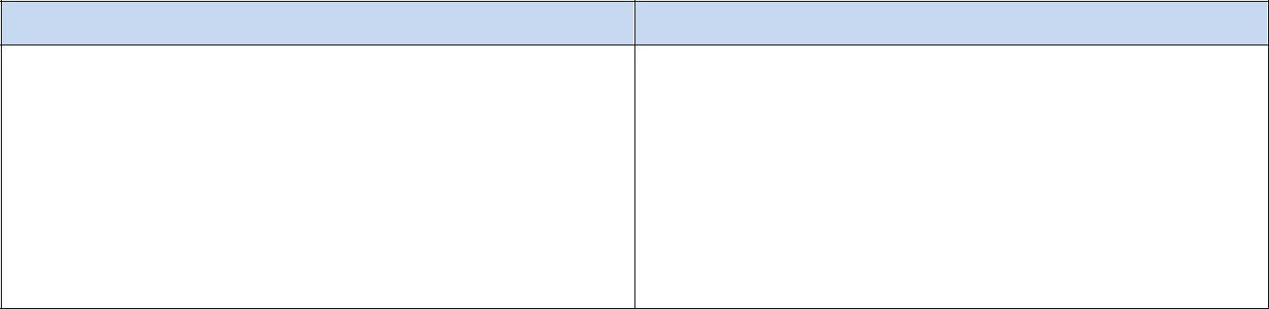

## Tools

**SSH and Telnet Client / Terminal Scripting Language**

**Operating System Protocols**

**Other languages**

Putty / putty Connection Manager. Python, Django, Flask

Windows and Linux(UBUNTU 12) TCP/IP, UDP, OpenLdap

SQL, HTML, CSS, JavaScript

# CERTIFICATIONS/ACHIEVEMENTS:

* + Visit to Rakuten Head office Tamagawa, Tokyo, Japan to support major rollouts.

# PROFESSIONAL EXPERIENCE:

Company Name:

Benison Technologies

## Python Developer (May 2020 to Nov 2020)

**Project Name: PCS**

**Language/Platform: Ruby**

**Team Size: 2**

PCS is a VPN that helps in connecting the users or clients to the internal machines and servers.

## Roles and Responsibilities:

* + Involved in Performance automation framework development using Ruby.
  + Involved in code refactoring using Ruby.

Company Name:

Avaya India Pvt Ltd.

## Python Developer (Feb 2019 to Jan 2020)

**Project Name: Maestro Language/Platform: Python, VMware. Team Size: 6**

Maestro is an Orchestration framework which helps in Orchestration/Automation of Avaya’s products in vCenter. Which helps in deploying a different set of applications on vCenter based on number of Customers.

## Roles and Responsibilities:

* + Done Development work on sending emails only to specific developers if their AFTs fail to run.
  + Developed rest Apis for deploying VMware instance.
  + Developed functionalities to configure the VMs after auto deployment.
  + Automated some basic functionalities of Docker using Python.
  + Have 6 months of experience into Docker.
  + Involved in Requirement Analysis, Code reviews
  + Worked on xml data parsing using xml lib.

Company Name:

Rakuten India Pvt Ltd.

## Python Developer (Oct 2017 to December 2018)

**Project Name: PORTA/FOREST APInization Language/Platform: Python, Aiohttp, MySQL Team Size: 2**

**FOREST –** APInization project convert and consolidate all API’s to a single architecture to write new RESTful API’s for all device configurations like VMware, DNS, SLB, Firewall etc.,

PORTA API and Batches – Sync PORTA DB data from different data sources donkey, Giant panda and WINES API’s, these data will be useful for PORTA API’s to deliver RESTAPI’s in a better way.

## Roles and Responsibilities:

* + Involved in Python Backend Development.
  + Build Asynchronous and non-blocking RESTful APIs for DNS/SLB operations usingPython required for internal infrastructure projects of Rakuten.
  + Involved in Requirement Analysis, identifying product Gap.
  + Involved in development, code reviews, unit testing and deployment on servers.
  + Automated the headless installation of the packages using Ansible playbook.
  + Developed REST Api's and Automated them for the purpose of Testing.
  + Assisted other team members in resolving the programmatically issues
  + Involved in Gathering the requirements.

Company Name:

Mindlogicx

## Python_Django Developer( Dec 2016 to Aug 2017)

**Project Name: IntelliExams (QPDS) Language/Platform: Python, Django, Postgresql Team Size: 10**

Question Paper Delivery System is a part of IntelliExams Project. The main objective of the project is to override the manual process of delivering the Question paper which exist in the current education system with a smart digitalized way of distributing the question papers in a secure way in order to avoid Question paper spam.

## Roles and Responsibilities:

* + Involved in Web development using Python and Django.
  + OpenLDAP automation and Development using Python and Django.
  + Experience in Creating REST api's using Django Rest Framework(DRF).
  + Involved in Gathering and writing the requirements.
  + Involved in designing the Flow charts and creating Activity diagrams for the newfeatures.

Company Name:

Citrix Systems

## Sr. Automation Engineer (Nov 2015 to July 2016)

**Project Name: Netscaler (Gateway Insight) Individual Contributor.**

Netscaler is a hardware device, it makes the apps and cloud based services run five times better offloading app and database servers, accelerating app and service performance and integrating security. Deployed in front of web and database servers, Netscaler combines high speed load balancing, content switching, data compression, and content caching and network optimization.

## Roles and Responsibilities:

* + Involved in UI automation using python and Selenium Web driver.
  + Involved in creating functions and API’s
  + Involved in fixing the bugs.
  + Involved in automation to generate traffic using python to verify the scalability.
  + Automated the shell prompt command lines using python modules.
  + Worked closely with the development and design team to resolve the issues.

Company Name:

Life Size Communications.

# Project 2

## Project Name: Automate VM

**Python Automation (July 2015 – September 2015) Individual Contributor**

* + Involved in VMware automation on how to connect and to fetch the details from the ESXi Server.
  + Linux command based cloning of VM’s
  + Linux command based Moving/Migrating VM’s between 2 ESXi hosts without V-centre.
  + Fetching the IP and MAC address of the individual VM’s using script.

## Automation Engineer (Dec 2012 – September 2015)

**Project 1**

**Project Name: UVC MP/MCU (Multipoint Control Unit) Team Size: 3**

UVC stands for Unified Virtual Collaboration. Here, MP/MCU is an application virtually enabled and runs on top of Ubuntu Platform and it is completely software based. Working is similar to the Bridge (**Bridge:** Hardware which helps in connecting multiple Audio/ Video Endpoints into a single conference). This is a significant shift from hardware limitations and dependencies.

## Roles and Responsibilities:

* + Automated MCU related scripts (Front end).
  + Involved in analysing and debugging the code.
  + Took initiative to work on MCU Lecturer mode.
  + Involved in reading and debugging MCU logs.
  + Created confluence pages and other supportive documentations as part of knowledge sharing.
  + Worked closely with Development team to resolve issues as well handled customer issues.

# Academic Record:

## EDUCATION:

**1. Bachelor of Engineering (BE)** from HKBK College of Engineering, Bangalore.

# Declaration:

I hereby certify that all the above information furnished is true to the best of my knowledge and belief.

Place: Bangalore **(SHASHIDHAR H.D)**