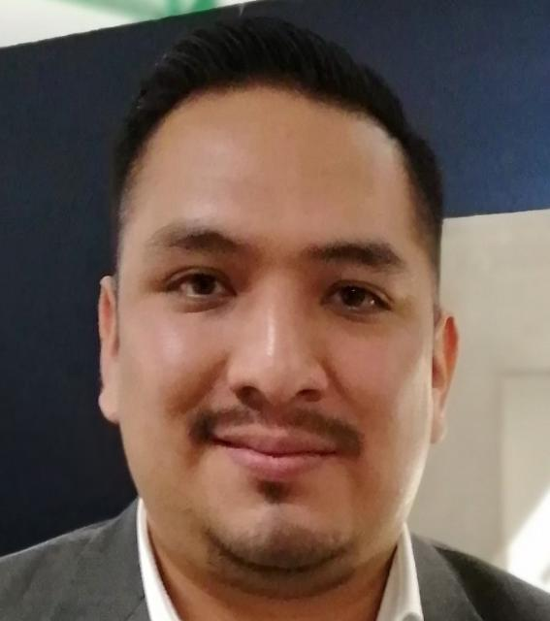

PERSONAL INFORMATION:
Complete Name: Gerardo Alvarez Murcia
Address: Playa Guitarrón 209 Int. 1, Reforma Iztaccíhuatl Norte, Iztacalco, Ciudad de México.
Phone: +521 55-27-69-05-68
Email Address: gerald_1847@hotmail.com

PROFILE:
Gerardo Alvarez Murcia I’m a Senior Consultant at ERP Soluciones. I have more than 8 years of Oracle successful projects implementation. I owe an Oracle CPQ´s certification and I have experience leading complex Oracle CX projects at multiple organizations like Financial Services, Real state, Manufacturing, Transportation and Newspaper company.

TECHNICAL SKILLS:
- BML: 100%.
- BMQL: 100%.
- Native Integrations: Oracle Sales Cloud / Order Management 100%.
- Custom Integrations: SAP / Salesforce / Legacy Systems.
- Web Services: SOAP / REST.
- Pricing: 100%.
- Formulas: 100%.
- Configuration Rules: Constraint, Recommendation, Hiding and Recommended Items. 100%.
- Commerce Rules: Constraint, Hiding and Validation. 100%.
- Document Designer: 100%.
- Email Designer: 100%.
- Migration: 100%.
- Data Tables: 100%.
- Layouts Desktop / Mobile: 100%.
- Approvals: 100%.
- Oracle Incentive Compensation: 80%.
- Oracle Sales Cloud: 80%.
- Oracle Service Cloud (RightNow): 70%.
- CSS: 70%

PROFESIONAL EXPERIENCE:
Company: ERP Soluciones.
Position: Oracle CX Manager / Architect
January 2020 - Present

Activities and Achievements:
- Implementing Oracle CX applications (Oracle CPQ, Oracle Sales Cloud, Oracle Incentive Compensation and Oracle Service Cloud (Rightnow)) with different costumers as an Architect / Developer.
- Coaching team members, modeling and developing functional and technical requirements.
- Admin all Oracle CX projects and reporting to one of the company´s CEO.
- Creating and showing Demos of different Oracle CX solutions.

Company: BDS Consulting
Position: Oracle CX Manager / Architect
June 2017 – January 2020
Activities and Achievements:
- Implementing Oracle CX applications (Oracle CPQ and Oracle Incentive Compensation) with different costumers as an Architect / Project manager / Developer.
- Coaching team members, modeling and developing functional and technical requirements.
- Admin Oracle CPQ and Oracle Incentive compensation projects and reporting to the CEO.
- Creating and showing Oracle CPQ´s Demos and Oracle Incentive Compensation solutions.

Company: AvanSaaS IT Consulting
Position: Oracle CX Manager / Architect
April 2012 – June 2017
Activities and Achievements:
- Implementing Oracle CX applications (Oracle CPQ, Oracle Sales Cloud, Oracle Incentive Compensation and Oracle Service Cloud (Rightnow)) with different costumers as an Architect / Developer.
- Coaching team members, modeling and developing functional and technical requirements.
- Admin all Oracle CX projects and reporting to the CEO’s.
- Creating and showing different Oracle CX Demos and solutions.
- Implementing consultant of Oracle Siebel CRM

EDUCATION:
- Computer Science Degree. Universidad Insurgentes. 2006 – 2009

CERTIFICATIONS AND COURSES:
- Certification. Oracle CPQ Cloud Service 2019 Sales Specialist (January 2021)
- Certification. Oracle CPQ Cloud Service 2019 Solution Engineer Specialist (January 2021).
- Certification. Oracle CX Sales 2020 Solution Engineer Specialist Assessment (January 2021)
- Certification. Oracle Engagement Cloud 2019 Sales Consultant (January 2021)
- Certification: Oracle CPQ Cloud Service 2016 Implementation Essentials (December 2016).
- Diploma: Project management with Microsoft Project (October 2015).
- Course: Yellow Belt Oracle CPQ Cloud (December 2014).
- Course: Blue Belt Oracle CPQ Cloud (December 2014)
- Course: General Product Support Specialist v4.0 (Nov 2014).
- Course: Oracle Fusion Customer Relationship Management 11g PreSales Specialist (February 2014).
- Course: Oracle RightNow CX Cloud Service Support Specialist (December 2013).
- Course: Personal growth and leadership (August 2008)

