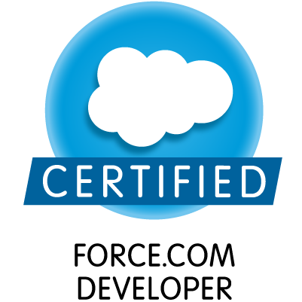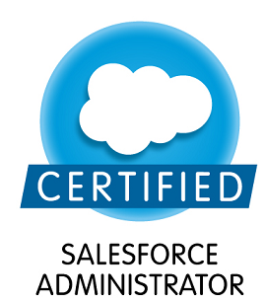

BRAJESH KUMAR

Present Address B.TECH(Computer Science)
Villa #60, Peninsula Solitaire brajeshsalesforce@gmail.com
Sarjapur,Bangalore, India Ph No- +917204179681, +918971999975

CAREER OBJECTIVE

I aspire to work in learning and challenging environment, utilizing my skills and knowledge to be the best of my abilities and contribute positively to my personal growth as well as growth of the organization.

SUMMARY

- 6 years 8 Months Experience as a SFDC Developer

TECHNICAL COMPETENCY

- Hands on experience in Salesforce Lightning
- Good Knowledge on Salesforce(Apex, Visualforce page), Java Script, Html, CSS, Core
- Good knowledge and hands on Integration (REST API)
- Able to Work as Administrator
- Able to Write Apex Classes
- Able to Make and design Visualforce Pages
- Able to write Apex Trigger
- Workflow, Approval process, Data Management
- Web Services.etc.
- Wave analytics(Done Training)
- Worked on Asp.net(C#),VB.net, JAVA

Career Progression

IDS NEXT Pvt Ltd, Bangalore, Software Engineer, (July 2012 - March 2014)
Capgemini India Pvt Ltd, Consultant, (May 3rd 2014 – December 2015)
Tek System Pvt Ltd, Senior Software Engineer, (3rd Jan 2016– 11th March 2018)
DXC Technology, Software Engineer II B, (12th Match- Present)

Achievement & Certification

Platform -1 Certified Developer
ADM 201 Certified Administrator
Veeva Certified Developer

Recognized as Project Star in Capgemini in 2015 received Certificate and Cash amount from VP.

EDUCATIONAL QUALIFICATIONS

- B.Tech (CS) in 2011 from Shri Ram Murti Smarak College of Engg. & Tech., Bareilly ,U.P. with an aggregate of 71%
- Intermediate in 2005 from S.S.B.Inter College, Ballia, U.P. with an aggregate of 73%
- High School in 2003 from S.S.B.Inter College, Ballia,U.P. with an aggregate of 67%

PROJECT DETAILS

Project #1

Project Name: SPT(Sales Process Transformation )
Role: Senior Developer, Team Lead
Technology Used: Lightning, Apex, Visual Force
Tools Used: Force.com platform
Description:

Team worked on redesign Opportunity Management in Lightning Platform which is part of Sales Process Transformation project. Same Module was in classic which is transformed in lightning. This module basically deals the Opportunity in SFDC. We have used Components, Events and Data Services etc.

Responsibilities:

- Worked on Lightning Design for existing classic module.
- Created Technical design documents and FDS for this requirements.
- Developed the SOQL queries and JS files to achieve requirements.
- Developed the business logic for Opportunity Management.

Project #2

Project Name: SPT(Sales Process Transformation)
Role: Developer
Technology Used: Apex, Visual Force
Tools Used: Force.com platform
Description:

Basically we are using standard functionality for salesforce to manage and track the HP hardware products
We are using standard lead process and opportunity management.

Responsibilities:

- Developed the User Interface using Visual force.
- Developed the SOQL queries to handle CRUD operations on Opportunity Management.
- Developed the business logic for Opportunity Management.

Project #3

Project Name: SFDC to SAPPI Integration
Role: Developer
Technology Used: Apex, Visual Force
Tools Used: Force.com platform, SKYVVA
Description:

This project basically we have done integration between Salesforce to SAP. We are transferring object’s record from Salesforce to SAP and vice versa.

Responsibilities:

- Developed Web Services and configured the settings.

Project #4

Project Name: Guest Dynamix.
Role: Developer
Technology Used: Apex, Visual Force.
Tools Used: Force.com platform.
Description:

- Guest Dynamix is a Customer Relationship Management (CRM) tool. This web-based application is built as solution for customer acquisition in hospitality industry.
- Guest Dynamix provides a method to measure and value customer relationship by maintaining guest profile information such as historical data about guests' likes and dislikes, profile picture and their specific wants and needs. Hotel staff can provide superior guest service especially to high profile, high spending customers.
- Loyalty Program: Loyalty Programs are structured marketing efforts that reward, and therefore encourage, loyal behavior — behavior which is potentially beneficial to the firm.
- A process where the high profile, high spending guests are provided with a loyalty card, rewards card, etc. Application identifies the card holder as a member in the loyalty program defined by the property. With the points awarded, the guest is entitled to either a discount on the booking or any other various services. Also, guest can carry forward the points and use for future stays.
- Customer Feedback Management: Measures customer/guest experience in order to improve customer satisfaction.
- Customer Portal: Guest portal allows to do reservations, redeem the loyalty/reward points, view past bill history, and view booking history.
- Social media Integration: Customer feedback through social networking sites on instant visit to property and services availed.
- Guest relationship management will capture all the guest related information to keep track of all the guests visited their property and which is then linked to loyalty program and feedback system.
- The objective of the module is to provide a central database of information on all contacts which can be used for the sales and marketing activities. The module is to be designed to contain all contacts, related opportunities, activities, maintain hierarchies and thus improve customer collaboration

Responsibilities:

- Developed Web Services for central Guest Info.
- Developed the User Interface using Visual force.
- Developed the SOQL queries to handle CRUD operations on Cantal Guest Info.
- Client side validations using JavaScript and Salesforce validation.
- Developed the business logic for Central Guest Info modules

Project #5

Project Name: ETL(Extract Transfer Load )
Role: Developer , Debugger
Technology Used: Apex Class,dot.net(c#),Web Service
Tools Used: Force.com platform,Visual Studio

Description:

This Application used to transfer Data from SQL Server to Salesforce .we have used web service, SOAP
API for transferring data.

Project #6

Project Name: Boehringer Ingelheim
Role: Consultant, Developer
Technology Used: Salesforce.com, Veeva (Salesforce Pharmacy App)
Description:
The Boehringer Ingelheim group is one of the world's 20 leading pharmaceutical companies. It operates globally with 140 affiliates and more than 46,000 employees. The company's key assets of interest are: respiratory disease, cardiovascular disease, Parkinson's disease, HIV, thromboembolic disease, cerebrovascular disease, oncology, diabetes and hepatitis. Since it was founded in 1885, the family-owned company has been committed to researching, developing, manufacturing and marketing novel products of high therapeutic value for human and veterinary medicine. . The Objective of this project is to capture details of calls, call interactions, and sample drops with respective to each account of users.
Responsibilities:

- Responsible for the Salesforce configuration items like Roles, profiles, layout designs, security settings, home page components etc.
- Performed CLM migration into Salesforce/Veeva application using apex data loader through CSV files.
- Created and deployed several reports for different user profiles based on the need in the Organization
- Created various Page layouts and configured Page layout assignments for various profiles based on record types.
- Worked on Classes, Visualforce Pages, and Custom settings.
- Created Apex classes, Triggers as per business needs.

PERSONAL PROFILE

Date of Birth : | 20th,June,1988
Father’s Name: | Ram Ji Prasad
Mother’s Name: | Sashi Devi
Permanent Address: | Durgesh Vastralaya ,Raniganj Bazar ,Ballia
Contact no: | 07204179681
Spoken Languages: | English, Hindi

DECLARATION

I certify that the information furnished above is true and complete to the best of my knowledge and belief.

Place: Bangalore , India Brajesh Kumar

