Venkata Rao Dande 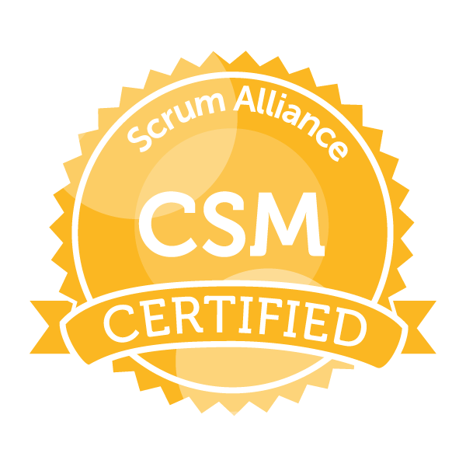

Phone: +91- 7708740763 E-mail: venkatrao.dande@gmail.com

Career Snapshot

Dynamic, Innovative and solutions focused IT professional, specializing in leading high-performing and multi-disciplinary teams from development through successful product launches. Accustomed to managing multiple projects and priorities in past-faced environments.

- 10 years of total experience with 7 years of software testing and 3 years of Scrum master experience
- Certified Scrum Master (CSM)
- Facilitating Sprint planning, Daily stand-up, Backlog refinement, Sprint demos, Retrospectives and stakeholder meetings
- Tracking and managing product backlog, burn-down metrics and velocity
- Expert at driving the adoption and enforcement of Scrum rules, removing impediments and fostering self-management
- Arranging show & tell calls with customers for early feedback
- Knowledgeable about software development life cycle (SDLC) and Software Testing Life Cycle (STLC) that includes specifying and analyzing requirements, release management
- Having 5+ Years of experience in Content Management System testing using OWCS
- Good exposure of client facing skills and interaction with Stake holders on daily basis
- Good experience of Quality Assurance methodologies like Waterfall and Agile Models
- Expert in different types of testing that includes Black Box testing, Smoke testing, System, Integration testing, End-to-End Testing, Data base testing and Regression testing
- Good experience in preparing daily, weekly status reports and defect metrics
- Coordinated with Dev team, Test team & ASG teams for on time delivery
- Working with ASG teams for live issues and helping them for quick resolutions
- Good experience in working with clients, project teams, designers and managing the creation of user interfaces
- Solid communication, collaborative and team building skills with acumen in training and supporting end-users and technical staff to achieve performance objectives

IT Experience – 10 Years

- Working as Senior Consultant in Virtusa Consulting Services Private Limited, Bangalore from Apr 2020
- Worked as Module Lead in Tech Mahindra Limited, Hyderabad from APR 2014 to Mar 2020
- Worked as Test Engineer in Virtusa Consulting Services Private Limited, Hyderabad from OCT 2010 to APR 2014

Onsite Project Execution Experience

- Worked as Scrum master & Test Manager in British telecom UK, Cardiff from Apr 2018 to Oct 2018 and from Nov 2015 to Oct 2016

Skill set

SDLC Methodologies : Waterfall and Agile
Testing Tools : Manual Testing, UI Path, Accessibility & Data base Testing
Operating System : Windows 7/8/8.1/10
RDBMS : SQL Server
Test Management Tools : Quality Center 10.0, ALM 11.0, JIRA, Share point
Tools : OWCS and AEM 4.4

Project experience:

BT AEM Portal – (From Apr 2020 to till date)

Overview: Adobe Experience Manager (AEM) is a web based content management system. It is a strategic enterprise web content management platform on which all digital capabilities are being built and integrated with internal systems. Our scope primarily includes redesigning the BT Storefront website and BT Sports portal

Project Role: Scrum master with following responsibilities:
- Facilitate Daily Scrum, Sprint Planning, Sprint Demo and Sprint Retro meetings
- Track and remove internal and external impediments for the scrum team
- Removed team impediments on a daily basis to allow the team to deliver the sprint goals and deliverables.
- Collaborated with members of the Product, Business and Engineering Teams to develop and maintain Product Backlogs
- Facilitate the grooming sessions with product owner to build product backlog
- Facilitate and plan for Go-Live activities
- Track and report Scrum team velocity
- Coordinate and work with multiple teams and business stakeholders for project planning and execution
- Ensure that the burn down chart is up to date, as well as monitoring the burn down chart
- Ensure that the Sprint Board (Jira) is up to date
- Track and communicate team velocity including sprint / release progress

BTSport - UEFA Champions League and Europa League digital Service: (From Sep 2017 to Mar 2020)

Overview: BTSport - UEFA Champions League and Europa League digital Service is a premium service to telecast UCL and UEL football Matches Live and provide instant live updates and all UCL, UEL centric data with rich user experience to the BT customers.

Project Role: Scrum master with following responsibilities:
- Facilitate Daily Scrum, Sprint Planning, Sprint Demo and Sprint Retro meetings
- Coaching the team on Agile principles and processes
- Track and remove internal and external impediments for the scrum team
- Facilitate the grooming sessions with product owner to build product backlog
- Facilitate and plan for Go-Live activities
- Track and report Scrum team velocity
- Coordinate and work with multiple teams and business stakeholders for project planning and execution

- Ensure that the burn down chart is up to date, as well as monitoring the burn down chart
- Ensure that the Sprint Board (Jira) is up to date
- Track and communicate team velocity including sprint / release progress
- Work closely with project owner in backlog management and continuous delivery of features.
- Educate and reinforce scrum methodology and agile framework to team members and stakeholders.
- Direct and lead development team from project initiation through the delivery of final product.

BT.COM and BTSPORT.COM: (From Dec 2012 to Aug 2017)

Overview: BT.com, the face of British Telecom helps its customers get more value out of the time they spend online, by combining the latest editorial content with easy access to all their BT online services making things simple and enjoyable.

BTSports is BT’s answer to the all-conquering Sky Sports to stream Football, Rugby, Motor Sport, NBA,UFC etc on any internet enabled devices like smart phones, Tablets, laptops. It also provides instant and live updates of the matches happening along with latest editorial sports content like videos, stories etc with rich user experience.

Project Role: Test Manager/Senior test Engineer with the following responsibilities:

- Attending Walkthrough and Understanding the business requirements
- Analyzing and identifying gaps in functional/business requirement
- Acting as SME and clarifying/Resolving author issues
- Handling the test team, assigning the tasks and tracking the status
- Attending the regular client calls to discuss about the status with the stakeholders
- Escalate the issues pertain to project requirements (Software, Hardware, Resources) to Project Manager
- Keep track of the new requirements / enhancements/critical requirements/user comments of the Project
- Review test cases prepared by team members and guide the team whenever required
- Perform integration testing, system testing and user acceptance testing
- Continuously monitoring the testing progress with team members and make sure to meet the given timelines
- Reporting and Tracking of Bugs in the Bug tracking tool till closure
- Track and prepare the report of testing activities like testing results, test case coverage, required resources, defects discovered, defects resolution and closure
- Involved in regular project review meetings & Testing Status Meetings and sharing test reports with various stakeholders.

Admin Center-CIG ENTITLEMENTS (From Oct 2010 to Nov 2012)

Overview: This is the new enhancement that an Admin Center Hub, which provide the entitlements to the user without dependency of customer, help desk in order to provide entitlements to the customers and manage there. Client wanted to test the impact of creating clients and linking the products to the created client. In turns wanted to validate how the entitlements effectively provided to the users of respective clients.
J.P. Morgan ACCESS Administration is your main resource for managing users and their system permissions (known as entitlements). Here, you can add users, view and add or edit product and account entitlements, manage requests and view account information. For greater convenience, some of these functions performed from different areas within the system.

Project Role: Software Test Engineer with the following responsibilities:
- Preparation of Test Data
- Defects logging and updating reports using ALM
- Designed more than 1000 test cases
- Logged more than 400 defects
- Responsible for Integration and System Testing
- Worked on all cross functional modules like Product management, User management, Search & Filter, Alerts & Notifications and Security & Policy
- Handled Client Management Module from offshore for two releases
- Supported ATS Bombay Team and resolved their issues
- Conducted TSDM Onboarding trainings in Offshore
- Communicated with Techops during Application downtimes
- Identified workarounds, when execution is blocking with some critical issues
- Trained the new resource to be the up to the mark as part of our requirement
- Responsible for Data base testing, Audits, Search &Filter and Alert& Notifications

