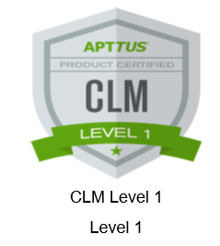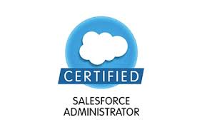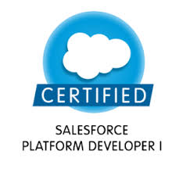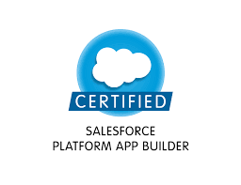

Mobile: + 91 9110253157

Email: alokkumar.1201@gmail.com **Alok Kumar**

Professional Summary:

* Having total 7+ years of work experience in IT with Apttus CPQ/CLM 2+yrs and Sales force CRM 5+ years.
* Have experience of both development and Support projects.
* Worked on different domain projects like Healthcare, Manufacturing, Retail etc.
* Good knowledge in Apttus CPQ and CLM features. Product configuration, Constraint Rules, Contract management, Price matrix and Price Rule Sets.
* Proficiency in configuring Approval Process (Apttus), Search Filters.
* Configured Catalog, Catalog hierarchy, Bundle, Nested Bundle, PLI with different Charges and Charge Type Criteria combination for all product & services, Attributes.
* Administration & Development in Salesforce CRM.
* As a Sales force developer, have involved in Developing Apex Classes, Triggers, Visual force Pages, Writing test classes.
* Implementing security and sharing rules at object, field, and record level for different users at different levels of organization. Also, created various profiles and configured the permissions based on the organizational Requirements.
* Created the Workflows, Approval Process, Process Builder and Validation Rules.
* Designed various WebPages in Visual Force for functional needs within Sales force.
* Involved in Salesforce.com Application Setup activities and customized the apps to match the functional needs of the organization.
* Created custom objects, tabs, fields, record types, page layout as per business requirements.
* Maintain Roles and Profiles in the Salesforce.com application, Custom Objects, Custom Tabs, Custom Fields, design of Visual Force Email Templates and various other components as per the client and application requirements.
* Changesets, Force.com IDE, Data Loader, Workbench and salesforce.com.
* Experienced in full software development lifecycle - Requirement Analysis, Design, Development, Testing and Production Support.
* Experience in Agile way of software implementation.
* Have good debugging, Trouble shooting, multitasking and problem solving skills.

Professional Experience:

* Working as **Senior Software Engineer** with **Tech Mahindra Ltd.**

Noida. Feb,2018- Till Present

* Worked as a **Senior Project Engineer** with **Wipro Technologies**, Bangalore. 2012-Jan,2018

Technical Skills:

* Apttus CPQ and CLM, Salesforce CRM, X-Author Word, SFDC Coding, SFDC Configuration, SFDC Administration.
* Programming Languages: Force.com Apex, Visual force, SOQL, C, C++, HTML5.

Skill Set:

* Analytical and problem solving skills.
* Excellent communication skills.
* Self-motivated and good team player.
* Flexible and focussed.
* Good inter personal skills.

Highest Qualification:

* M.tech in Software Engineering from BIT’s Pilani, 2016.

**Project’s handled(6 Projects):**

|  |  |  |  |
| --- | --- | --- | --- |
| **Latest Project** | ApttusCorporation | | |
| **Client** | Change Healthcare(CHC) |  |  |
| **Role** | Senior Developer and Technical Lead, Working with Apttus for development of new features in CPQ and CLM for Change Health Care project for their multiple business units. Have also done a complete project of migrating the customer Legacy data to Apttus platform for CLM process. | | |
| **Description** | Apttus Corporation provides quote-to-cash software solutions delivered on the Salesforce platform. The company’s quote-to-cash software solutions include e-commerce, configure price quote, contract management, and revenue management solutions to enterprise, and small and medium business customers. | | |
| **Tools** | X-Author Word , Change Sets, Force.com IDE, Data Loader, Workbench. | | |

|  |  |  |  |
| --- | --- | --- | --- |
| **Project** | Ether | | |
| **Client** | Shell |  |  |
| **Role** | Senior Developer | | |
| **Description** | Ether is a Force.com application developed to create and maintain Ether projects of Shell.  Ether is a business planning tool that provides an aggregated financial overview of strategic growth projects and the base business of Shell Chemicals and Manufacturing covering a time frame of 10 forward years as well as historical performance.  Key capabilities that the Ether tool supports are the 10 year Strategic Plan Update (SPU), Site Value Growth Plan, annual target setting and tracking for the Key Next Steps and growth pipeline review by the various leadership teams.  Ether is developed in-house and hosted with Force.com. | | |
| **Tools** | Change Sets, Force.com IDE, Data Loader, Workbench. | | |

|  |  |  |  |
| --- | --- | --- | --- |
| **Project** | Echostar Purchasing System-Brazil | | |
| **Client** | Hughes Network |  |  |
| **Role** | Senior Developer | | |
| **Description** | Hughes Communications is a provider of satellite-based communications services. The company operates its satellite business through its wholly owned subsidiary, Hughes Network Systems LLC.The project involves in handling cases logged by the Users of Brazil of Hughes Network System and resolution and post resolution activities.  The project implements Service Cloud feature. | | |
| **Tools** | Force.com IDE, Data Loader, GIT Stash. | | |

|  |  |  |  |
| --- | --- | --- | --- |
| **Project** | CapitalOne – Risk Management | | |
| **Client** | CapitalOne |  |  |
| **Role** | Developer | | |
| **Description** | CapitalOne is one of the largest retail banker in the United States of America. The project involves complete risk management of the capitalone financials through Initiatives. Have been working on the modules such as ‘Third Party Management’ , ‘Business as Usual’ and ‘Credit Management’ using salesforce.com | | |

|  |  |  |  |
| --- | --- | --- | --- |
| **Project** | Tesco Retail | | |
| **Client** | Tesco |  |  |
| **Role** | Developer | | |
| **Description** | Tesco is one of the largest retailing company. The project involves the Salesforce Export Tool which is an online system that has been developed to provide basic catalogue and ordering capability to the Tesco Export team and its customers.  An Export Customer will be able to log on to the system, browse through a catalogue specific to them, and  place an order. The Export Team will be able to amend the order and divide it depending on who is fulfilling  the order (Tesco UK Distribution Network or directly to supplier). | | |
| **Tools** | Force.com IDE, Data Loader | | |

|  |  |  |  |
| --- | --- | --- | --- |
| **Project** | Baxter | | |
| **Client** | Baxter Pharmaceuticals |  |  |
| **Role** | Developer and Admin | | |
| **Description** | Baxter is a Pharmaceutical Company. The project involves Creating new country implementation. The existing Baxter pharmaceuticals salesforce app has been extended for the new countries that are Russia and Greek Customers. The application deals with Hospitals, Doctors and Baxter medicine suppliers. | | |
| **Tools** | Force.com IDE, Data Loader | | |

Personal Details:

|  |  |
| --- | --- |
| **Gender** | Male |
| **Nationality** | Indian |
| **Marital Status** | Unmarried |
| **Alternate Phone No.** | +91 9110253157 |

Information mentioned above is true to the best of my knowledge.

**Alok Kumar**

**(Place: Delhi)**