Angshuman Sengupta

Microsoft Certified: Azure Administrator Associate® | Advanced Certified Scrum Master® | Agile Coach | Azure DevOps | Business Analyst | QA Lead

Post: 118, Santoshpur Avenue, Kolkata-700075
Mobile: +918879877534

E-mail: asengupta.sn@gmail.com
Social Website: https://www.linkedin.com/in/angshuman-sengupta/

Profile Summary:

Mission-focused Scrum Master with extensive experience coaching and mentoring highly skilled teams. Azure DevOps professional with more than 11+ years of experience delegating tasks and managing projects.

Areas of Expertise:

- Experience in handling Sprints for a successful business delivery and Facilitates Sprint events as needed.
- Worked on creating CICD environments using Azure DevOps along with cross cloud infrastructure development using Terraform, PowerShell and AZ CLI.
- Expert Experience and familiarity with Manual Testing, Defect Management, Production Support, Product testing.
- Identifying, investigating, and analyzing business processes, procedures and work practices.
- Leadership in strategic development for business needs, articulating ideas, team management, mentoring, problem solving, conflict resolution and crisis management. Expertise in bringing together talented developers in a cohesive, team focused manner to empower business.
- Good team lead who listens, able to collaborate with diversely talented team members, and integrate their different perspectives into meaningful action.

Career Timeline:

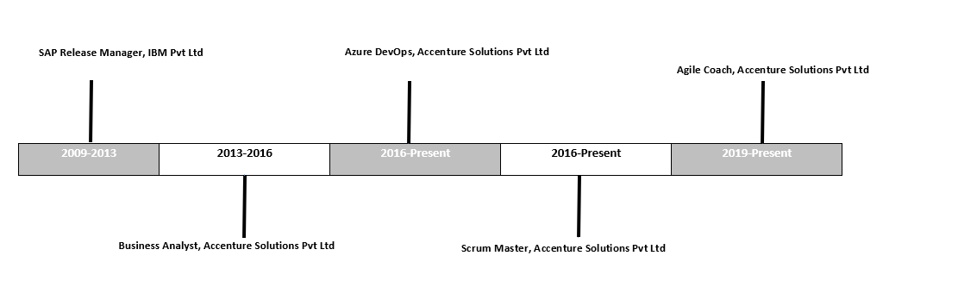

Education:

- Bachelor of Information Technology from Netaji Subhas Engineering College, Calcutta, India (2008)

Summary of Project Experience:

Accenture Solutions Pvt. Ltd. (May 2013- Present)

Jan 2019 - Present

Agile Coach:

- Recognized and tapped talented staff to fill key positions and maximize productivity.
- Identified and proactively solved internal problems related to employee turnover by revamping training approaches.
- Scheduled and taught in class and online courses to increase learning opportunities.
- Eliminated process gaps by implementing new methods of standardized training.
- Mentored new hires, resulting in stronger staff development and increased productivity.
Mar 2016 – Present
Scrum Master:

- Facilitated Scrum framework – sprint planning, backlog grooming, daily scrums, sprint reviews and sprint retrospectives.
- Planned Agile best practices and encouraged team cohesion, overcoming impediments and hurdles to productivity.
- Drove Scrum team progress to overcome obstacles and realize success throughout life of each sprint.
- Coached teams in Agile practices and provided necessary training to create positive mindset to Agile methodologies.
- Led sprint reviews, daily scrums and planning meetings to realize full team engagement.
- Managed product backlog and supported Scrum framework for monthly sprint releases.
- Shielded scrum team from external interference for optimal productivity and success of Agile process.
- Applied agile methodology to shorten cycle time and achieve target margins.
- Worked effectively with multiple Scrum teams both internally and on-shore.
- Managed and motivated project teams to promote collaboration and keep members on-task and productive.
- Involve in creating Sprint Goal to have user stories from Product backlog to execute sprint.
- Help Product owner in finding Techniques for effective Product Backlog Management.
- Ensure the Product increment is right on track.
- Ensure sprint is closing as per the checklist in Definition of Done.
- Involved in Sprint reviews to understand the inputs. from stakeholders to improve the quality of deliverable.
- Involved in Sprint Retrospective to understand the position of the team and to collect action items for the consecutive sprint.
- Involved in Product Backlog Refinement to estimate and to plan the team to take up prioritized stories for consecutive sprints.
- Handled a team which processing the applications deployment automatically Under Dev Ops process.
- Taking initiatives to complete the profiling to each application for which deployment automation is require.
- Involved in discussion with application managers and SMEs of each application to understand the current deployment process to make a standard process.
- CSM and A-CSM Certified.

Jan 2016 - Present

Azure DevOps:

- Worked on creating CICD environments using Azure DevOps along with cross cloud infrastructure development using Terraform, PowerShell and AZ CLI.
- Have experience in automating Infrastructure as code from scratch encompassing application and database deployment
- Worked with Azure PaaS services like Logic Apps, Azure Functions, APIM, Web App, etc.
- Creation of YAML multistage pipelines and making generic templates to be used by several projects.
- Created a secure and managed Azure environment using terraform for cross cloud development as well as full CICD environment set up.
- Az-104 Certified.

May 2013 - 2016

Business Analyst/QA Lead

Business Analyst:

- Involved in report testing activities of the releases on application. It involved analyzing Business Requirement Documents (BRD) and preparing Functional specification Documents (FSD) for respective CRs on the new enhancements/features, bug fixes, changes made on an existing function, and preparation of test case documents with relevant evidence and providing signoffs within the target release dates.
- Identifying, investigating, and analyzing business processes, procedures and work practices.
- Identifying the business requirements and the same communicated to the Development team and make sure that the requirements enhanced so that it releases to the production environment within the deadlines.
- An ability to understand business process and communicate the output of complex analysis at an appropriate level for the intended audience.
- Coordinate between the Business and the Client's IT team
- Give prior notice to the Business and the Client IT team regarding possible issues.
- Acts as an intermediary between the Production team and the Development team in resolving any functional and technical issues by verifying the same in Front end and Back end of the Application.
- Involved in testing activities. The testing involved in performing the testing on the new enhancements/features, bug fixes, changes made on an existing function, and preparation of test case documents with relevant evidence and providing signoffs within the target release dates.
- Identifying the bugs and the same communicated to the Development team and make sure that the bugs rectified so that it releases to the production environment within the deadlines.
- Coordinating weekly Business call, understanding Client requirements and providing them valued Satisfaction.
- Make sure defects are in right way until closed in Azure DevOps.

Other Notable Assignments

IBM India Pvt. Ltd. (June 2009 – May 2013)

SAP Release Manager:

- Creation/ Deletion/ Change of SAP users in Development, Testing & Production Systems.
- User Locking/ Unlocking and Password reset.
- User validity management.
- Changing existing user’s security access through Assigning/ Revoking roles from users.
- Performed Creation/ Deletion of roles.
- Extensively used PFCG (Profile Generator) to create, modify and customize Authorizations, Roles and Authorization objects.
- Managing the end-to-end lifecycle release cycle for application development especially involving the activities from testing through go-live and early life support.
- Validating application development and testing plans as well as release schedules.

