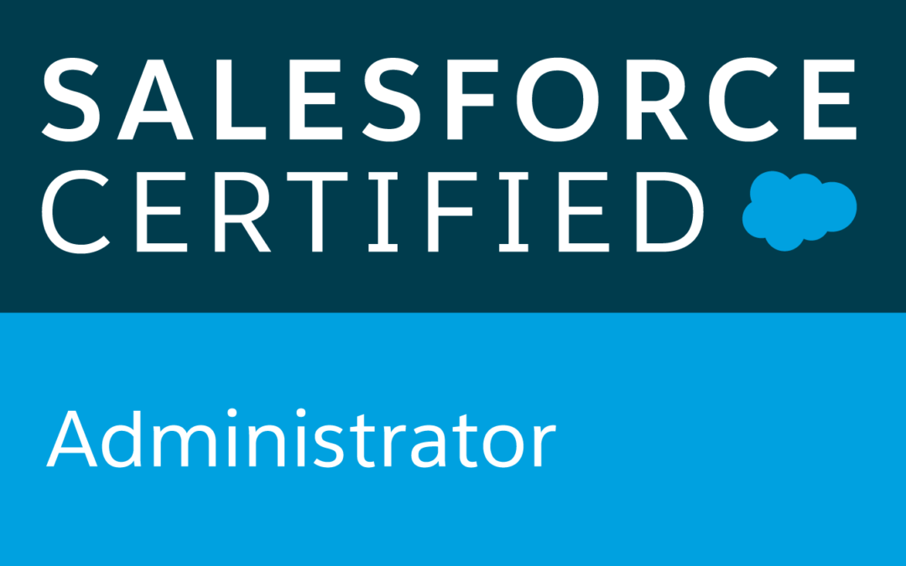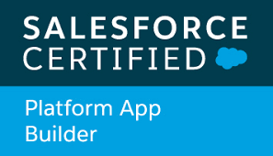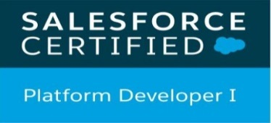

**Dileep**

**Sales force developer**

**Email: salesforce.requirements20@gmail.com**

**Phone: 315-615-3716**

**SUMMARY OF QUALIFICATION:**

* **Over 8 years of IT** experience across various domains and **5+years** of experience in **Salesforce.com CRM** platform using **administration, development, integration, deployment, communities, lightning component development, lightning design system and classic to lightning migration and 2 years** of experience in **Java/J2EE.**
* Profound knowledge of **Software Development Life Cycle (SDLC)** concepts from planning through implementation and maintenance. Proficient in formulating planning and documentation for **project scope, process design, system configuration, test readiness, deployment and post implementation support**.
* Proficient with Sales Cloud, Service Cloud, Call Center, Force.com, Portals, **Chatter and App-exchange on Sales force.**
* Expertise in **Object Oriented Programming** using Java and J2EE related technologies.
* Expert in design and development of **applications using JAVA/J2EE technologies** like Servlets, JSP, JMS, JDBC, JSF, Struts, EJB, Hibernate, Spring, Web Services, Java Beans, RMI and XML.
* Experience in programming, deploying of **middle-tier popular J2EE Application** Servers like IBM WebSphere, JBoss and Tomcat.
* Experienced in customizing **standard objects Accounts, Contacts, opportunities, Products, Price books, Cases, Leads, Campaigns, Reports and Dashboards,** Extensively Created **Roles & profiles** and configured the permissions based on the organizational hierarchy with **Data Cleansing**, Instrumental in Designing **Custom Formula Fields, Field Dependencies, Validation Rules, Workflows, Approval Processes, Page layouts and search layout.**
* Implemented **workflows and Batch classes** and schedule jobs for send sending notification.
* Written triggers and **batch classes** in Salesforce.
* Strong exposure in creating various **Page Layouts profiles** and configured the User permissions based on the organizational hierarchy, Experience in creating **validation rules, workflows, approval process, and dynamic approval process**, implementing and supporting modules like **Partner Relationship Management and Service Cloud implementation,** in **data migration from Legacy Systems using Data Loader, Import Wizard,** pervasive, Cast Iron **and Demand Tool.** Have good knowledge on **Informatica/ETL** Tool and **Informatica on Demand.**
* Secured hands on experience in Administration setup like manage Users, Security Controls and Data Management, Highexperienced with Web services **API, WSDL, SOAP, XML**, and XSLT, Proficient in working with Java and associated J2EE technologies like **JSP, JDBC, EJB 2.1, EJB 3.0.**
* Skilled in understanding and implementing the new **salesforce Lightning Experience.**
* Analyzing the Scenarios for switching between salesforce **classic and the Lightning Experience.**
* Used the **Lightning Aura framework** to build the components when upgrading legacy customer portal to Community for Clients**.**
* Worked on consolidation of all existing Workflow rules in the **Lightning Process builder flows** and created one process builder for each object and managed all actions in the single flow.

**Technical Skills:**

|  |  |
| --- | --- |
| Salesforce Technologies | SalesForce.com, Force.com, Apex Language, Apex Classes/Controllers, Apex Triggers, SOQL, SOSL, Visual Force Pages/ Component, s-Control, Apex Web Services,WorkFlow and Approvals, Dashboard, Lightning Web Components. |
| Salesforce Tools | Force.com IDE (Eclipse), AJAX Tool Kit, Force.com API tools (Data Loader), Force.com Explorer, Force.com Platform |
| ETL Tools | Data Loader, Salesforce-to-Salesforce, Apex- Explorer, Informatica. |
| Languages | Apex, C/C++, Java, JavaScript, HTML, XML, CSS, AJAX. |
| Database | SQL Server 2008, Oracle, MySQL. |
| Web | HTML, XML, CSS, JSP, JavaScript, WSDL, SOAP0. |
| Tools | MS Office, Adobe Photoshop, MS Excel, Silverlight, Eclipse IDE. |
| Web Servers | IBM WebSphere 4.x/5.x, Apache Web Server, Tomcat 6.x |

**certifications:**

**• Salesforce Admin Certified**

**• Salesforce Platform Developer (DEV 401)**

**• Salesforce Platform App Builder**

**professional experience:**

**Client: Janus Henderson Investors, Denver, CO June 2020-Till date**

**Role : Salesforce CRM Developer**

**Description:** Janus Henderson is a range of financial products to individuals, intermediary advisors and institutional investors globally under the trade name Janus Henderson Investors.

**Responsibilities**:

* Developed **Apex Classes, Triggers**, and **Visual Force pages, Components**.
* Interacted with different business teams and developing teams to acquire the requirements and documentation of business and technology requirements.
* Designed, developed and deployed the **Custom Apps, Custom objects, Custom Fields, Custom buttons, Page layouts, Custom tabs, Components, Visual Force Pages, Apex classes** to suit to the needs of the application.
* Worked in **Agile methodology, attended daily scrum meetings, weekly grooming meetings and sprint review meetings**.
* Implemented **Salesforce Lightning Components** for users within the **organization, developed Lightning components and server-side controllers** to meet the business requirements.
* Created **Lightning components** and apps combining **Lightning Design system, Lightning App Builder and Lightning Component features**.
* Used refined global search in Lightning by developing **Apex classes and Controllers**.
* Used **field level security** along with page layouts in **Lightning to manage access to certain fields.**
* Involved in developing **Salesforce Lightning applications using Lightning Components, Controllers and Events and used custom CSS in the components.**
* Developed **Lightning Component Framework and built Lightning component using aura framework**.
* Manage **page layouts, fields, and system interface/capabilities, Lightning Component.**
* Converted all the existing **Visualforce pages to lightning Web Components.**
* Used **Data Loader for insert, update, bulk import or export of data from Salesforce .com sObjects used it to read, extract, and load data from comma separated values (CSV) files**.
* Created Apex methods for the **lightning controller and helper methods to perform DML operations on the case records**.
* Worked on **Test classes of various triggers and apex classes** in the application to maintain minimum of 75% code coverage.
* Extensively Worked with **SFDC Visual Force Pages, Triggers, Validation rules, sharing rules, Assignment rules, Web services, Tabs, Custom Objects, Reports and Dashboards.**
* Integrated Salesforce data with external systems by writing **Salesforce REST Web Services for Inbound classes and used Http Request methods to call external application REST API endpoint**.
* Used **HTTP Callout using JSON to fetch records/data from other system and display them on the fly in the Visualforce Page** each time the page opens.
* Experience on day to day production support.
* Working knowledge of Project Management tools – **Azure Devops, Jira**.
* Created the **Branches, Pull requests to move the components by using the Azure Devops**.

**Environment**: **Saleforce.com, Apex Classes, Controller Classes, Triggers, Visualforce, REST/SOAP API, Field Service Lightning Salesforce.com Data Loader, Workflow & Approvals, Reports, Custom Objects, Custom Tabs, Page layouts, Email Services, SOQL, SOSL, Sandbox, Force.com IDE.**

**Client :Cherwell Software, Colorado Springs, CO Sept 19-May20**

**Role: Salesforce Developer/Admin**

**Description:** Cherwell Software is a global leader in enterprise service management, empowering organizations throughuse of intuitive technology for better, faster, and more affordable innovation. Our solutions and our people build lasting relationships.

**Responsibilities:**

* Involved in various stages of Software Development Life Cycle (SDLC) including **analysis, requirement engineering, architecture design, development, enhancements, testing**.
* Designed, developed and deployed **Apex Classes, Controller Classes for various functional needs in the application**.
* Developed various **Visualforce Pages, Apex Triggers to include extra functionality and wrote Apex Classes and Controller to provide functionality to the visual pages**.
* Created **Custom Objects and fields for transactional and contractual information**.
* Designed and deployed **Custom tabs, validation rules, Approval Processes and Auto-Response Rules for automating business logic**.
* Created **workflow rules and defined related tasks, email alerts, and field updates**.
* Implemented **pick lists, dependent pick lists, lookups, master detail relationships, validation and formula fields to the custom objects**.
* Created **page layouts, search layouts to organize fields, custom links, related lists and other components on a record detail and edit pages**.
* Worked extensively in **force.com sites with Customer community**.
* Created **workflow rules and defined related tasks, time triggered tasks, email alerts, filed updates to implement business logic**.
* Involved on **creating lightning Pages inside Lightning Community Builder**.
* Created **Community, Enabled Community Users, Profiles and Access.**
* Created **templates, approval processes, approval page layouts and defined approval actions on them to automate the processes**.
* Created various Reports (**summary reports, matrix reports, pie charts, dashboards and graphics**) and Report Folders to assist managers to better utilize Salesforce as a sales tool and configured various Reports and for different user profiles based on the need in the organization.
* Worked on implementing **Customer communities** forCherwell. Using the **Customer community**, the customer can find the required banking information. Go through the articles that are published.The community site also contains branding pages to show case articles.
* Developed **Apex Classes, Controller Classes and Apex Triggers for various functional needs in the application**.
* Used **SOQL & SOSL for data manipulation needs of the application using platform database objects**.
* Used **field level security along with page layouts to manage access to certain fields**.
* Customized **Contacts in Salesforce org to store relevant marketing data points**.
* Created **workflow rules and defined related tasks, email alerts, and field updates**.
* Implemented **pick lists, dependent pick lists, lookups, master detail relationships, validation and formula fields to the custom objects**.
* Created **page layouts, search layouts to organize fields, custom links, related lists and other components on a record detail and edit pages**.
* Generated **discover reports and presented campaign engagement statistics to business owners to direct future strategies and initiatives**.
* Implemented **Data Loader** through **the Command Line Interface to extract the data from database**.

**Client: Vertafore INC, Denver, CO Mar 19-Aug 19**

**Role: Salesforce Developer**

**Description:** Vertafore is an insurance agency and brokers, MGAs, and carriers to help them better manage their businesses and processes to grow revenue and be more profitable.

**Responsibilities:**

* Involved in various activities of the project, like **development meeting, requirement gathering, and analyzing requirements, documenting the functional and nonfunctional requirements**.
* Designed, developed and deployed the **Custom Apps, Custom objects, Custom Fields, Custom buttons, Pagelayouts, Custom tabs, Components, Visual Force Pages, Apex classes** to suit to the needs of the application.
* Integrated SFDC with Rally to send the **Cases information using REST API via Middleware (Celigo).**
* Developed **Rest API callouts** to perform data sync between **salesforce and Native CPQ**.
* Using the **Salesforce Rest Request and Rest Response objects, created Rest API's using Apex Rest**.
* Implemented Salesforce.com web services client using **Salesforce web services API, Java, XML and partner WSDL.**
* **Experience in developing Web Services using REST API and Apex Batch**.
* Design and developed **APEX based REST APIs** to allow transactions to happen independently in the cloud regardless of backend availability.
* Extensive hands on experience in consuming as well as developing API's for **REST based Web services to integrate third party functional modules into the core application**.
* Extensively worked on both **Enterprise and Community editions of MULE ESB**.
* Experience in using the**Tableau Server, Tableau Desktop and Tableau Public**.
* Involved in reviewing business requirements and analyzing data sources form **Excel/Oracle SQL Server for design, development, testing, and production** rollover of reporting and analysis projects within **Tableau**.
* Secured **Tableau server to protect the Tableau environment, security group**.
* Developing various tableau dashboards prototype for the future uses and conversion of current excel reports into tableau.
* Involving in daily scrums and post scrums with the director.
* Upgraded some Apps from **Salesforce Classic to Lightning experience to develop rich user interface and better interaction of pages.**
* Created multiple **Lightning Components, added CSS and Design Parameters that makes the lightning component look and feel better.**
* Hands on experience on **salesforce packages and lightning. Implementing salesforce lightning components for small set of users within the organizations.**
* Created Apex methods for the **lightning controller and helper methods** to perform DMLoperations on the case records.
* Created multiple **Lightning Components, added CSS and Design Parameters** that makes the Lightning component look and feel better.
* Worked on **Lightning Process builder flows, Connect API, Chatter and quick Action**.
* Good Experience on **Salesforce Lightning. Experience in integration with ERP (Sales Cloud, Service Cloud).**

**Environment:** **Saleforce.com platform, Apex Language, Lightning Components, Pages, Data Loader, HTML, Java Script, Workflow & Approvals, Reports, Agile, Custom Objects, Custom Tabs, Email Services, Security Controls, Sandbox data loading,Lightning.**

**Client: TXU/Vistra Energy, Dallas, TX Jun 18 – Feb 19**

**Role: Salesforce Developer**

**Description:** Vistra Energy is a premier, integrated power company based in Irving, Texas, combining an innovative, customer-centric approach to retail with a focus on safe, reliable, and efficient power generation.

**Responsibilities:**

* Worked on **REST API** web services for lead management, **SOAP API** web services with XML as intermediate platform.
* Performing the **analysis of business as well as technical requirements to design the solution** by customizing different standard objects of Salesforce.com. Developed custom **Apex classes**, tests and triggers by applying design patterns to control code execution, avoid runtime limits, and remain bulk-safe and used **SOQL**&**SOSL** for data manipulation.
* Implementation of **Batch Classes, Scheduled Classes** as part of the Business Requirement.
* Worked on **REST/SOAP** Web service to integrate Salesforce with third party systems.
* Developed **Apex Classes**, and **Apex Triggers**, **Apex Schedule**, **Batch Apex**, **Apex Webservices** for various functional needs in the application Classes and ensure on getting maximum Test Coverage, maintained around 85 percent for the code. Review code for potential performance issues, security and reusability.
* Extensive experience in designing of custom objects, custom fields, role based page layouts, Workflow Alerts and Actions, Validation Rules, Approval Processes, custom Tabs, report folders, report extractions to various formats.
* Involved in developing **Salesforce Lightning applications** using **Lightning Components, Controllers and Events and used custom CSS in the components**.
* Developed **Lightning Component Framework and built Lightning component using aura framework.**
* Used refined global search in **Lightning by developing Apex classes and Controllers.**
* Used field level security along with page layouts in **Lightning to manage access to certain fields**.
* Implemented Salesforce web services like SOAP and REST API, Java, XML.
* I was Involved in developing **Salesforce Lightning applications using Lightning Components, Controllers and Events and used custom CSS in the components**.
* Developed **Lightning Component Framework and built Lightning component using aura framework.**
* Created Apex methods for the **lightning controller and helper methods to perform DML operations on the case records**. Used Salesforce1 simulator during the development to test if the **lightning components works properly on the mobile device.**
* Strong Experience in **Salesforce Lightning components** design & designing compact layouts using Apex triggers, Page layouts, Visual force pages, workflows for Mobile platform.
* Created **Lightning Components using Controllers, Helper Methods, AngularJS, CSS and Bootstrap**.

**Environment:Saleforce.com platform, Apex, Lightning Components, Agile Methodology,Data Loader, Workflow&Approvals, Reports, Custom Objects, Email Services, Lightning, Visualforce pages.**

**Client: Charles Schwab, Denver, CO Dec 16 – May 18**

**Role: Salesforce Developer**

**Description:**It is one of the largest banks in the United States and it is one of the largest brokerage firms in the United States.The company offers an electronic trading platform for the purchase and sale of financial securities including common stocks, preferred stocks, futures contracts, exchange-traded funds,mutual funds, and fixed income investments. It also provides cash management services.

**Responsibilities:**

* Used Force.com Developer toolkit including **Apex Classes, Apex Triggers and Visualforce pages to develop custom business logic.**
* Customized application to extend Salesforce functionality and wrote **Apex Classes** to provide functionality to the **Visualforce pages**.
* Created **Visualforce Pages** to provide UI to the custom objects.
* Developed and maintained SFDC analytical **reports and dashboards** for management review and planning for accurate forecasting purposes.
* Administrator for different salesforce.com CRM application for **sales cloud and service cloud**.
* Created **Page Layouts, Record Types, Profiles, Permission sets, security and sharing, Cases, Report Types, Reports and Dashboards, master-detail and lookup relationships.**
* Performed zuora CPQ related configuration for **product setup, approval matrices, approval rules, process builders and flows.** Involved in end to end testing and configuration enhancements for the **CPQ and CLM functionalities.**
* Driving business requirement related meetings in order to capture the **technical requirements for the zuora CPQ implementation.**
* **Involved in Configuration for connecting the zuora to salesforce.**
* **Experience in zuora cpq mainly in the field mappings for product integration.**
* Connecting the salesforce CPQ to **zuora connector using the global classes.**
* Experience in using the **zuora connection to salesforce cpq for the price calculations**
* Designed and developed **Apex Classes, Controller Classes, extensions and Apex Triggers** for various functional needs in the application.
* Designed and deployed **Custom objects, Entity-Relationship data model, Cross Object Formulas, roll up Summary, validation rules, Page layouts, Custom tabs, Components**, to suit application needs.
* Developed page layouts with HTML pages using Salesforce pages with different **Meta data dependencies.**
* Worked on **Agile/Scrum Methodology** using Version One and SDLC.
* Setting up and configuring Salesforce.com and **SteelBrick** for client use including customizations to meet our clients’ desired business processes, reports and dashboards.
* Performed **Steelbrick CPQ** related configuration for product setup, approval matrices, approval rules, process builders and flows.
* Created integration with **Steelbrick CPQ and CLM applications** and automating processes on salesforce1 platform.
* Experience with **Steel Brick CPQ for subscription, billing, invoicing and can take control of sales process from Quote to Cash. Generated Revenue recognition status automatically with Steel Brick CPQ**.

**Environment:** **Saleforce.com platform, Apex, zuora CPQ, Agile Methodology, Visualforce, Data Loader, Workflow & Approvals, Reports, Java, SOAP, WSDL & RESTful Web Services.**

**Client: Gexa Energy, Houston, TX Oct 14 – Nov 16**

**Role: SalesforceDeveloper**

**Description:**Gexa Energy’s mission is to be an industry leading retail electricity provider of choice in competitive markets by expanding their brand and reach by meeting the changing needs of both residential and commercial customers through innovative solutions and operational excellence.

**Responsibilities:**

* The role is to ensure that the **deliverables** are expected to meet the **business needs, be secure, scalable, maintainable, supportable and highly available, comply with standards** and **be consistent** with the **architectural framework.**
* Conducting **activity-based analysis of key business processes**, identifying quick hits that result in efficiency gains and making final recommendations to management.
* Associated with **Project Management, PMO** and **Business Analysis** teams to provide **project overview** for **business review** and **project kick-off meetings**.
* Supporting **data migration activities** for migrating data from various business centers and business center users with the support of Salesforce.com.
* Interacting with various business user groups for gathering the requirements for **CRM implementation**.
* Implementing the requirements on Salesforce.com platform and **Force.com IDE Plug-in** using **Eclipse**.
* Designing various **HTML Email** and **Visual force email** templates.
* Supporting Salesforce.com Application Setup activities and customizing the apps to match the functional needs of the organization.
* Developing **Apex Classes, Controller Classes and Apex Triggers** for various functional needs in the application.
* Developing **Custom Objects, Custom Reports** and configured the **Analytic Snapshots** to dump the data on regular basis for the sales performance and lead generation statistics.
* Developing and deploying the workflows and approval processes.

**Environment**: **Salesforce.com platform, ApexLanguage, Visual force (Pages, Component & Controllers), Pages, HTML, Java Script, Workflow & Approvals, Reports, Integration, Custom Objects, Custom Controls, Sandbox data loading, Eclipse IDE Plug-in, Google Visualization API.**

**Client: Value labs – Hyderabad, India OCT 12 – SEP 14**

**Role: Java/J2EE Developer**

**Description:**Value Labs is an Indian-based global IT services and consulting company that provides information technology and business consulting services. Value Labs has been named as "50 Best Places to Work for India".

**Responsibilities:**

* Worked directly with user groups in analyzing and specifying business requirements for the design and development of project.
* Designed application with UML (Unified Modeling Language).
* Developed application based on SDLC (Software Development Life Cycle).
* Actively involved in configuring the Application Server and deployed all the modules like Web modules and Business modules.
* Created user-friendly GUI interface and Web pages using HTML, JSP.
* Developed the Front-End JSP and HTML.
* Developed JSP's, Java Beans and Servlets to interact with Data Base.
* Extensively used JavaScript for client side validations.
* Used XML parsers to parse and fetch information from XML templates.

**Environment:** **Java, J2EE, JSP, Servlet, JDBC, SQL, JavaScript, HTML, Struts, CSS, Oracle, XML, Apache Tomcat Server**.