**Nikunj Vaidhya**

[**Nvaidhya18@gmail.com**](mailto:Nvaidhya18@gmail.com)

**609-216-3361**

**Somerset, NJ**

**New Jersey Institute Of Technology (2019)**

**Bachelors In Business information System**

**Background Statement:**

Highly qualified, talented, and tenacious IT professional armed with broad-based background and skills in developing, maintaining, and supporting software and systems, using various tools to manage several facets of technical projects, creating, updating, and maintaining documentation for the knowledge and managing projects in challenging, fast-paced consulting environments. Displays outstanding ability to plan, coordinate, and implement practices and procedures to bring significant improvements in efficiency, productivity and processes towards the successful attainment of individual and organizational growth.

**Objective:**  
Seeking to leverage background and experience to take next career step with a highly respected organization focused on creating strong global teams.

**Core Competencies:**

* Demonstrated experience in developing solutions and managing resolution in AWS Cloud Platform.
* Thorough understanding of the importance of accurate, detailed reports, plans and documentation.
* Critical thinking skills to determine if there are any weaknesses within a designed plan.
* Establishing project goals and resolving issues with on-going project.
* Strong motivator/team player with effective and excellent planning, organizational, and negotiation strengths as well as the ability to lead, reach consensus, establish goals, and attain results.
* Ability to communicate effectively to clarify complex data and sensitive info.
* Ability to facilitate teamwork, build rapport, manage conflict, and teach, coach, counsel.
* Committed to professional development, willing and able to complete special trainings as required.

**Technical skills:**

**Operating systems:** UNIX, Linux, Windows.

**Database Tools:** MySQL, Dynamo DB and MongoDB.

**Frameworks:** React J.s, Spring4.0, Spring MVC, D2/D3 Dashboard

**Application Servers:** IBM Apache Tomcat, Glassfish, and AmazonEC2.

**Java IDEs:** Net Beans, Android Studio, I, Eclipse.

**Cloud Computing:** Amazon EC2, Amazon S3, Amazon RDS, AWS Lambda, Amazon SQS, AWS Identity   
and access management, AWS Cloud Watch, Amazon EBS other services of the   
AWS family.

**Skills:** Jira, Microsoft Office suite/ Visio, Software Architecture, Power Shell, Tableau

**Areas of Expertise:**

AWS Cloud Development

Analytical Problem Solving

User Interface Development

Splunk / Splunk Analysis

SoftwareDevlopment/ Documentation

SCRUM / AGILE

Framework: React JS, D2/D3 Dashboard

**Professional Experience**

**Hermitage Infotech, NJ June 2019 – Till date**

**Jr Developer**

**Duties and Responsibilities**

* Design, implement and maintain all AWS infrastructure and services within a managed service environment
* Design, Deploy and maintain enterprise class security, network and systems management applications within an AWS environment
* Implement process and quality improvements through task automation. Institute infrastructure as code, security automation and automation or routine maintenance tasks
* Perform data migration from on premises environments into AWS
* Support the business development lifecycle (Business Development, Capture, Solution Architect, Pricing and Proposal Development)

* **Splunk Dashboard**
* Created Splunk Dashboard to monitor activity of backend servers and register and report any irregularity.
* Develop alerts and timed reports Develop and manage Splunk applications
* Provide leadership and key stakeholders with the information and venues to make effective, timely decisions
* Collaborated with support team for other solutions network security solutions
* Ensuring support tickets are fully updated with the most current data. Provide proper escalations and handoffs to management and support staff
* Communicate with peers and supervisors routinely, document work, meetings, and decisions
* Work with multiple data sources

**NJIT Senior Year Capstone Project, Newark, NJ Jan 2018 – Mar 2019**

**Risk Val Financial Solution**

* Implemented a Web Console for Managing Production Tasks that will Displayed the current status of the backend process on a dashboard.
* This project was focused on development of a web console that displays the current status of the backend process on a dashboard issues that require a simple and straightforward fix, the Web Console should perform auto-recovery when it detects an issue.
* **Narrative:**
* If a service runs into an unhealthy state, it will send out an alert to our operation .When an issue arises, the operation team will be able to execute the appropriate recovery procedure through the Web Console. The Web Console will provide a way to view the status of recovery, and a history of past recovery attempts. Implement recovery SOP scripts. For issues that require a simple and straightforward fix, the Web Console should perform auto-recovery when it detects an issue
* We were able to displays the current status of the backend process on a dashboard issues that require a simple and straightforward fix, the Web Console should perform auto-recovery when it detects an issue.

**NJIT CPT Internship Project, Newark, NJ**

**Interning Project/ Scrum Master**

* Managing expectations and stakeholders, and communicating project status, milestones, and unexpected difficulties effectively
* Ensuring that all project team members understand and accept the project goals
* Managing relations/dependencies to other projects and/or related activities
* Projects impacting one major OpCo and / or a number of application areas
* Independently manages team assigned to project
* Demonstrates in-depth knowledge of project management principals
* Certification - Certified AWS solution Architect Associate

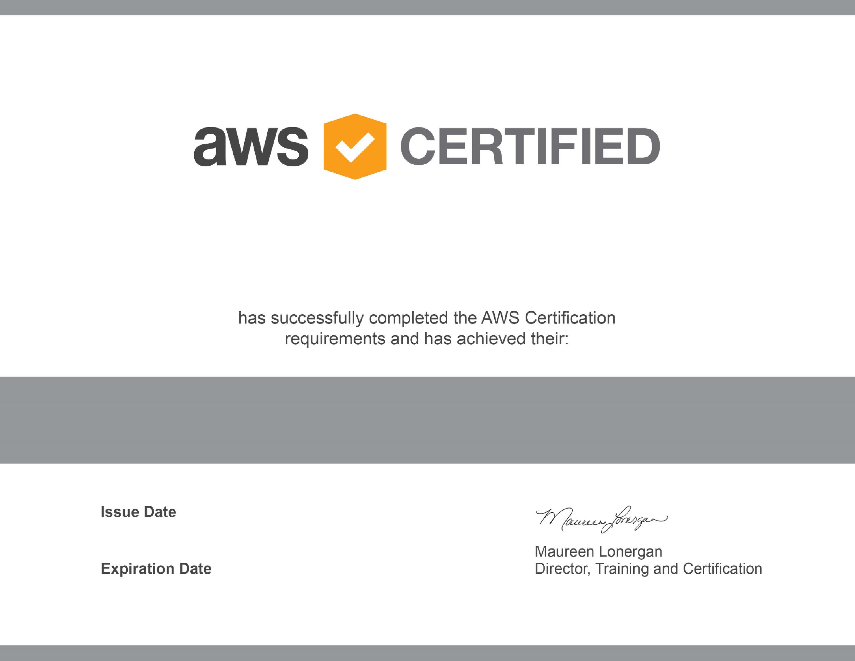

Nikunj Vaidhya

AWS Certified Solutions Architect - Associate

Jun 05, 2020

Jun 05, 2023

Validation Number 2KCTGJM2NB41QMGH

Validate at:

[http://aws.amazon.com/verificatio](http://aws.amazon.com/verification)

[n](http://aws.amazon.com/verification)