**Software Development Specialist / Team Lead**



Soumyadeep Nanda

CPQ/CLM Expert in Salesforce ecosystem

Certified CPQ Specialist, expert in Contract Lifecycle Management, Quote to Cash, Billing systems

especially around Apttus, Cloudsense and Salesforce CPQ systems

soumyadeepn@gmail.com

+918888803673

Pune, India

linkedin.com/in/soumyadeep-nanda-b691b55

[4](https://www.linkedin.com/in/soumyadeep-nanda-b691b554/)

**WORK EXPERIENCE**

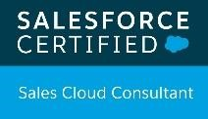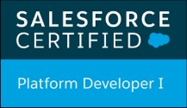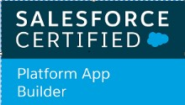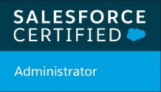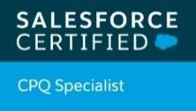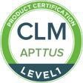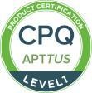

Accenture

*10/2016 - Present*, Reading/Slough(UK) */ Pune(India)*

*Accenture plc is a fortune 500 multinational professional services company*

* As a CPQ and CLM Expert I am responsible for End to End **implementation of CPQ and CLM** enablement for the clients
* Conduct **workshops with clients** to understand their requirements around the product model to configure complex products and align with product rules
* Develop **complex document mergefields** logics via X-Author for Word as we as utilizing X-Author for Excel to deliver multi dimensional quoting
* Provide **overall Solution technical leadership** through the project lifecycle including High Level Assessments, Architect steers and Low Level Salesforce designs
* **Leadership and ownership** of technical design, development and implementation of assigned Salesforce.com, CPQ and CLM projects
* Conduct design reviews and identifying opportunities to re-use components contributing to the definition of development standards

***Contact****: Mike Pearson - +447768357179*

**Senior Software Engineer**

Apttus

*10/2015 - 09/2016*, *Ahmedabad (India)*

*Apttus is an American business-to-business software provider specializing in business process automation.*

* A **CPQ and CLM Expert**, responsible for End to End implementation of CPQ and CLM implementation for Managed Services.
* Proven track record mentoring and providing technical guidance to others for CPQ, CLM and Salesforce.
* Lead large team and triaging with clients, developers, Test engineers and Tech architects and product engineers for solution designs.
* As s MS Representative, the complete implementation and solution is a one stop shop hence responsible for build test and deploy for the client.
* Creating complex document logics and **Approval (IWA)** processes to be utilized along with **X-Author for Word and Excel.**
* Solution building and development for CPQ taking into consideration the existing implementation of products, product rules and attribute definitions.

***Contact****: Tejas Shah - +919909948152*

**Senior Software Engineer**

Syntel (Now – Atos-Syntel)

*12/2012 - 09/2015*, *Pune (India)*

*Atos Syntel provides IT services such as traditional application development and maintenance, data warehousing and business intelligence, as well as digital services like social media, mobile, cloud, analytics, IoT and AI and automation-powered solutions.*

* Analyze and understand the User Requirement Specification and Test Requirement Analysis.
* Proven track record mentoring and providing technical guidance to others for CPQ, CLM and Salesforce.

# SKILLS

Apttus CLM

Apttus CPQ

Business Analysis

Cloud Sense CPQ

Sales Cloud

Salesforce Consultant

Salesforce CPQ

# CERTIFICATES

Salesforce CPQ Specialist

*(08/2018 - Present)*

Apttus CPQ (10/2015 - 10/2016)

*(10/2015 - 10/2016)*

Apttus CLM (10/2015 - 10/2016)

*(10/2015 - 10/2016)*

Salesforce Certified Sales Cloud

*(02/2018 - Present)*

Salesforce Platform Developer 1

*(09/2017 - Present)*

Salesforce Platform App Developer

*(06/2017 - Present)*

Salesforce Admin

*(02/2015 - Present)*

# HONOR AWARDS

Title/Award Name

*Name of the institution that issued/awarded it*

# LANGUAGES

|  |  |
| --- | --- |
| English  *Native or Bilingual Proficiency* | Hindi  *Native or Bilingual Proficiency* |
| Odiya  *Native/Bilingual Proficiency* | French  *Elementary*  *Proficiency* |

# INTERESTS

Photography Culinary