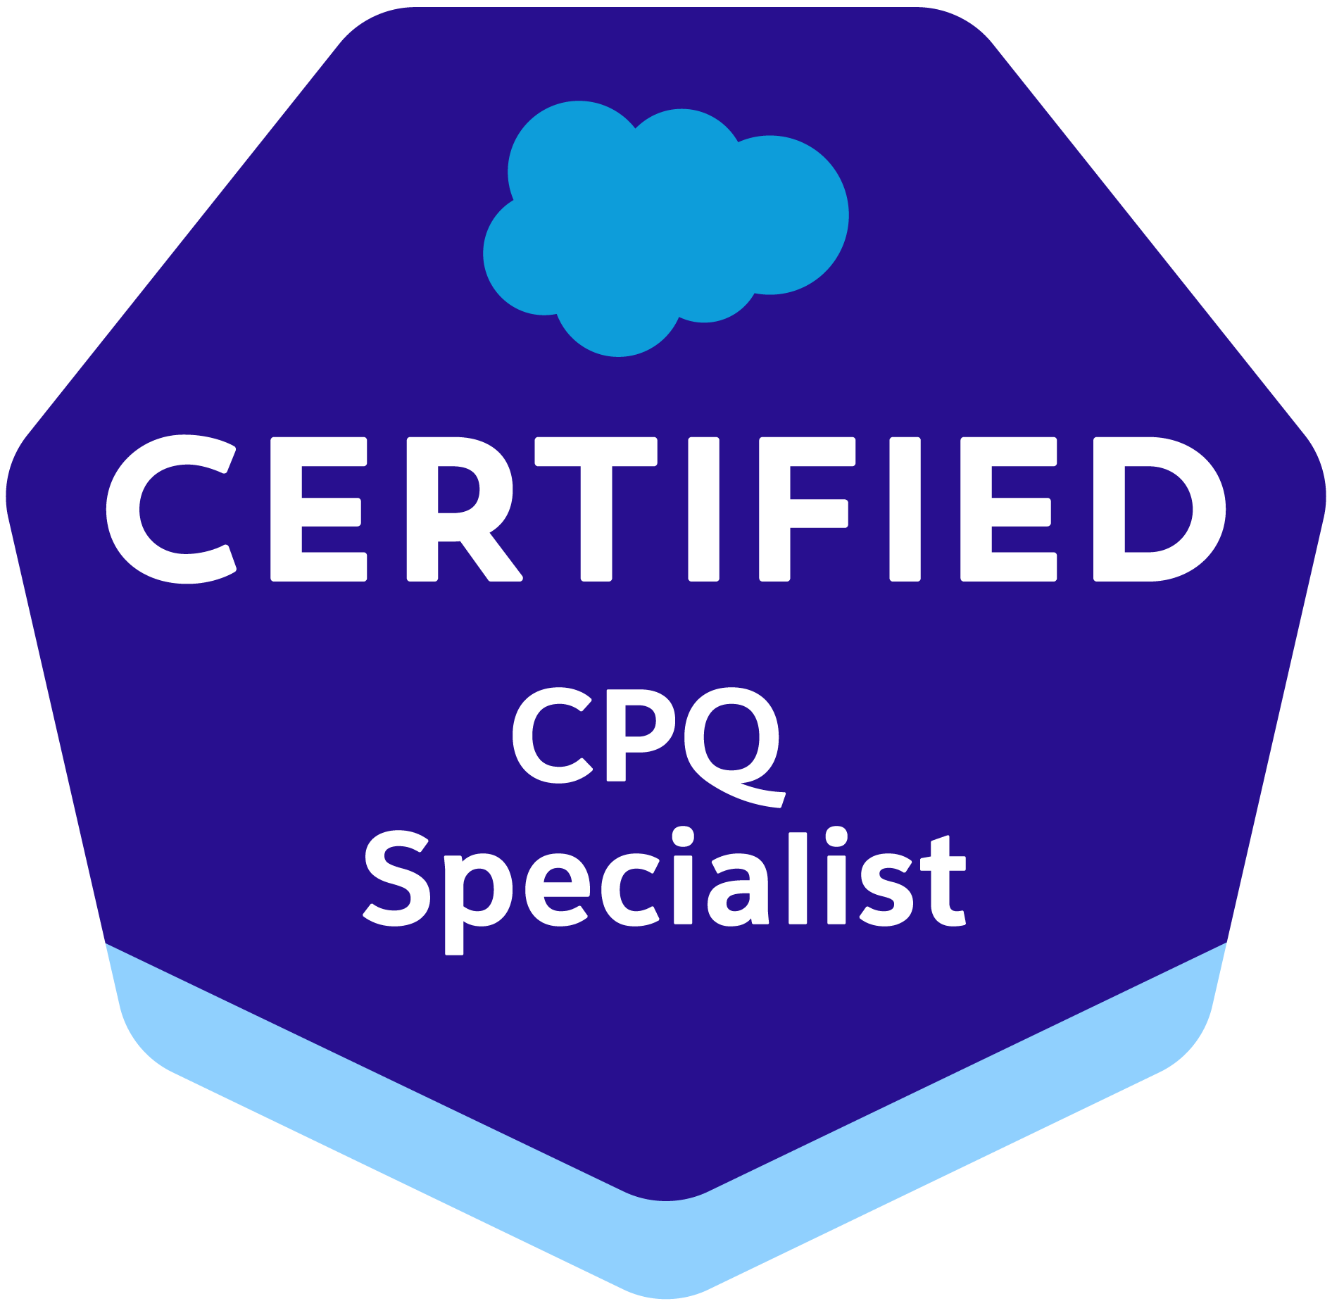
Prasanna Velan Sekar
Mobile: +91-780-694-8881
E-Mail: prasanndevi@gmail.com
___________________________________________________________________
Summary

- Around 15 years of experience in PeopleSoft CRM, EPM, HRMS and Finance domains as Technical Consultant.
- Currently working as Senior Technical Architect.
- Extensively worked and led the Development, Implementation and Upgrade projects.
- Worked as Onsite Tech Lead and involved in Requirement Analysis and Design with Business and Functional Team.
- Worked as Offshore Team Lead and effectively handled the team, deliverables, and the projects.
- Having excellent knowledge and understanding of PeopleSoft architecture and infrastructure.
- Have Good Functional knowledge on Requisition, Purchasing and Eprocurement and Accounts Payable Module.
- Involved in implementation of many inbound, outbound interfaces and reports, enhancements, and production support tickets in FSCM Module.
- Good knowledge in most of the tools in PeopleSoft (like App Designer, PeopleCode, App Engine, Integration Broker, Workflow, Comp Interface, Portal).
- Designed and Developed an Application engine which convert word document into PDF using third party tool.
- Demonstrated ability to analyze the requirements and deliver assignments as per project specifications and deadlines in a fast-paced work environment.
- Extensively worked on integrations with PeopleSoft using Integration Broker and Web Services.
- Performed Unit Testing, Integration Testing and Migration of Projects.
- Demonstrated ability to analyze requirements and deliver solutions.
- Conducted PeopleSoft Technical training for Fresher and other Projects Members.
- Have valid US H1B visa until Oct 2021 and I140 Approved.

Professional work Experience

- Working as a Senior Technical Architect in Hexaware Technologies since Aug’ 15 – Till Date – Chicago, Illinois & Chennai, India.
- Worked as a Senior Software Engineer in CSC since April’10 – Aug’ 15.
- Worked as Associate Technical Consultant in Wipro since Jan’07– April’10.
- Worked as an Associate Consultant in I-flex solutions since Oct’05–Jan’07.

Technical Proficiency:
ERP | PeopleSoft
Domain Expertise | CRM, EPM & FSCM
ERP Packages | PeopleSoft CRM 8.9  PeopleSoft EPM 8.8 ,8.9 & 9.1  PeopleSoft FSCM 8.9  People Tools 8.46 ,8.48, 8.49 ,8.50, 8.51 ,8.54
ERP Modules | EPM(ABM), CRM (Call Center) & FSCM (Purchasing & Accounts Payable)
ERP Development Tools | PeopleCode, Application Engine, Application Designer, File Layout, Internet Technology, File Layout
ERP Reporting Tools | PS Query, SQR
ERP Integration Tools | Integration broker, Workflow, Component Interface and ExceltoCI
Languages | C and C++
Databases | Oracle9i, Oracle 10g, Oracle11 & 12, SQL Server

Qualifications
Qualification | Institute | Year of Passing
BE | Prathyusha Engineering College, Chennai | 2005

Trainings

- Data Warehousing by SQL Star International Chennai

Awards

- Got Feather in the Cap award for best performance in Wipro

Certification

- Salesforce Admin
- Salesforce Platform Developer 1
- Salesforce CPQ Specialist
- ITIL Foundation V3

Career Profile:

For Hexaware Technologies

1. | Project | : | The Northern Trust – FR2052a Federal Reporting
 | Duration | : | Aug’15 – Till Date
 | ERP | : | PeopleSoft EPM 9.1
 | Role | : | Technical Lead/Architect
 | Location | : | Chicago - Illinois, USA & Chennai, India.

Description:

The Federal Reserve Bank and Basel Accords require banking organizations to hold quality assets that can be easily and quickly converted to cash, equal to or greater than their projected net cash outflow during a 3-day stress period.

This project is to meet the Federal Reserve requirements of providing detailed liquidity related data, used in FR 2052a reporting and to calculate Northern Trust’s Liquidity Coverage Ratio.

- Ability to calculate the LCR daily and monthly data.
- Expandable to calculate to all Affiliate LCR’s
- Capability to make manual inputs/adjustments/updates to fill in data gaps or correct general ledger errors.
- Data Validation Framework, Including audit reports and threshold validation exceptions.

Responsibilities:

- Working as onsite Technical Lead/Architect.
- Preparing Technical Specification Documents, Reviewing Unit Test Plan with test cases and expected results based on the Functional Requirements.
- Onsite Coordination with Client Team and with offshore team.
- Preparing High Level Design Document and Detailed Design Document.
- Gathering requirement from Client Business Team, Preparing the Technical Design documents after analyzing the functional requirements; Issue and gap analysis of the problem Design, Construction and Testing.
- Providing functional/technical knowledge to team members.
- Writing SQL Queries to compare the report and the database data
- Interacting with the client and the onsite coordinator for issues and queries in the project.
- Tracking deliverables on timelines.

Functional:

- PeopleSoft delivered Record Metadata, Table Map, Data Map, Filters, Constraints and Allocation Manager Rules.
- Knowledge of the multiple Legacy system and understand the different ways of data flow into the system.
- Reconciling the data for to fit into the process/reporting.

2. | Project | : | The Northern Trust – Salesforce CPQ
 | Duration | : | Dec’18 – Dec’19
 | ERP | : | CPQ
 | Role | : | Technical Lead
 | Location | : | Chicago - Illinois, USA.

Description:

The Northern Trust current state Opportunity management system that enables users to select products from a custom price book and manually add products to the opportunity. This project is implementing Salesforce CPQ replacing the existing system. SDFC CPQ solution will effect some fundamental changes to Object/Data model underlying Northern Trust Processes.

Responsibilities:

- Configured bundles (features, options, option constraints and configuration attributes), product rules, price rules, Discount schedules, pricing, contracted prices, quote templates, quote processes and custom actions.
- Managed products, price books and price book entries.
- Creation and maintenance of reports to support the business in salesforce.
- Worked on Quote to Opportunity synchronization.
- Worked on Approval management.

For DXC Technologies formerly Computer Science Corporation

3. | Project | : | Kaiser Permanente – CIWRS
 | Duration | : | Apr’12 – Aug’15
 | ERP | : | PeopleSoft CRM 8.9
 | Role | : | Team Lead
 | Location | : | Chennai, India / Los Angeles, USA

Description:

Complaints Integrated Workflow and Reporting System (CIWRS) project is to provide a system that meets Kaiser Permanente’s regulatory and compliance requirements for Member Contact Tracking. The system includes compliance, complaint and grievance workflow, on-line help, and state / federal reporting tools for Member Services, Member Relations, Patient Assistance, Clinical Review/Special Services and HPRS Departments. This system serves as a repository for all aspects of contact and escalation for the Member complaint and grievance processes.

Responsibilities:

- Worked as onsite Technical Lead.
- Worked on converting word document to pdf through application engine using third party tool. This has reduced the manual effort put in by the users.
- Worked on Fit-Gap Analysis and provided 8.51 features recommendations.
- Onsite Coordination with Client Team and with offshore team.
- Preparing High Level Design Document and Detailed Design Document.
- Gathering requirement from Client Business Team, Preparing the Technical Design documents after analyzing the functional requirements; Issue and gap analysis of the problem Design, Construction and Testing.
- Assisted the client in day-to-day technical production support.
- Preparing Technical Specification Documents, Unit Test Plan with test cases and expected results based on the Functional Requirements.
- Providing functional/technical knowledge to team members.
- Unit testing and documenting the test results with screen shots.
- Writing SQL Queries to compare the report and the database data
- Interacting with the client and the onsite coordinator for issues and queries in the project.
- Documenting existing processes in the system.
- Prepared Technical Design Documents and Test Plan.
- Tracking deliverables on timelines.

Functional:

- Tracking and resolution of member and non-member complaints, compliments, inquiries, grievance and appeals.
- Interfaces with third party system to download member information.
- Auto letter generation for member/non-member communications

4. | Project | : | Kaiser OneLink - Financial Supply Chain Management
 | Duration | : | Apr’10 – Aug’12
 | ERP | : | PeopleSoft FSCM 8.9
 | Role | : | Team Lead
 | Location | : | Chennai, India

Description:

OneLink is the PeopleSoft Financial Implementation and support/enhancements for both Southern California and Northern California region. It comprises of implementation of Purchasing and Inventory modules on PeopleSoft SCM and Payables and General Ledger on PeopleSoft Financials.

Responsibilities:

- Worked in Development tickets. Developed SQR which involves creation of 2 tabs in the Excel Sheet with detailed report in one tab and summary report in other tab.
- Modified delivered 12 Months Issue History Report based on Client Requirement.
- Developed and modified Application engine for many inbound and outbound interfaces.
- Worked in File Layouts, Peoplecode.
- Fixed many Production support tickets.
- Worked in Enhancement tickets.
- Worked in Purchasing and Accounts payable Module.

For Wipro Technologies

5. | Project | : | Citi Bank – Citi Country Core (EPM Support and Enhancement)
 | Duration | : | June’09 – Apr’10
 | ERP | : | PeopleSoft EPM 8.9
 | Role | : | Team Member
 | Location | : | Chennai, India

Description:
The Citi Reporting Core is designed to be a single system for financial reporting, using a common set of standards, manipulated through a consistent process across countries and businesses.

Responsibilities:

- Preparing High Level Design Document and Detailed Design Document.
- Reviewing client deliverables.
- Created reusable sessions and workflow.
- Interacting with the client on business decisions/issues.
- Guiding the offshore team for issues and queries in the project.
- Documenting existing processes in the system.
- Interact with senior management on Client Side developments.
- Assigning work units to team members.

6. | Project | : | Key Bank – HR Apps Support
 | Duration | : | Aug’08 – May’09
 | ERP | : | PeopleSoft HRMS 8.8 & 8.9
 | Role | : | Team Member
 | Location | : | Chennai, India

Description:
Project is PeopleSoft HR Application 8.8 Production support which involves
Analysis, Change Request and production support tickets.

Responsibilities:

Technical:
- Prepared Analysis document and estimated the time limit for the development of new CR/Enhancement/Issues.
- Created and customized medium and complex PeopleSoft objects.
- Modified the people tools objects and application engine as per project requirement to incorporate the new additional changes.
- Involved in writing, debugging and testing the code written for the various issues and CR’s developed.
- Worked in performance tuning of Application Engine programs.
- Worked on complex queries.

Functional:
- Worked on e Performance in HRMS 9.0
- ePerformance, Workforce Administration and Talent Acquisition Manager

7. | Project | : | Client Profitability
 | Duration | : | May’07 – Jul’08
 | ERP | : | PeopleSoft ABM
 | Role | : | Team Member
 | Location | : | Singapore

Description:

Credit Suisse plan to calculate the client profitability. This project provides an automation process which will enable the user to achieve cost and management accounting analysis. The process will replace the manual work of the end user to analyze the profitability of its client. Peoplesoft EPM – ABM is the application suite of peoplesoft, which will help the users to achieve cost and management accounting analysis using the peoplesoft EPM – ABM technology.

Responsibilities:
Technical:
- Created customized Application Engines Programs and Run control pages
- Worked on analyzing the model.
- Created Model ID, Filter, Constraint, Model Generator, Ledger Generator and ABM Model.
- Worked on preparation of Technical Specifications, Program Specifications and Unit Test Plans.
- Performed Unit Testing, Maintenance and Migration of various projects.

Functional:
- Worked on PeopleSoft ABM Model like Ledger Generation, Model Generation and ABM Model

8. | Project | : | HRMS Application
 | Duration | : | Jan’ 07 – May’ 07
 | ERP | : | PeopleSoft HRMS
 | Role | : | Team Member
 | Location | : | Chennai, India

Description:

This project involves creating a single HRMS system for recording and updating personal information and action of employees, benefits and payroll information.

Responsibilities:

Technical:
- Worked in the development of Inbound Interface.
- Extensively worked with Application Designer to modify record definitions, pages, components, menus and giving access to them by using maintain security.
- Used People Code to perform data validations and field level security.
- Customized the existing pages and Created new page according to client requirements.
- Performed Unit Testing, Maintenance and Migration of various projects.

9. | Project | : | PS EPM – Global Consumer information database
 | Duration | : | Dec’ 05 – Jan’ 07
 | ERP | : | PeopleSoft EPM
 | Role | : | Team Member
 | Location | : | Chennai, India

Description:
Citigroup is implementing a warehouse solution to enable:

- Analysis of the Global Consumer data
- Financial Management & Regulatory Reporting

The warehouse solution will be rolled out using peoplesoft EPM.EPM is the warehouse application suite of PeopleSoft, which comprise of analytics like Enterprise Warehouse, Enterprise portal and integrated development environment – People Tools. This project involves implementation of the EPM application (referred to as Global Consumer Information Data - GCID) across the group.

Responsibilities:
Technical:
- Developed Application using Application Designer PeopleCode and Application Engine.
- Worked on peoplecode for hide/unhide the fields, set the defaults values and data validations.
- Used Data Loaders to perform edits and transformation.
- Uploaded data from flat files to Peoplesoft tables using Application Engines and File Layout.
- Performed Unit Testing, Maintenance and Migration of various projects.

