**ROMI KUMARI**

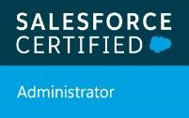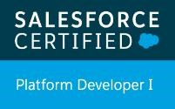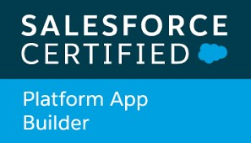

+91 8368905298

romiray21@gmail.com

[Type text] [Type text]

# Profile Summary

* 3 year of experience as Salesforce Developer in Accenture.
* Salesforce Certified Administrator.
* Salesforce Certified Platform App Builder Certification.
* Salesforce Certified Platform Developer 1.
* Copado Certified Administrator.

# Professional Experience

**Accenture Salesforce Developer May 2018 -Till Date**

* Working as a Salesforce Developer for an American multinational analytics and technology client.
* Have an idea on Salesforce.com services: Sales Cloud.
* Worked on ERP based managed package like Apttus.
* Currently working on a Vaccine Management Project in Aura components.
* Responsible for creating new functionalities and enhancing the existing ones for the end users.
* Experience in Apex classes, Test classes, Batch Apex, custom user interfaces with Visualforce, Custom controllers.
* Creating and Updating Data Models, Custom Objects, Workflow, Approval Process, Custom Metadata, Email templates etc.
* Creating formula fields, roll up summary fields, sharing rules, roles, profiles, settings, reports, dashboards etc.
* Performing unit testing on the newly created functionalities.
* Hosted daily updates and performed regular demos to key stakeholders and oversaw monthly releases and projects using Nova Suite and PM fixes.

# Academic Achievements

|  |  |  |  |
| --- | --- | --- | --- |
| **Degree** | **Year** | **Institute, University/ Board** | **% /CGPA** |
| B.Tech, (CSE) | 2014-2018 | Jaipur Engineering College and Research Centre (RTU) | 73.4% |
| H.S.C. | 2012-2013 | Kendriya Vidyalaya (CBSE) | 83.50% |
| S.S.C. | 2010-2011 | Kendriya Vidyalaya (CBSE) | 10 CGPA |

# Academic Projects

* Website: Lifehawn.com. Content based on motivational quotes. Building websites and improving SEO.
* Website building at Capellasoft.com/Way2College.com. Improved UI and built functionality to help real time user to search for colleges and universities easily.

**Languages worked on**

* Apex, SOQL, Html, CSS, C++, C, SQL.

# Other Activities and Awards

* Pinnacle Award Winner at Accenture.
* Participated in C/C++ coding competition in college.

• Volunteered in technical events in college.

# Skills, Strengths And Competencies

* Highly motivated, Team oriented
* Strong business communication skills

