RESUME:-

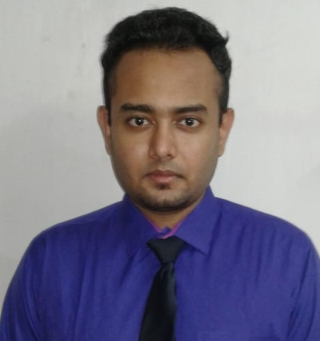Sayan Bishnu

Contact Details:-

Ph. No: 9123034192,

7688040126

Email Id: sayanbishnu63@gmail.com

Address: 55 Shantinagar Road, Moti lal Lane ,

P.O. Bhadrakali, PS. Uttarpara,

Dist- Hooghly, West Bengal,

Pin- 72232.

Personal Details:-

Date of Birth: 02/01/1999(age 21)

Gender: Male

Height: 5’9 Weight: 72 kg

Verbal communication: Hind,English,Bangla,Punjabi.

Physical Condition: Physically Fit.

Father’s Name: Sankar Bishnu.

Mother’s Name: Swapna Bishnu.

Objective:-

Work hard to achieve goals for the organization and to achieve my dreams.

|  |  |  |  |  |
| --- | --- | --- | --- | --- |
| Education | Board/  Universiy | Name of  institution | Year of  passing | Percentage |
| B.tech in Mechanical  engineering | Makaut | Techno Main,  Salt Lake. | 2021 | 6.88 (cgpa) |
| Intermediate(XII) | ISC | A.D.L.S. Sunshine  School | 2017 | 84% |
| High School(X) | ICSE | D.B.M.S  English  School | 2015 | 85% |

Education Qualification:-

Professional Skills:-

* Good communication skills
* Leadership
* Analytical skills
* Basic computer knowledge
* Work life balance
* Foreign languages : Spanish, Arabic.

Technical Skills:-

* Autocad
* Solid works
* C, Java programming and Microsoft Office.
* Accounting Management

Certification:-

* Operation Management - EDX
* IIT Bombay certification for C programming
* AutoCAD and Solid works- UDEMY
* Digital Marketing – GOOGLE
* Accounting For Corporation- UDEMY
* Home Business Basic Sales & Marketing Tools - UDEMY

Achievements:-

* Member at Pankh(NGO)
* Member at ISHRAE
* Best actor award for performing the act “Khokho” for our school drama club “Nritya Natak Manchya”
* Won first prize in Slogan Writing Competition

Training:-

Completed vocational training at Mukesh Hyundai Training center in Kolkata relate to automobile industry.

The experience was very good which provided knowledge about the vast technical field of automobile.

Internship:-

Summer intern at toppr.com 02/05/2020 to 12/05/2020,