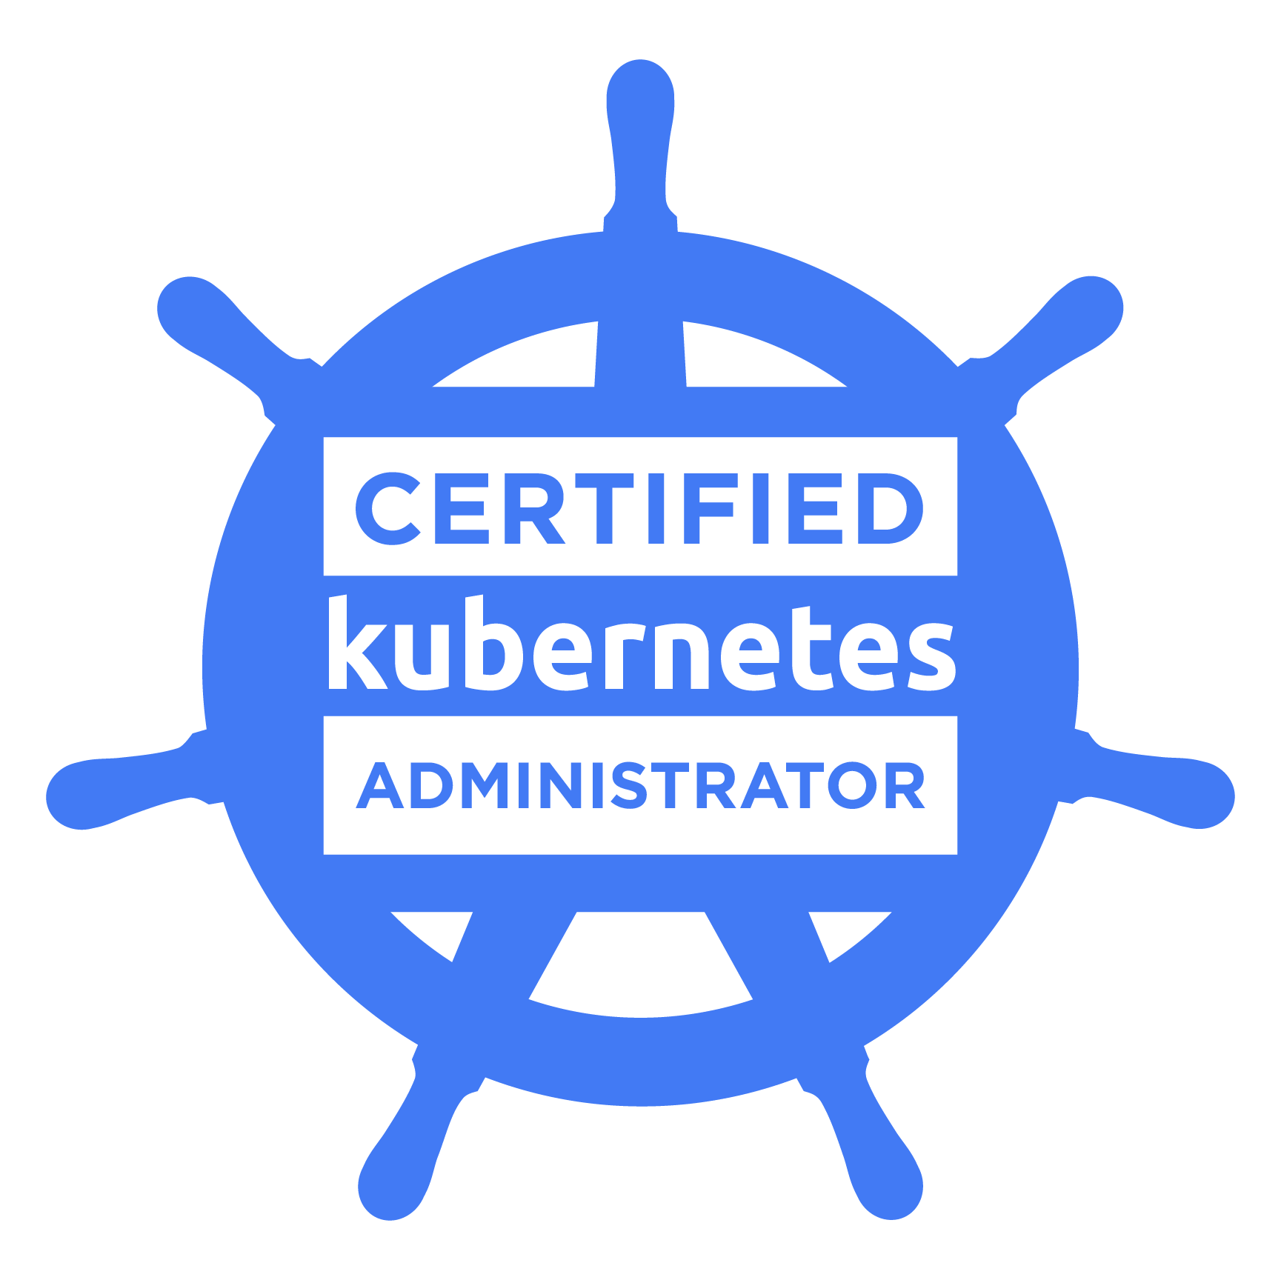
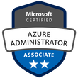
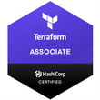

RAKSHITH G

Ph: (919) 714 9811

Email: rakshithg7890@gmail.com

10+ years experienced & result oriented Cloud/DevOps Engineer possessing in-depth experience of managing cloud-based technology & effectively handling configuration & Deployment of Infrastructure & services. Gained hands-on experience in implementing core DevOps concepts such as containerization, virtualization, version control, cloud computing, database management & administration, load balancing, etc. by using a wide variety of technologies while working with multiple DBMS, Operating Systems & programming languages. Drives excellence in every project to deliver outstanding results.

KEY SKILLS

• Cloud Technology Management • Containerization • Pipelining • Version Control • Load balancing • Configuration Management • Virtualization • Cloud Computing Server Maintenance • Infrastructure Monitoring • Security & User Administration Shell Scripting • CRUD • Networking & Configuration • Deployment & Provisioning • Database Management • Database Administration

PROFESSIONAL SUMMARY

- Defined architecture, design, governance and implementation plans for hosting complex highly available, scalable application workloads on MS Azure /AWS.
- Designed solutions leveraging IaaS, PaaS, App Services, Azure Functions, Logic Apps, Web Jobs, hosting Microservices into Container Instances, AKS clusters, Service Fabric mesh.
- Experience in migrating on-premises to the Microsoft Azure using Azure Recovery Service Vault and Azure backups, Azure Fabric, Docker containers to the cloud in Azure, and created Domain Controller in one of the Virtual Machine and added users to Domain Controller.
- Experience in the areas of DevOps, CI/CD Pipeline, Build and release management, Azure/AWS, and Linux/Windows Administration.
- Experienced in custom solutions capacity planning, physical and logical architecture, Identity management, administration, deployment, IIS Configuration, application scale out, application gateway and load balancer, high availability and disaster recovery configurations
- Hands-on experience in an environment of Amazon Web Services (AWS) products gained good knowledge in Elastic Cloud Computing, Simple Storage Services, Glacier, Block Storage, Elastic Beanstalk, Amazon Lambda, Virtual Private Cloud, Load balancing, Relational Database Service, and Cloud Watch.
- Experience in designing and deploying AWS IaaS, PaaS, SaaS, Lambda Functions and EKS clusters using Cloud Formation and Terraform.
- Have experience in Automating the detection and remediation of identity-based risks, investigate risks using data in the portal, & Export risk detection data to third-party utilities for further analysis using Azure active directory identity protection.
- Experience in optimizing solution performance, security, environment stabilization & maintenance of existing & legacy applications and strategizing the Legacy System Modernization
- Implemented Azure DevOps Pipelines for CI/CD setup, deployed applications automatically by enabling the triggers to deploy and Migrated TFS CI/CD pipeline into Azure DevOps pipeline and restored the artifacts into azure artifacts.
- Worked on Azure Kubernetes Service to deploy a managed Kubernetes cluster in Azure and created an AKS cluster in the Azure portal, with the Azure CLI, also used template-driven deployment options such as Resource Manager templates (ARM) and Terraform.
- Hands-on experience in deploying Kubernetes Cluster on cloud environment with master/minion architecture and wrote many YAML files to create many services like pods, deployments, auto scaling, load balancers, labels, health checks, Namespaces.
- Deployed Flux in Kubernetes Cluster for continuous delivery of Helm Charts by integrating Flux with the Helm repository.
- Proficiency in using Docker Hub, Docker Engine, Docker images, Docker Weave, Docker Compose, Docker Swarm, and Docker Registry and used containerization to make applications platform when moved into different environments.
- Worked on setup the Kubernetes sandbox on Azure Kubernetes Services (AKS) for testing the different features and manage containerized applications using its nodes, ConfigMaps, selectors, services, and deployed application containers as Pods using various pod controllers’ deployments, DaemonSets, and Statefulsets.
- Troubleshoot the build issues during the Jenkins build process and Developed build and Deployment scripts using ANT and MAVEN in Jenkins to automate the project’s lifecycle. Efficient experience in using Nexus and Artifactory repository managers for Jenkins and Maven builds.
- Experienced in setting up various Jenkins jobs to pull the code from the GitHub repository and perform continuous integration and continuous delivery by writing a Jenkins file using Groovy scripting language.
- Experience in Configuration management tools such as Chef, Ansible, and Puppet. Wrote Chef recipes and cookbooks in Ruby scripting.
- Experience in building private cloud infrastructure of OpenStack, deploying through Ansible Playbooks, and maintaining them in production.
- Experienced in Ansible tool, which is used to manage and configure nodes, Managed Ansible Playbooks with Ansible roles and used Ansible Tower to manage Multiple Nodes and Inventory for different Environments.
- Expertise in Terraform to reliably version and create Infrastructure on Azure/AWS cloud. Created resources, using Azure/AWS Terraform modules, and automated infrastructure management
- Experienced with Terraform key features such as Execution plans, Resource Graphs, Change Automation, and extensively used Auto Scaling for launching cloud instances while deploying Microservices and used Terraform to map more complex dependencies and identify network issue.
- Hands-on experience with Version Control tools such as Git, Bitbucket, and SVN in Branching, Merging, and Tagging and maintaining versions across Windows and Linux platform.
- Hands-on experience with databases like MySQL, MongoDB, Postgres, Cassandra for creating tables, views, triggers, etc.
- Experienced in Integrated ELK Stack to an existing appliance framework for real-time log aggregation, analysis, and querying (Elasticsearch, Logstash, Kibana) and using ELK Stack.
- Excellent knowledge on agile methodologies, agile operations process, and tools area and experience in using Software Development Life Cycle (SDLC) Waterfall methodologies.
- Broad experience in Linux/Unix System Administration, System Builds, Server Builds, Installations, Upgrades, Patches, Migration, and Troubleshooting.

TECHNICAL SKILLS

Cloud Platforms : Azure, AWS, PCF, OpenStack.
Operating Systems : CentOS, RHEL (6.x, 7x), Ubuntu, Solaris, Windows.
Containerization Tools : Docker, Kubernetes, Mesos, OpenShift, AWS ECS, AKS, ECR.
Versioning Control Tools : Subversion (SVN), GIT, Stash, Bitbucket.
CI/CD Tools : Jenkins, Bamboo, Hudson.
Logging & Monitoring Tools : Azure Monitor, Nagios, Splunk, ELK, CloudWatch, Prometheus, New Relic.
Configuration Tools : Ansible, Chef, Puppet.
Build Tools : Ant, Maven.
Languages/ Scripting : C, C++, Python, Java/J2EE, JavaScript, C#, Ruby, YAML, Ruby, Asp.Net.
IDE &amp; Developing Tools : Eclipse, Notepad++, Sublime, JBoss, MAMP, Putty, VirtualBox, Microsoft Visual Studio, JIRA.
Web Technologies : HTML/HTML5, CSS/CSS3, JavaScript, jQuery, Ajax, JSON, XML, JSP.
Application Server : Web Sphere, Apache Tomcat, JBoss.
Database : SQL, MySQL, Azure Cosmos DB, Amazon RDS, Oracle, DB Design
NoSQL (DynamoDB, MongoDB, Cassandra)

PROFESSIONAL EXPERIENCE

Sr Cloud Infrastructure Engineer

J.B Hunt - Lowell, AR. Jan 2019 - present

- Managed design, installation, administration, and optimization of Hybrid cloud components to ensure business continuity (i.e. Azure Active Directory, ADFS SSO & VPN Gateways).
- Evaluate on-Premises data center workloads, estimate cloud migration, implementation, and maintenance efforts
- Working on On-Premises to Azure migration, Jira to Azure DevOps Migration, GitHub to Azure DevOps Migration along with experience in configuring and using PaaS offerings (like Azure Database services, Azure Kubernetes, Azure Containers, DNS, Application gateway rerouting, Application Insights, Azure Container Monitors, etc.).
- Migrated on prem to windows azure by building azure disaster recovery environment, azure recovery vault and azure backups from the scratch using power shell script.
- Managed to migrate SQL Server databases to SQL Azure Database using SQL Azure Migration Wizard and used Ruby API to upload agent logs into Azure blob storage.
- Migrated websites to Microsoft Azure cloud and deploying applications on multiple web servers and maintained load balancing, high availability, and synchronized on-premises Active Directory users to office 365 with AD CONNECT.
- Built an application environment to operate at high availability in different Azure regions by using CDN, Azure Traffic Manager, App Services-Web Apps, Active Directory, Storage Queues, Cognitive Services, Azure Search, Storage Blobs, Redis cache, and SQL Database.
- Configured RBAC and Azure Monitor for adding security in Azure Cloud and Network Security Groups for Subnet and NIC level for Azure Virtual Machine
- Deployed ASP.NET web Application in Azure using Web App service, connected it to Azure SQL Database and used Azure DevOps to provide CI/CD pipeline and created Azure Active Directory (AD) tenants and managed to restrict the Access to Azure DevOps.
- Creating and Managing Virtual Machines in Windows Azure and setting up communication with the help of Endpoints. Configured Shared Access Signature (SAS) tokens and Storage Access Policies in Azure Cloud Infrastructure.
- Experienced in writing AZURE Resource Manager (ARM) Template to deploy multiple resources and extensive experience in designing custom build steps using PowerShell scripts and ARM templates to automate the provisioning and deployment process.
- Modernize legacy monolithic mission critical applications using Microservices architecture leveraging Azure Kubernetes Service & Service Fabric mesh.
- Configured AppDynamics cluster agent to monitor AKS pod failures and restarts, node starvation, missing dependencies such as Services, Config maps and Secrets.
- Implemented Terraform Enterprise to provision infrastructure across Azure workloads and Kubernetes clusters.
- Extensively involved in Infrastructure as Code, execution plans, resource graph, and change automation using Terraform.
- Created Terraform templates for provisioning virtual networks, subnets, VM Scale sets, Load balancers, and NAT rules and used Terraform graph to visualize execution plan using the graph command.
- Worked with Terraform Templates to automate the Azure IaaS virtual machines using Terraform modules and deployed virtual machine scale sets in a production environment.
- Created builds and release pipelines in Azure DevOps and done deployments using SPN (secure endpoint connection) for implementing CI/CD.
- Deployed and Configured Artifactory and Integrated Azure Pipelines with Artifactory to save the build artifacts, Docker images and retrieve them during resource provisioning.
- Configured Kubernetes cloud to provision dynamic pods as worker nodes for various jobs in the Kubernetes cluster by creating service accounts and set up Docker in Docker (DIND) Daemonsets to provide virtual docker daemon and separate host daemon.
- Configured and Integrated Docker container orchestration framework using Kubernetes by creating pods, deployments, and used Python Scripts to schedule, deploy, and manage container replicas onto a node cluster using Kubernetes.
- Worked on production-grade Kubernetes cluster, configuring pod security policies, and allocating dedicating CPUs by configuring isolcpu at the kernel level and making sure pod has guaranteed QoS-class and configured several global network policies in Calico in Kubernetes cluster for ingress/egress rules at the subnet level.
- Managed Kubernetes charts using Helm, and built reproducible Kubernetes applications builds, managed Kubernetes manifest files, and Helm package releases.
- Used helm to set up Prometheus and Grafana on our existing Kubernetes cluster for collecting logs and visualizing on a graphical dashboard.
- Worked on Ansible to automate repetitive tasks, quickly deploys critical applications, and proactively manage changes and written Ansible Playbooks to perform middleware binary Installation and Configuration tasks involving JDK, Tomcat binaries installation.
- Installed and configured Nagios as a monitoring tool for disk usage, CPU utilization, list of open files, etc. Setup threshold alerts in Nagios XI and updated contact definitions to notify potential service or host interruptions.

Azure DevOps Engineer
DTCC – Tampa, FL. Sept 2016 – Dec 2018

- Dealt with Microsoft Azure IaaS – Cloud Services, Virtual Networks, Virtual Machines, Resource Groups, Express Route, Traffic Manager, VPN, Load Balancing, Application Gateways, Virtual Machine Scale Sets, and Auto-Scaling.
- Configured Azure Virtual Networks, subnets, DHCP address blocks, Azure network settings, DNS settings, security policies, and routing.
- Designed ARM templates for provisioning Azure resources like Application Gateway, Azure Policy, Network Security Groups, and Azure Application Insights.
- Configured different types of blobs, Block blobs, Page blobs, and Append blobs in Azure for storing a large amount of unstructured object data such as text or binary data, that can be accessed from anywhere via HTTP or HTTPS.
- Configured Azure Serverless applications with built-in security and monitoring – Azure Active Directory, Azure Key Vault, Cosmos DB integration, Serverless Kubernetes, etc.
- Created Azure Automation Assets, Graphical runbooks, PowerShell runbooks that will automate specific tasks.
- Expertise in deploying Azure AD Connect, configuring ADFS authentication flow, ADFS installation using Azure AD Connect.
- Automated provisioning of Hybrid solutions connecting Azure to on-premises resources via IAC, Azure Express Route, and Azure Hybrid connections.
- Extensively worked on Terraform modules that had version conflicts to utilize during deployments to enable more control or missing capabilities. Managed different infrastructure resources, like physical machines, VMs, and Docker containers using Terraform.
- Expertise in building Jenkins jobs to create Azure Infrastructure by pulling Terraform code from GitHub repositories, ability to work closely with teams, to ensure high quality, timely delivery of builds, releases.
- Included Vulnerability Detection as a part of the CI/CD workflow using Jenkins Pipelines, SonarQube, Quality Gates. Installed Jenkins/Plugins for GIT Repository, Setup SCM Polling for Immediate Build with Maven and Maven Repository (Nexus Artifactory).
- Implemented CI/CD webhooks & workflows around Jenkins to automate the dev-test deploy workflow around Ansible codebase. Installed and Managed Jenkins and Nexus for CI and Sharing Artifacts respectively within the company.
- Experienced with deployment automation of all the microservices to pull the image from the private Docker Registry and deploy to Docker Swarm Cluster using Ansible.
- Deployed Windows and Linux based Docker containers with popular container orchestrators like Kubernetes and DCOS provisioned by the Azure Container Service and integration of container registries.
- Deployed Kubernetes Cluster on cloud/on-premises environments with control/compute architecture and wrote many YAML files to create many services like pods, deployments, auto-scaling, load balancers, labels, health checks, Namespaces, Config Map.
- Worked on Ansible Playbooks, Modules, Roles, and used them in Cloud (Azure) environments and experience with Ansible Tower to manage multiple nodes and manage inventory for different environments.
- Used GIT as a source code management tool for creating a local repo, cloning the repo, adding, committing, pushing the local repo changes, saving changes for later (Stash), recovering files, branching, and creating tags.

AWS Infrastructure Service Engineer

UHG - Brentwood, TN July 2014 – Aug 2016
- Worked on core AWS services (S3, EC2, ELB, Route53, VPC, auto-scaling, etc.), deployment services (Ops-Works and Cloud Formation), and security practices (IAM, Cloud watch and Cloud trail).
- Designed AWS cloud formation templates to create custom securitized VPC, Subnets, NACLs, NAT to ensure the successful deployment of web applications and database templates in private environments.
- Migrated the MySQL database from on-premises to AWS Aurora RDS, thereby enabling automatic extending the system’s storage. Used AWS Data migration services to combine databases, thereby enhancing data compatibility.
- Used AWS Beanstalk for deploying and scaling web applications and services developed with Java, Node.js, Python, and Ruby on familiar servers like Apache, Nginx, and Tomcat.
- Setup the CloudWatch monitoring dashboards with SNS notification configurations on various performance metrics retrieved from various AWS Resources.
- Worked at optimizing volumes and EC2 instances and created multiple VPC instances. And Deploy and monitor scalable infrastructure on Amazon web services (AWS).
- Hands-on experience in migration of one Business from a physical data center environment to AWS. Worked at optimizing volumes and EC2 instances and created multiple VPC instances. And Deploy and monitor scalable infrastructure on Amazon web services (AWS).
- Managed IAM policies, providing access to different AWS resources, design and refine the workflows that were used to grant access. Configured access for inbound and outbound traffic for RDS DB services, DynamoDB tables.
- Integrated ELK Stack to an existing appliance framework for real time log aggregation, analysis, and querying (Elasticsearch, Logstash, Kibana) and using ELK Stack, Elasticsearch for deep search and data analytics. Logstash, Splunk for centralized logging, log enrichment and parsing and Kibana for powerful and beautiful data visualizations
- Created Python scripts to fully automate AWS services, including ELB, Cloud Front distribution, EC2, Security Groups, and S3. This script creates stacks, single servers and joins web servers to stacks.
- Created customized Amazon Machine Images (AMI) based on already existing AWS EC2 instances by using create image functionally snapshot which was used for disaster recovery as well.
- Automated the implementation of VPCs, ELBs, security groups, SQS queues, S3 buckets by using Terraform and used Terraform as a tool to manage different cloud infrastructure resources.
- Experience in working with AWS EC2 Container Service plugin in Jenkins, which automates the Jenkins master-slave configuration by creating temporary slaves.
- Designed end-to-end automation of infrastructure and continuous delivery of the applications by integrating cloud formation scripts, Jenkins, AWS & Ansible playbooks.
- Integrated Jenkins with various DevOps tools such as Nexus, SonarQube and used the CI/CD system of Jenkins on Kubernetes container environment, utilizing Kubernetes and Docker for the runtime environment for the CI/CD system to build and test and deploy.
- Worked on Container management using Docker by writing Docker files and set up the automated build on Docker HUB and installed, configured, Kubernetes.
- Experience in developing Cookbooks, Recipes, Resources and Run lists, managing the Chef Client nodes, and upload the Cookbooks to chef-server from Workstation using knife command, Berkshelf dependency manager, and Test kitchen to validate Chef Cookbooks.
- Implemented the Blue/Green deployment strategy by creating new applications that are identical to the existing production environment by using automation frameworks such as Terraform templates.

Python Developer

Hyundai Mobis – Chicago, IL. Feb 2013 – June 2014

- Managed, developed, and designed a dashboard control panel for customers and administrators using Django, PostgreSQL, Flask, and VMWare API calls.
- Developed consumer-based features and applications using Python and Django in test-driven Development and pair-based programming.
- Implemented the concepts of multi-thread processing to achieve a high throughput of the application using Python.
- Installation, configuration, integration, tuning, backup, crash recovery, upgrades, patching, monitoring system performance, system and network security, and troubleshooting of Linux/UNIX servers.
- Plans and facilitates the organization of PostgreSQL information bases to guarantee exact, proper, and successful information use, including information base definition, structure, documentation, long-range necessities, and operational rules.
- Developed Python-based API (RESTful Web Service) to track sales and perform sales analysis using Flask and PostgreSQL. Developed and designed an API (RESTful Web Service) for the company’s website.
- Developed a custom dashboard using Python Flask and configured it with a backend database using Flask SQLAlchemy.
- Developed Python, Perl, and shell/bash scripts for Tomcat servers. Wrote automation scripts in Python for build and release process.

Sr Systems Administrator

Wipro Ltd – Hyderabad, India. Aug 2011 – Dec 2012

- Worked on Installation, Configuration, and Maintenance of Apache Tomcat, Web Sphere, and JBoss servers in AIX and Linux environment.
- Lead projects creating the supporting Infrastructure for future Linux-based servers, including software distribution, security, remote Access, fault-tolerance and disaster recovery, and backup.
- Setting up, configuring, and troubleshooting TCP/IP, DHCP, DNS, CIFS, NTP, and Samba servers on different multi-platforms (Windows, Linux)
- Installing, configuring, and administering DNS, NFS, NIS, Mail servers, FTP servers, RPM servers on Red Hat Linux, Ubuntu, CentOS, Fedora platforms.
- Provided systems administration support to Linux systems, including server and workstation upgrades, backup and disaster recovery, monitoring, user account setup
- Planned and performed the upgrades on Linux and AIX operating systems and hardware maintenance on HP and POWER servers, such as increasing memory, disk, and replacing failed hardware.

Linux Administrator

DBS Bank – Hyderabad, India. June 2010 – July 2011

- Created and modified application related objects, created Profiles, users, roles, and maintained system security.
- Managed and administrated all Linux/UNIX servers, includes Linux operating systems, by applying relative patches and packages at regular maintenance periods using Red Hat Satellite server, YUM, RPM tools.
- Developed UNIX and Perl Scripts for manual deployment of the code to the different environments and Email the team when the build is completed.
- Creating the shell scripts to automate cron jobs and scheduling these jobs by creating crontabs.
- Installed and administered VMware, vSphere, ESX, and Vcenter servers.

Education

Master’s in Computer Science Engineering
Northern Illinois University – Dekalb, IL

Bachelor’s in Electronics and Communication Engineering
Osmania University – Hyderabad, India

