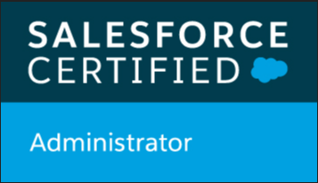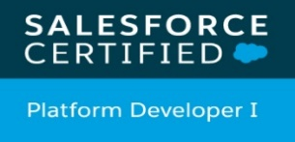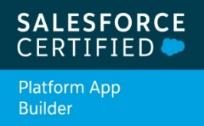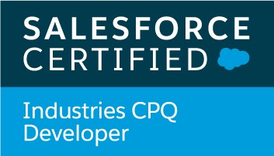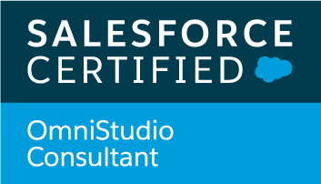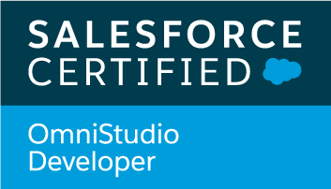

**Ratnakar S. Mahajan** [mahajan.ratnakar29@gmail.com](mailto:mahajan.ratnakar29@gmail.com)

Sr. Salesforce/Vlocity Developer **9860591044**

**Objective:-**

To learn and function effectively in an organization with my hard work to constantly upgrade my knowledge, experience and skills .And pursuing the unending goal of achieving excellence in all walks of life

**Professional Experience**

Highly proficient in SFDC cloud application development, design, customization of the software solutions in SFDC and Vlocity

* **5+** years of experience encompassing Product Design, Application Development and Support; Worked extensively on Cloud computing solutions with domain expertise on **force.com** and **Salesforce.com.**
* Proficient 4years of experience in **.**Net Application development. SQL Server 2000,2005,2008,2008R2
* Good hands on experience in Salesforce Customization including **APEX classes, Triggers and lightning components**.
* Almost 2 years of Vlocity development Experience.
* Good Expertise on creating/configuring **Vlocity Console Cards, Data Raptor, OmniScript, Integration procedures**, Development and REST tooling API’s related to Vlocity.
* Knowledge of Vlocity **CPQ**
* Good knowledge on **Order Capture**, **EPC, Product & Pricing, Advance Promotion, Context Rules, Advance Rules**.
* A team player with a strong work ethic, a positive attitude and the ability to make the best use of individual resources.
* Learn and adapt quickly to new roles and responsibilities.

**Awards & Certifications**

* Awarded in current Organization (Tech Mahindra) by “**POB**” (Pat on Back).
* Awarded for significant contribution towards excellent performance.
* **Vlocity Developer Certified.**
* **Vlocity CPQ Developer I**
* **Platform Developer I Certified.**
* **Salesforce Certified Administrator**
* **Platform App Builder**

**Work Experience**

* **Current Organization**- Atos-Syntel Pvt ltd.
* Duration: Jun 2020
* **Previous Organization**: Tech Mahindra, Pune.
* Duration: July 2016 to May 2020.
* **Previous Organization**: PC Technoledge Pvt. Ltd, Mumbai.
* Duration: January 2007 – July 2015.
* **Project Experience:**

**Humana Product Rating**

Humana is the big healthcare giant in USA. Providing the health and health related plan services to their customers like Medical and Dental. Generate the quote and plan according to eligibility of the employee and provide the services. Utilize the salesforce, Lightning and Vlocity for the building the application.

**Technologies**: Lightning aura Components, Apex Classes, Vlocity Integration Proc, Cal Matrices, Cal Proc. Etc.

Role: Sr. Salesforce Developer.

Worked on the Dental and Medical Integration procedure using the vlocity tool. Created Data raptors for the fetch and stored the data and transform the data. Calculation Matrix and calculation procedure for generate the plan according to eligibility.

**Volvo Cars USA**

**Technologies**: Apex, Workflows, Process Builder, Validation Rules, Apex triggers, Lightning Components.

Role: Sr. Salesforce Developer.

Developed Application for Volvo cars Internal Employees. Employees who want to new car or Old car on lease those can able to do the Order using this application. Complete application is developed using aura components. Participate in design and development. Deliver the application successfully.

**Responsibility:**

* Integration with CRM, developed using Lightning components.
* Integration with Mulesoft
* Implement Approval Process, Lightning Flow
* Worked on data model design

Created Process builder for fields update, Validation rules, Workflows.

**A1 Digital**

**Technologies**: Apex, Workflows, Process Builder, Validation Rules, Apex triggers, Lightning Components.

Role: Sr. Salesforce Developer.

This is the Current Project on which I am working, we have deploy the two phase successfully, now the third phase is going on. Implemented CRM with complete Quote and Contract cycle developed using lightning. System is integrated with 3 third party system. We have used SOAP API for an integration.

**Responsibility:**

* Integration with Sugar CRM, developed using Lightning component
* Integration with ServiceNow , developed using Lightning component
* Implement Approval Process, Quote and Contract Cycle
* Created Process builder for fields update, Validation rules, Workflows.

**Client:-UK**

Technologies: Vlocity Modules, Apex Coding, Workflows, Apex triggers, Objects. Vlocity CPQ  
Role: Sr. Salesforce Developer.

Work for the UK based client, it was Telecommunication solution. Involved lots of third parties in existing system. System are integrated with BSS, Docusign, LOM etc.. Developed B2B and B2C Scenarios using vlocity.

**Responsibility:**

* Capture Lead from web portal and convert it to Account, Contact and Opportunity.
* Design the **Omniscript** for B2C and B2B Scenario using the vlocity components.
* Design the **DataRaptor** for Extracting and Loading the data from-to Salesforce.
* Provide the 360 degree view of customer using **Console card.**
* Launch the Omniscript from custom button on Visualforce page.
* Launch the Omniscript on link click.
* Capture complete Order journey using Salesforce and Vlocity Omniscript.

**Telco Enterprise (**Complete End to End Solution for Telecommunication**)**

**Product Based.**

Technologies: Apex Coding, Workflows, Apex triggers, Objects.  
Role: Sr. Salesforce Developer.

This Cloud Computing project involves E2E Solution on Force.com using tight integration with Sigma CPQ (Product Configuration, Price and Quote).

Capture complete Lead to Order journey.

**Responsibility:**

* Involved in the design of the application.
* Worked on standard objects as well as custom objects.
* Implement the apex classes and triggers on Account, Opportunity, Quote and Order for various operations.
* Created data validation rules and formulas as per business requirement.
* Created workflow rules to automate tasks, email alerts, field updates and time-dependent actions.
* Create automatic Contract using
* Handle complete Quote management.
* Worked on Contract Life Cycle management, Implement approval process.
* Generate the Quote pdf and send it as email customer using customization.
* Written the Rest service to consume the xml generated by middle ware server after order submission to downstream server to update the order status on Order object.

Written the Rest service to send the sites details at the time of product configuration for specific location.

**Chhattisgarh Swami Vivekanand Technical University (e-RPS)**

**Role -: Team Leader**

**Responsibilities:**

* Assist to Provided business analysis, gathered requirements, designed and developed integrated IT solutions and business processes to meet client and internal user requirements.
* Created technical, functional and business specifications
* Consulted with teams to determine the technical feasibility of client requests and provided time estimates.
* Worked with high level business managers to effectively prioritize activities and achieve defined objectives.
* Developed and interpreted technical documentation.
* Coordinated with onsite and offshore team.
* Monitored progress on tasks and status of deliverables
* Was responsible for obtaining Boeing acceptance on coding standards and deliverables.
* Participated in all status review meetings.
* Used ADO.Net for database access.
* Work on Client side and update the applications and reports
* Upgrade the application on new Technologies successfully.

**Environment :** .Net Framework, ASP.Net, ADO.Net, Visual Studio .NET 2010, .NET Frame work 3.0, 3.5, Windows7,8, SQL Server 2008, SQL Server 2008 R2, Crystal Reports 9 and 11, Windows Servers 2008.

**Maharashtra State Board of Technical Education (e-RPS)**

**Role -: Team Leader**

**Responsibilities:**

* Assist to Provided business analysis, gathered requirements, designed and developed integrated IT solutions and business processes to meet client and internal user requirements.
* Created technical, functional and business specifications
* Consulted with teams to determine the technical feasibility of client requests and provided time estimates.
* Worked with high level business managers to effectively prioritize activities and achieve defined objectives.
* Developed and interpreted technical documentation.
* Coordinated with onsite and offshore team.
* Monitored progress on tasks and status of deliverables
* Was responsible for obtaining Boeing acceptance on coding standards and deliverables.
* Participated in all status review meetings.
* Used ADO.Net for database access.
* Work on Client side and update the applications and reports
* Upgrade the application on new Technologies successfully.

**Environment:** .Net Framework, ASP.Net, ADO.Net, Visual Studio .NET 2010, .NET Frame work 3.0, 3.5, Windows7,8, SQL Server 2008, SQL Server 2008 R2, Crystal Reports 9 and 11, Windows Servers 2008.

**Chhattisgarh Swami Vivekanand Technical University (IEES)**

**Role -: .Net Developer**

**Responsibilities:**

* Assist to Provided business analysis, gathered requirements, designed and developed integrated IT solutions and business processes to meet client and internal user requirements.
* Created technical, functional and business specifications
* Developed and interpreted technical documentation.
* Coordinated with onsite and offshore team.
* Monitored progress on tasks and status of deliverables
* Was responsible for obtaining Boeing acceptance on coding standards and deliverables.
* Participated in all status review meetings.
* Work on Client side and update the applications and reports
* Upgrade the application on new Technologies successfully.

**Environment:** .Net Framework, VB.Net, ADO.Net, Visual Studio .NET 2005, 2008, .NET Frame work 2.0/3.0, Windows XP, SQL Server 2005, 2008, Crystal Reports 9 and 11, Windows Servers.

**Goa University Integrated Enrolment and Examination System (GUIEES)**

**Role -: .Net Developer**

**Responsibilities:**

* Designing the Forms and Coding.
* Debug the Existing code and solved the issued.
* Created Crystal reports as per the Clients requirements
* Work on Client side and update the applications and reports

**Environment:** .Net Framework, VB.Net, ADO.Net, Visual Studio .NET 2005, .NET Frame work 2.0/3.0, Windows XP, Oracle, Crystal Reports 8.5, Windows Servers.

**Academic**

* MBA
* B.Com