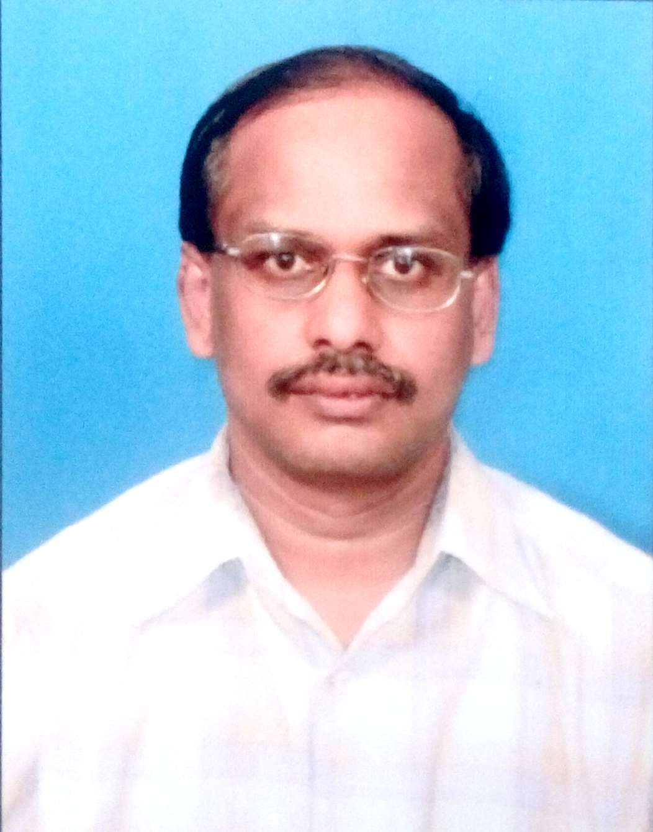**o**

**Anandan V. S.**

**E-Mail: vsanandan@hotmail.com / vsanandan@yahoo.com**

**Phone: +91-9443675664 / +91-8682877021**

**Accomplished Technology Lead for JAVA & MEAN full stack development**

Over 17 years’ rich, cross-cultural experience with impressive success in end-to-end technical design, architecture, implementation & delivery of software products / solutions in IT industries & 5 years in Electronics Industries. Contributed at all levels of development – UI / UX design, business logic implementation at server, & coding of the applications using Java, Microservices, REST API using Spring Boot, Database design, JUnit Testing with Mockito for Code-coverage, Fixes to SonarQube & Fortify issues, Code review & CICD, Deployment for Enterprise Mobile and Web Applications – Native and Hybrid Platforms – Cordova. NoSQL databases such as MongoDB. Experience in working with JavaScript variants such as NodeJS, Vue.js, MEAN full stack. Rich knowledge in Mathematical and Statistical Data modelling, Simulation, Data Science

Targeting assignments as **Technical Architect/Lead in Full stack development** with a leading IT company

|  |  |  |
| --- | --- | --- |
| **Skill Set:**   * Software Development Life Cycle (Conceptual & Physical Design, Implementation, Production Roll-out, Maintenance & Support) * Requirement Gathering & Analysis * Technical Analysis * Coding, Code Refactoring & Review * JUnit Test writing for Code coverage using Mockito Java REST APIs * Project Prototype/POC Preparation * Embedded Software Development * Platform Enhancement, Stabilization * Agile Development Methodology * Team Recruitment, Training, Career Development & Knowledge Transfer   **Technical Skills**   * Algorithms & DataStructures * Mobile Development using web Technologies & Native code * Experience in Mathematical & Statistical Model Development for Simulation * Web Development Technologies: HTML5, CSS3, JavaScript, AJAX, JQuery, JQueryMobile * Full Stack Development using MEAN - MongoDB, AngularJS & NodeJS * Object Oriented Programming using Java & C++ in Eclipse/STS and Netbeans IDE. Knowledge in Spring Framework (REST API) * Design Patterns, UML Diagrams * J2EE - Core Java, UI using Java AWT, Swing, JAXB, JSP, Servlets, REST API * Data Processing using XML, JSON Format through REST API, SOAP * Databases: NoSQL Programming, SQL Programming with MySQL, SQL-Server, MS-Access * UNIX/Linux OS: Shell Programming, Processes, Networking Tools * C/C++ Programming Environment under UNIX/Linux  Systems,, valgrind memory analyser. * Knowledge in IoT, Data Science |  | **Profile Summary**   * Skilled in leading all technical aspects of software development lifecycle starting from Requirements Specification – Documenting, analysis, Design, Development & Testing * Achieved on-time & quality delivery of multiple product releases, for clients spread across the globe including UAE, Australia, Singapore, Malaysia. * Individual contribution from the stages of project visualization to all activities of development. * Dynamic, flexible &approachable with excellent planning, analytical, problem solving, execution and team leadership skills   **Work Experience**  **Jun’2019 – till now: Experis-IT Man Power, Bangalore as Senior Lead Consultant**   * Working at client’s place, Chennai, managing a team of developers. Supporting them during admissions, development activities, bridging the gap between developers and the organization for all the procedures and policies. Managed a team among developers for writing Unit test cases for Code-coverage, fixing of SonarQube & Fortify scan issues; Preparing the build reports using Jenkins CICD environments. * Worked as a Scrum team developer for 5 Progressive Improvements – Involved in development activities using Spring boot Java, Microservices, REST API, Hibernate-MySQL, Oracle, PostGres; NodeJS, VueJS, HTML5, CSS3, JUnit test programming using Mockito for Code coverage for various modules, Reporting the SonarQube issues, fixing of Fortify Scan issues. * **Projects**: Planning Capacity and Seeding IEN modules - As the network domain is expanding with the new 5G technologies, network organizations are using data science techniques to calibrate the bandwidth requirements and pre-install the fibers, cables & other elements to support the future customers. The developed software support whenever a new customer joins and the available resources are evaluated, predicting the future requirements for 5 or 10 years in a specified geo-location etc. Worked at all levels of development, understanding requirements & features, designing, coding, review, testing & fixing of issues.   **Jan’2018 – Sep’2018: KorComptenz Consultancies Pvt. Ltd. as Project Manager (Mobile Applications)**   * Interacting with clients to understand the requirements, attending client calls, guide a development team and individually contribute in all stages of development activities for both native and hybrid mobile applications. JIRA, Smartsheet for development tracking. Integrated GPS, Geofencing & beacons; Crashlytics Fibre; REST API. |

* **Projects:**
  + Health-care applications (in both Android and iOS): Applications to monitor the walking and Gym activities of users to update their healthcare parameters daily and on achieving goals, giving reward points
  + Banking application using PhoneGap: Changing the login url, publishing the modified app in stores
* **Individual contribution** includes design of mockup pages, back-end REST API logic support, Code review, testing and publishing the app.

**May’2017 – Nov’2017: CanGo Networks Pvt. Ltd., Chennai as Sr.Technical Project Manager**

* Lead a team of developers to deliver product features in co-ordination with the customer requirements in a timely manner –Development frameworks & technologies – Java Spring, REST API, Web Apps – JS, HTML5, CSS3.
* **Project:** **Network Topology Product (Minerva):** The topologies for CS, PS core elements, Radio, Microwave and GPON network elements are generated from the log files and stored in big data server. Using REST APIs, big data queries are made and topologies are displayed in web clients using AngularJS.
* **Individual contribution** includes describing the parsing logic for network topology from the NE log files, AngularJS implementation in the front-end, REST API using Java to bring the necessary topology details, code review & testing

**Jan’2012 – May’2017: Kaspon Techworks Pvt. Ltd., Chennai as General Manager & Architect**

**Role**:

* Lead a numer of mobile & web app teams for end-to-end development of products from the stage of conceptualisation to realisation at client site; mentoring, guiding, reviewing and contributed in architecting the solutions for complex applications.
* Rendering post-implementation, application maintenance and enhancement support to the client; ensuring all solutions are scalable, extensible & available from architecture stand point.
* **Individual contribution:** Architecting the solution, designing the front-end UI/UX, back-end logic, database design, developing the critical part of the application using Java, JavaScript, Angular, NodeJS and other technologies, implementing the business logic using required data structures, reviewing all developmental activities and testing.

**Key Projects:**

* HRMS Mobile Application
* Third Eye – Spot Audit (Both Web and Mobile Apps)
* eCapex-Revex Workflow Management Mobile Application
* Hourly Production Tracking
* Office Tour Manager
* Personal Accountant
* Field Service Professional
* Hospital Management System
* Managed Appliances
* Mobile Application for Field Staff & sugarcane farmers (GPS, Google API)

**Description about some of the key projects:**

1. **Third Eye –** A product from Kaspon to be used by infrastructure industries to test the infrastructure projects. Testers can report from remote infrastructure sites using their mobile. Native and Hybrid mobile apps for the front-end, node.js for hosting the app, mongodb to store the configuration details
2. **Field Service Professional –** Servicing various house-hold appliances received as tickets are assigned to field service professionals can track to their customers and service with the help of this application. Ticket and servicing details are stored in MongoDB. **GPS tracking, Online-offline synchronization achieved**
3. **Workflow Management –** Approval for requests made from various departments for the expenditures to be approved by numerous management team who keeps travelling can do the same using this mobile app. .NET backend, PhoneGap front-end application.
4. **Hourly Production Tracking –** In the manufacturing plant, the employees are expected to produce given number units, and they have to keep update the number of units manufactured during their shift timings. This will be presented to the manager and team to keep track of the manufacturing plant. PhoneGap application with .NET back-end.
5. **Office Tour Manager –** The application can be used by employees of an organization who keeps travelling to various destinations, update their expenditures, claming the same. Developed using Native Android. Backend integrated with Php and MySQL.

**Highlights:**

* Delivered 100+ Mobile (Android Java, iOS Native, Hybrid Solutions using PhoneGap, HTML5, CSS3, J2EE, Javascript, Jquery,JQueryMobile, Shell Scripting, Windows Platforms) and Desktop Web applications, including:
  + Integration of Google Maps, GPS Information, Localization for international apps, Online-offline synchronization
  + Localization, Online/Offline Synchronization using local SQLite Database
  + Bluetooth Control, Camera Control, Video & Graphics Integration, Push Notifications
  + Web Service API Development using REST principles, AJAX principles, Node.JS based back-end support
  + Web applications using MEAN full stack
* Built robust architecture (logical & physical) for different solutions by managing the security, performance, availability, compliance, scalability and maintainability aspects

**Nov’2006 – Dec’2011 & May’2003 – Oct’2005: NMSWorks Software Pvt. Ltd., Chennai as Lead Engineer**

**Projects:**

1. **P2MS – Performance, planning and management systems** – For both web and windows client to collect the performance of network elements and links. Backend Java technology with MySQL / Oracle database
2. **Zonal level configuration module**: User can configure the zones, subzones, regions in the hierarchical model in XML file using JAXB and JavaSwing. User security module
3. **Network element management using MODBUS** - Using modbus protocol, the element details are read from them and instructions are given
4. **Web client control** – Web clients features (reports) are implemented using AJAX and JavaScript calls. JSP, Servlets are used for various reports.
5. **Scheduled Reports**: Reports of various network elements and links are generated periodically and whenever a user requests for the same, the same can be obtained from the back-end and displayed.

**Highlights:**

* Performed design & development of:
  + Integrated Network Management Software Product for various Telecom & Data Networks
  + Solutions for NMS and EMS of networks – Links, Routers, Switches, Alarm Monitoring Devices and other IP elements
  + Graphical User Interfaces for both Windows & Web based solutions using J2EE – JSP, Servlets, Core Java, AWT, Swing, RMI, XML Technologies (JAXB, Parsing), HTML, CSS, JavaScript
  + Performance Monitoring Analytical & Reporting Solutions: Crystal reports, Java based reports
  + Integrated Network Management Systems – Periodic reports on link availability and link utilization
  + P2MS – Performance, Planning and Management systems
* Worked extensively on Integrated Development Environments – Eclipse, Netbeans; Conducted training Programs.

**Nov’2005 – Oct’2006: KLA Tencor (I) Pvt. Ltd., Chennai as Software Engineer**

**Highlights:**

* Designed & developed:
  + Embedded Software solutions for Windows based Material Handling Systems using .NET and C#
  + Solution to provide Help contents, in the form of HTML, to end users of the Material Handling Systems Software

**Previous Work Experience**

**Apr’ 2001 – Apr’ 2003: Ushamartin Academy of Communication Technology, IIT Madras, Chennai as Lecturer**

**Apr’ 1999 – Mar’ 2001: Amrita Institute of Technology and Science, Coimbatore as Senior Lecturer**

**Apr’ 1998 – Aug’ 1998: Texas Instruments (I) Ltd., Bengaluru as Software Engineer**

**Mar’ 1996 – Aug’ 1996: Advanced Micronic Devices Ltd. (AMDL), Bengaluru as Project Engineer – Hardware**

**Oct’ 1994 – Feb’ 1996: DigiproTekmarketingPvt. Ltd., Bengaluru as Application Engineer**

**Aug’ 1991 – Sep’ 1994: United Systems Engineers Pvt. Ltd., Hosur, Tamil Nadu as Engineer**

**Academic Details**

* 1996 - 1998: M.Tech. (Computer Engineering) from SJCE, University of Mysore, Mysore with 85.15% marks
* 1988 - 1991: B.Tech. (Electronics Engineering) from M.I.T., Anna University, Chennai with 66.58% marks
* 1985 – 1988: B.Sc. (Mathematics) from Periyar Arts College, Cuddalore, University of Madras, with 91.1% marks

**Personal Details**

**Date of Birth**: 3rd June 1967

**Address:** No. 10, 1st Floor, Sri Narayana Apartments, 4th Cross, Rajesh Nagar, Pallikaranai, Chennai -600100

**Languages Known**: Tamil, English and Kannada.

**Passport Number:** M3050317 **Date of expiry**: 19/10/2024