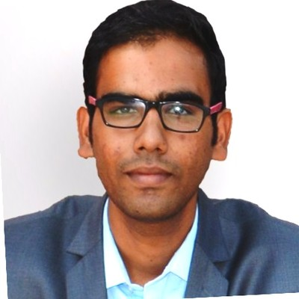

**Rakesh Dagdi**

**Mobile: +91-8884266458**

**E-mail: rdagdi2@gmail.com**

Professional Snapshots

* Having Extensive experience in software industry with 2.5 years of experience in different domain such as Energy and Utility, HealthCare and Management, Quality Assurance and **Salesforce CRM Testing**.
* Extensively worked in testing, troubleshooting and debugging of the application.
* Experience in SFDC functional testing on **Sales Cloud in APTTUS CPQ, X-Author app testing and Service Cloud**.
* Have good working knowledge on Agile methodology, involved in daily **Scrum calls, Grooming & Retrospective**.
* Trained in **Java J2EE**.
* Experience in **Tosca, Selenium**.
* Excellent professional ability to work independently and as a team member to perform Functional Testing, System Testing, Integration Testing, Smoke Testing, Sanity Testing, Regression Testing, GUI Testing
* Thorough Knowledge of Software Testing, CRM Salesforce Testing and preparation of test cases
* A keen communicator with the ability to work in team and relate to people across all hierarchical levels in the organization.
* Closely worked with clients and co-ordinate between onshore and offshore teams.

Educational Profile

|  |  |  |  |
| --- | --- | --- | --- |
| **CERTIFICATE/DEGREE** | **UNIVERSITY/ BOARD** | **COLLEGE/SCHOOL** | **PERCENTAGE** |
| 10th | CBSE | KV AFS Yelahanka | 90 |
| 12th | CBSE | KV AFS Yelahanka | 82 |
| B.E | VTU | NMIT, Bengaluru | 78 |

Technical Skills

* **Functional Modules:** Energy and Utility, HealthCare and Management
* **Tools:** Azure DevOps, Tosca,Selenium, Eclipse, Visual Studio
* **Languages:** Java J2EE
* **Web Technologies:** HTML, CSS, JavaScript
* **Database:** SQL Server
* **Cloud Technology:** Salesforce
* **Core Concept/ Methodology:** OOPS, Agile

Organizational Exposure-

* **Organization:** Wipro
* **Designation:** Project Engineer
* **Duration:** Nov 2017 – Till Date

Projects Executed-

Project 1

* **Project Title:** NPI2CASH
* **Client:** Philips - One of the largest electronics companies in the world, currently focused in the area of healthcare and lighting.
* **Duration:** From Sept, 2018 to till Date.
* **Project Type:** Agile Development
* **Technology:** Salesforce Technology
* **Description:** This projects was build upon APTTUS CPQ integrated with Salesforce and included creation of dynamic, robust and easy to maintain business flow which will start from the Lead generation to creation of quotes and further ends with the successful closing of the deal which will generate cash(business)
* **Responsibilities:**
  + Responsible for the quality deliverables of the requirements by the customers.
  + Analysis of the stories, Creation of the scenarios, Authoring and Execution of the test cases with Automation of core scenarios for future RT runs.
  + Followed agile methodology.
  + Functional testing of Objects like Account, Contact, Opportunity and validation rules.
  + Performed testing of various Roles and Profile with different Permission Sets.
  + Involved in Daily stand up calls and business acceptance calls.
  + Involved in defect calls and use of DevOps Azure tool for logging defects.

Project 2

* **Project Title**: OnePort
* **Client:** Chevron Corporation is an American multinational energy corporation.
* **Duration:** From March 2017 to July 2018.
* **Project Type:** Agile Development
* **Technology:** Java J2EE, Spring MVC, (SAP Hybris)
* **Team Size:** 70
* **Description:** The project was about developing an e-commerce website, which will help client in shipping, billing and selling of lubricants to their customers.
* **Responsibilities:**
* Responsible for end-to-end delivery of data on-boarding stories including design, development and unit testing.
* Coordinated with geographically distributed teams for a successful development, testing and deployment

Personal Information

* Date of Birth: 17th April,1995
* Gender: Male
* Marital Status: Unmarried
* Nationality: Indian
* Location Preference: Bangalore

Declaration

I hereby declare that the above written particulars are true to the best of my knowledge and belief.

DATE: Rakesh Dagdi

PLACE: Bangalore